Name: Class: Mark:

1. Which one of the following adhesives is safest to use? [1]
⬨ Contact adhesive
⬨ PVA
⬨ Polystyrene cement
⬨ Hot-glue

2. Name a suitable adhesive for joining foam core. [1]

3. Explain two precautions that should be taken when using solvent-based adhesives
to ensure the safety of the user. [4]

4. Study the pasta packaging below. Describe two advantages of using hot-melt glue
to seal the package. [4]
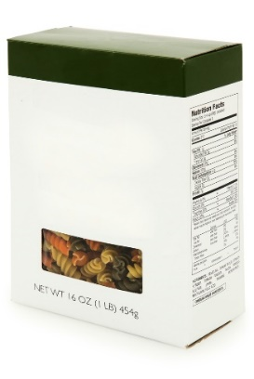

5. Explain how to apply and bond two surfaces using contact adhesive. [4]

6. Discuss the advantages and disadvantages of using a jig to manufacture a batch
of 300 units of packaging. [6]

[Total 20 marks]

