Name: Class:

Task 1
What are the pros and cons of the screen printing process? Consider the following factors:
- Set-up cost
- Efficiency
- Quality of print
- Types of substrate
- Scale of production

Pros:

Cons:

Task 2
Suggest one advantage, one disadvantage and one suitable application for each of the three print processes below:
- Offset lithography
- Flexography
- Digital printing
Offset lithography
Advantage:

Disadvantage:

Application:

Flexography
Advantage:

Disadvantage:

Application:

Digital printing
Advantage:

Disadvantage:

Application:

Task 3
You have been commissioned to create a theatre program for a new musical in your local theatre. The image below shows the cover for the show program. The show will run for four nights and 125 copies are required for each performance. The show opens in one week.
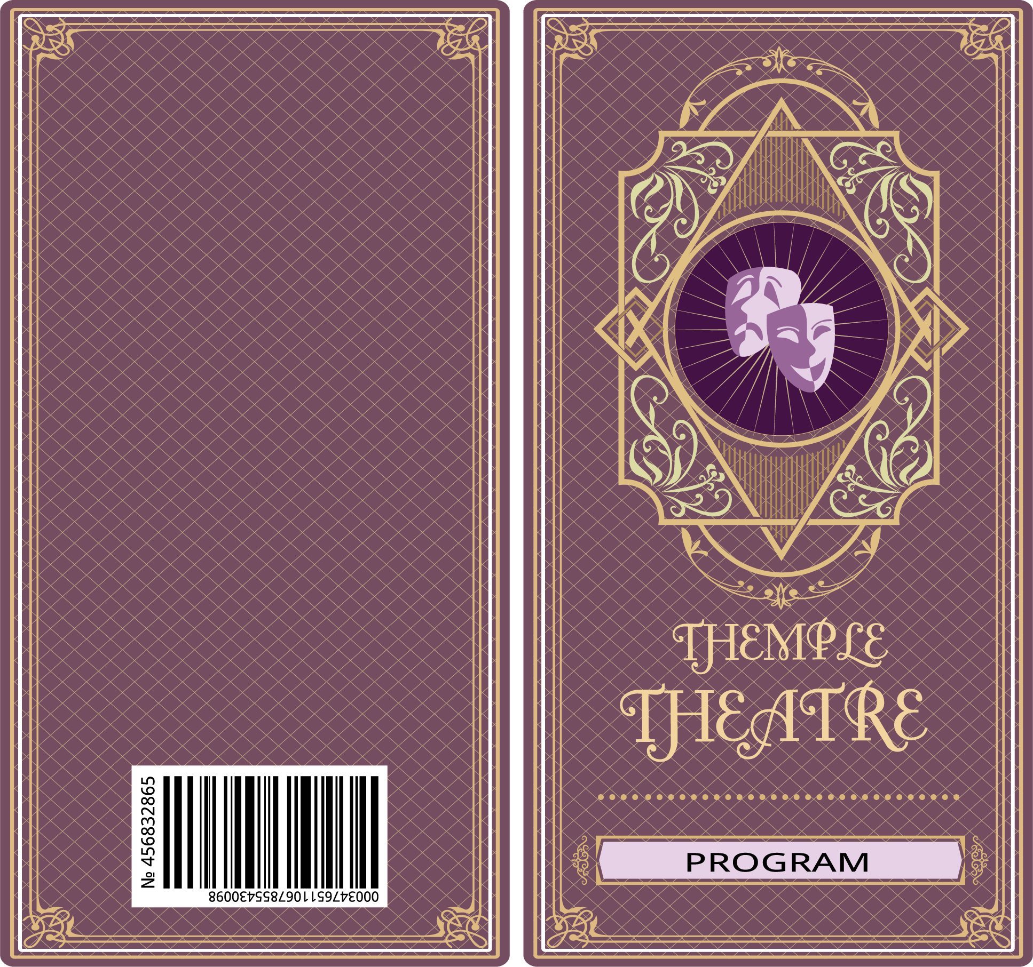
Suggest a suitable method for each of the following and justify your response.
- A suitable printing method for the cover
- A finish to make the cover more durable while still maintaining a professional look
- Two finishes to enhance the aesthetics of the cover
Printing method:

Durable finish:

Finish to enhance aesthetics:

The musical is a hit and is now transferring to the West End. The show will run for 12 weeks and performances will be every evening from Monday-Saturday with an afternoon performance on a Wednesday and Sunday. The theatre requires 625 programs per show.
Calculate the number of programs required and suggest a justify a suitable printing method for a production run of this size.

