Name: Class: Mark:

1. Which one of the following print finishes is hardest to recycle? [1]
⬨ Encapsulation
⬨ Foil blocking
⬨ Varnishing
⬨ Lamination

2. Which one of the following best describes the method used to commercially print
onto plastic bags and drinks cans? [1]
⬨ Ink jet printing
⬨ Offset lithography
⬨ Screen printing
⬨ Flexography

3. State three benefits of using lamination on papers and boards. [3]

4. Explain why embossing and debossing might be described as a waste-free
finishing process. [2]

5. The diagram below shows part of an offset lithography machine.
(a) Add three labels to show the printing plate, the blanket cylinder and the
impression cylinder. [3]

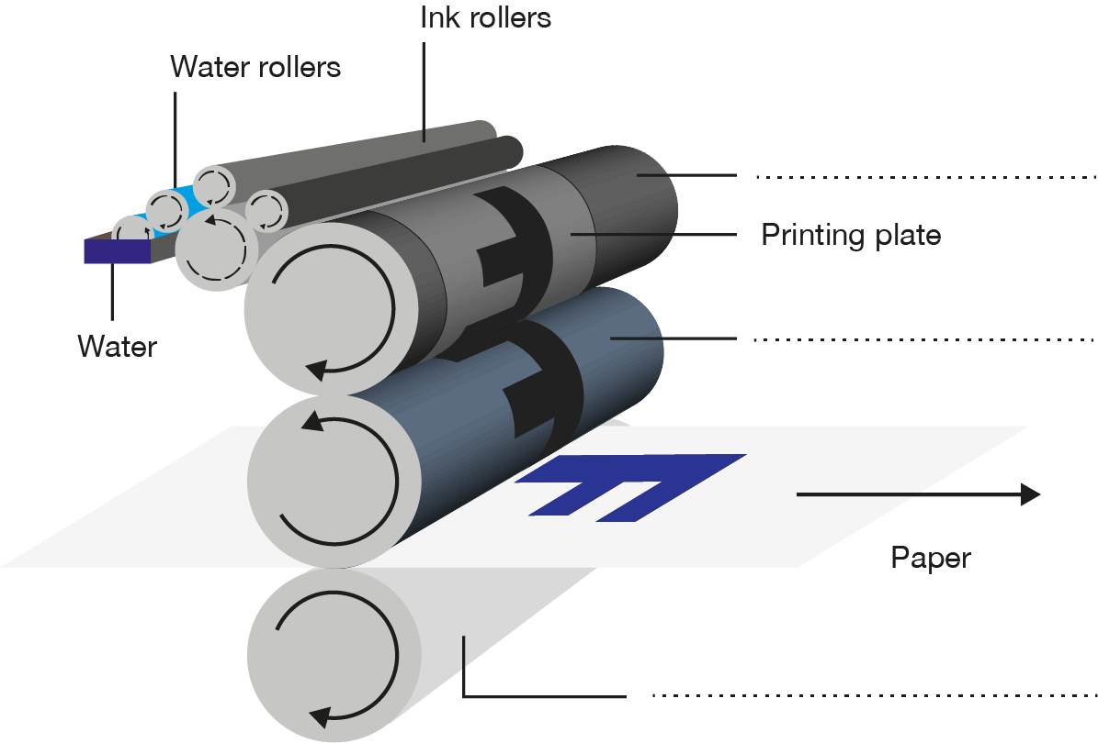
(b) A high-end catalogue is due to be printed and finished using offset lithography. Explain two ways in which costs of the print run could be reduced. [4]

6. Compare digital printing and screen printing as potential methods for printing
the greetings card below. [6]



[Total 20 marks]

