Name: Class:

Task 1
Complete the table below by identifying the mechanical properties of the material used in each product.
For each product say why its properties are relevant for its intended purpose.
Product | Mechanical property | Reason
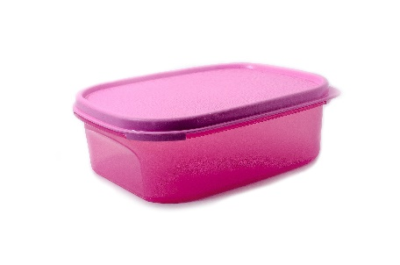
Lunch box
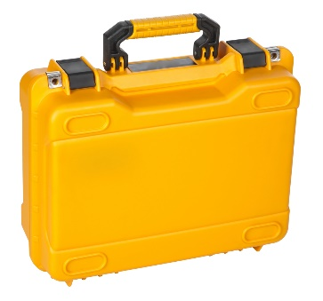
Tool carry case
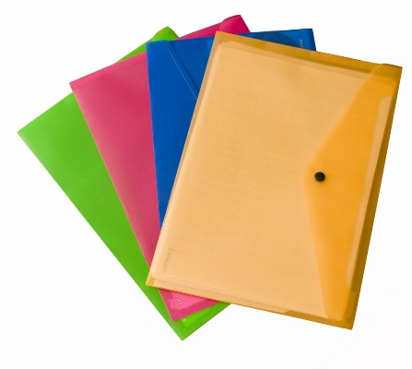
Document folders
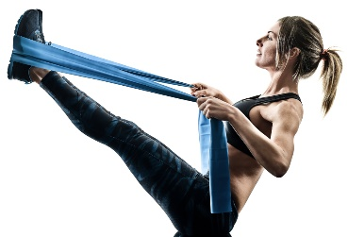
Fitness band

Task 2
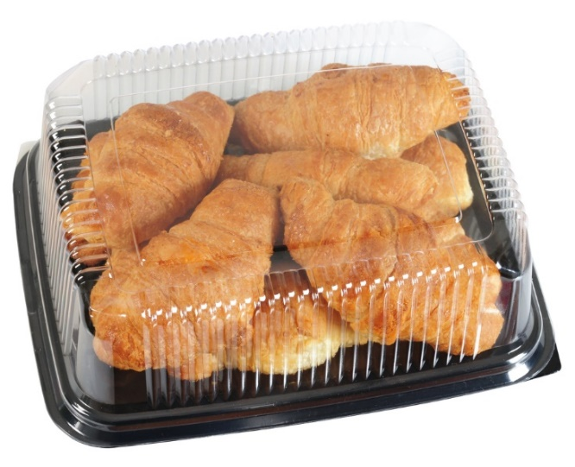
Study the image above and discuss the use of polymers in terms of their suitability for
food packaging.

Plenary Task
Complete the table below by identifying which type of additive(s) would be included in the products shown or by giving the function of the additive
Product | Type of additive | Function of additive
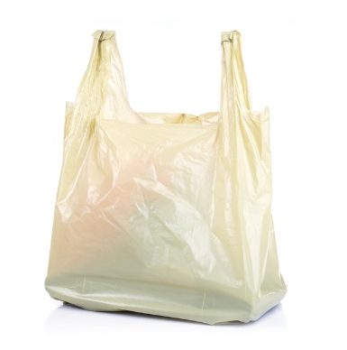
Carrier bag
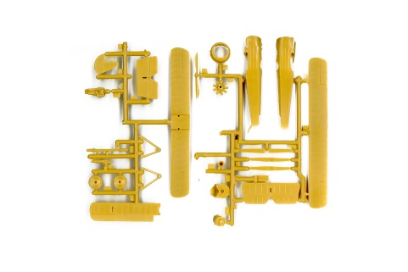
Model airplane kit
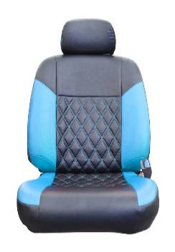
PVC car seat
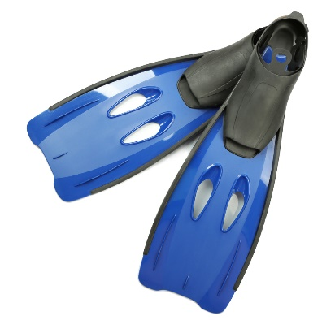
Swimming fins / flippers

