Name: Class:

Plenary task
Study the product images in the table below.
Suggest an appropriate thermoplastic for each product and explain why that material is an appropriate choice.
Product | Thermoplastic | Reason
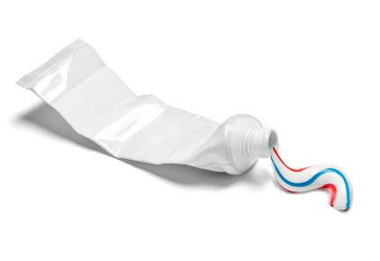
Toothpaste tube
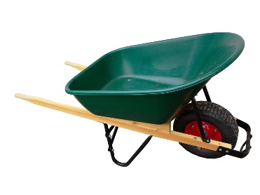
Wheelbarrow hopper

Ring binders
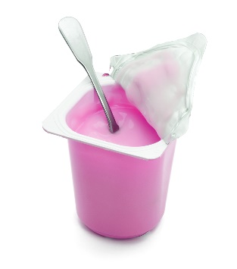
Yoghurt pot

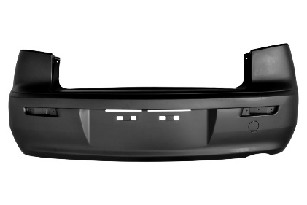
Car bumper
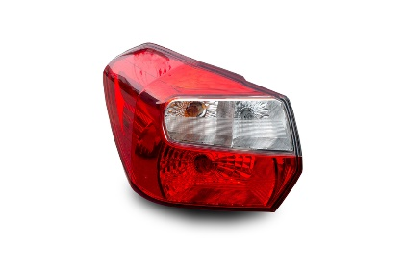
Rear car lamp cover
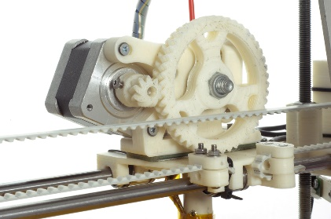
Machine gears
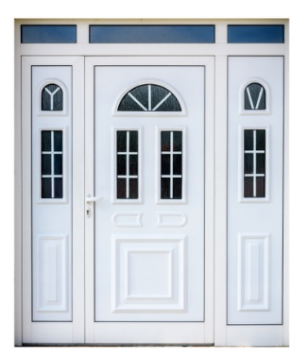
Front door
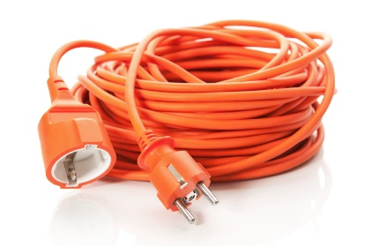
Electrical cable casing

