Name: Class: Mark:

1. Give one source of natural polymers. [1]

2. This question is about thermoplastics.
(a) What is polymerisation? [3]

(b) Explain using notes and sketches how the polymer chains in thermoplastics are connected and how this affect the way they behave. [3]

3. Name one polymer that is commonly used in the manufacture of ropes for use in the marine industry and explain what properties make them suitable for this application. [2]

4. This question is about thermosetting plastics.
(a) Name the type of polymerisation used to create thermosets. [1]

(b) Explain how cross-linking occurs. [1]

(c) What type of reaction is caused? [1]

(d) Use a sketch to illustrate how the polymer chains in a thermoset lie after
cross-linking. [1]

5. Study the image below.
(a) With reference to both the physical and mechanical properties, evaluate the use of
urea formaldehyde (UF) in this plug socket. [2]


(b) Explain one way in which UF is used as an adhesive in the timber industry. [2]

6. Suggest and justify an appropriate polymer for use in the manufacture of the contact
lens case pictured. [3]

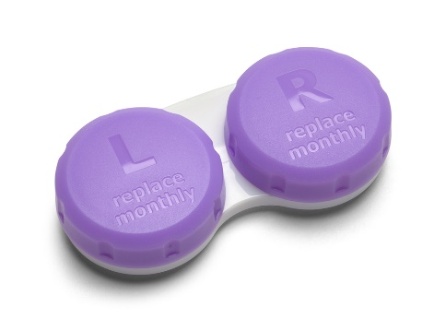

[Total 20 marks]

