Name: Class:

Task 1
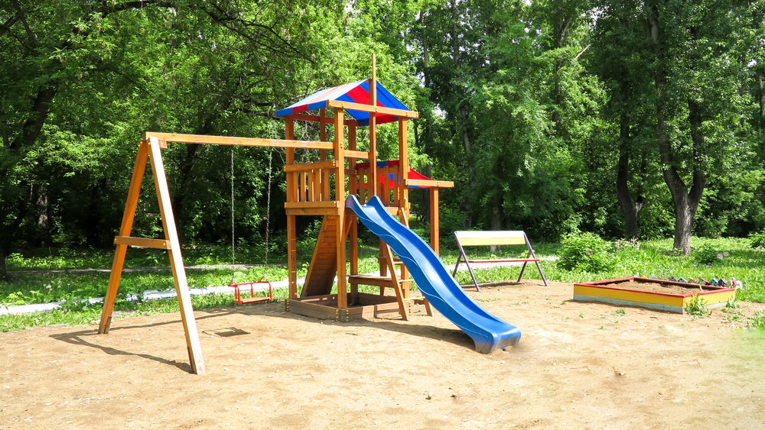
A company designing play areas for primary schools is looking for an alternative surface to the sand currently in place. They have considered tarmac but decided this was too unforgiving a surface when children fall. They have looked at woodchip, however it was found that this was too messy, and the woodchips could be walked into the school buildings on children’s shoes.
Suggest an alternative surface for the playground, explaining what advantages it has to offer.

Task 2
The box below is used to store and transport wine glasses.
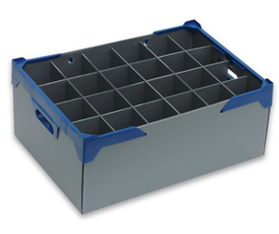
Discuss the advantages and disadvantages of using fluted polypropylene sheet to make this wine storage box.
Advantages:

Disadvantages:

