Name: Class: Mark:

1. Complete the table below by stating what stock form of material was used for each of
the given products. The first one has been done for you. [3]

Product | Stock form
Clear acrylic menu frame | Sheet
Graphic lettering on the side of a coach
Internal protective packaging for a laptop
Injection moulded pencil sharpener

2. The photo below shows some rainwater guttering manufactured from a polymer.
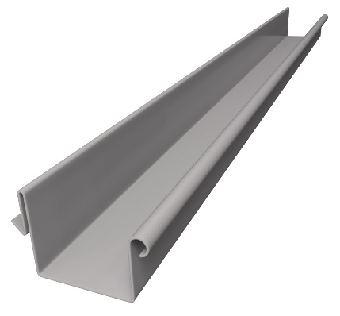

(a) Name the process that has been used to manufacture the polymer rain water
guttering shown above. [1]

(b) Give two reasons for your choice of answer to part (a) above. [2]

3. Draw and label the cross section of a sheet of foam board. [2]

4. This question is about foam board.
(a) Explain two reasons why foam board is an appropriate material to make concept models of some modular storage furniture. [4]

(b) Explain one reason why solvent based adhesives are not the best choice for joining
foam board. [2]

5. Explain one reason why it is important for polypropylene film to be able to withstand
heat when being used in the food packaging industry. [2]

6. Describe using notes and sketches, the process of using a hot wire cutter to cut
Styrofoam making sure you include any relevant health and safety issues. [4]

7. Study the image below.



With reference to both the physical and mechanical properties, evaluate the use of Plastazote® foam as a swimming buoyancy aid for young children when learning
to swim. [6]

[Total 26 marks]

