Answers
Task 1
1. Carbon fibre is a very strong composite material made from thermoset polymer and carbon fibres. It is used to make bike frames, car chassis and running blades.
A bike frame design has a mass of 1.75 kg. If the ratio of polymer to carbon fibre is
3 : 4, calculate the mass of polymer and carbon fibre are needed to manufacture 100
bike frames.
Polymer: | Carbon fibre:
3 + 4 = 7  $\frac{1.75}{7}=0.25$ kg  0.25 × 3 = 0.75 kg | 1.75 – 0.75 = 1 kg  Or 3 + 4 = 7  $\frac{1.75}{7}=0.25$ kg  0.25 × 4 = 1 kg

2. Epoxy resin is a thermoset adhesive which is made by adding a resin to a hardener. Study the design of the epoxy resin dispenser below and estimate the ratio of resin to hardener being dispensed.
1 : 1
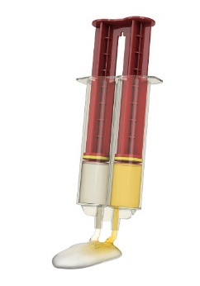
3. A particular type of stainless steel contains iron, nickel and chromium in the ratio of
47 : 35 : 18 by mass.
How much iron, nickel and chromium are present in 20.0 kg of stainless steel?
47 + 35 + 18 = 100 parts
Iron: $\frac{47}{100}$ × 20 = 9.4 kg, nickel $\frac{35}{100}$ × 20 = 7 kg, chromium, $\frac{18}{100}$ × 20 = 3.6 kg

Task 2
1. Calculate the following:
(a) A student makes a wooden chair in which $\frac{1}{4}$ of the total cost is teak and $\frac{1}{3}$ of the cost is pine. The remaining costs were made up of components and finishes.
If the total cost of the chair was £52.50, work out the cost of the teak and the cost of the pine to the nearest penny.
Cost of teak = $\frac{1}{4}$ x £52.50 = £13.13
Cost of pine = $\frac{1}{3}$ x £52.50 = £17.50
(b) The average car engine weighs 158 kg.
The ratio of the mass of the engine to the mass of the car is 1 : 11.
What is the mass of the car?
158 x 11 = 1738 kg
2. In a school, there are 40 students studying GCSE Design and Technology this year.
The number of students studying GCSE Design and Technology this year is an increase of $\frac{1}{4}$ on the numbers studying the course the previous year.
How many students studied the course the previous year?
Let N = the number of students last year.
Number of students this year = number of students last year + $\frac{1}{4}$ of the students last year.
40 = N + $\frac{1}{4}$ N
40 = $\frac{5}{4}$ N
40 x $\frac{4}{5}$ = 32 students

