Name: Class:

Starter



In pairs or small groups, study the images below and discuss any components that are not made from a single material, such as metal, plastic, wood or fabric.
 |  |   
 | 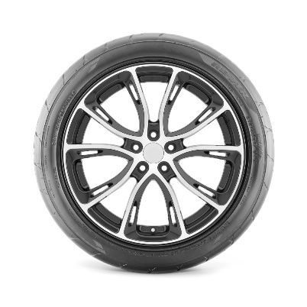
 |  | 

Task 1
Duct tape is a heavy-duty tape which consists of three materials:
- Cotton mesh (scrim)
- Outer polyethylene coating
- Rubber-based, pressure sensitive adhesive
Take a closer look at a piece of Duct tape.
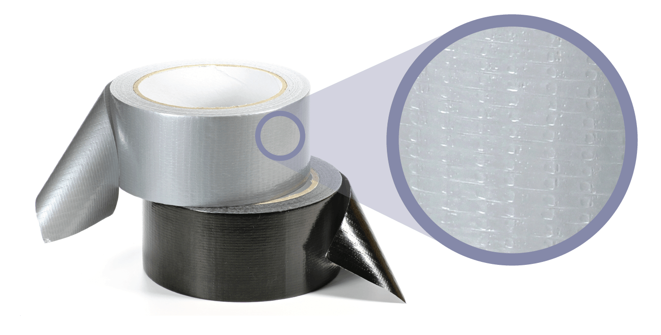
What properties does it possess?
Physical properties | Mechanical properties | Working properties
Task 2
Read the following facts comparing CFRP and GRP and answer the questions below.
- CFRP is lighter than GRP, it has a superior strength to weigh ratio
- GRP is more cost effective than CFRP although both require labour intensive ‘lay-up’ by hand
- CFRP is significantly more stable in extreme temperatures
- Long strands of carbon fibers are very difficult and expensive to manufacture but the manufacture of glass fibres is much easier
- Both materials are very strong, but CFRP is more rigid – GPR has more flex
- CFRP has higher tensile strength than GRP
Which material, out of GRP and CFRP, would be best suited to the following products
and why?
Product | Material choice and justification
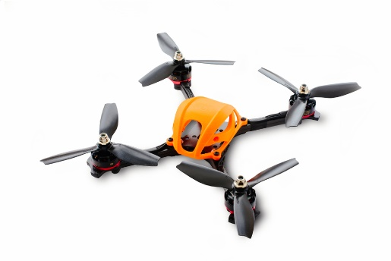  Body of a drone | Material:  Justification:
  Hull of a boat | Material:  Justification:
  Helicopter blades | Material:  Justification:
  Rocket parts | Material:  Justification:

Task 3
Study the image below which shows a shopfront made from aluminium composite board and fibre cement.

Aluminium composite board
Fibre cement
Discuss the advantages of using each of these materials for shops and warehouses.

