Name: Class:

Task 1
The names of smart materials often indicate a given property that changes and/or the stimuli that they are affected by. Study the example below.
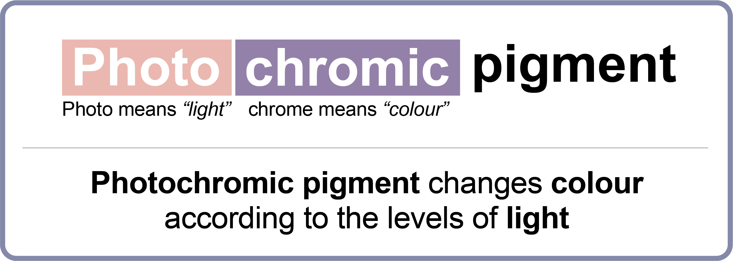
Use the example above to guess the property and stimuli associated with each of the smart materials below and have a go at writing your own definition for each.
- Shape memory alloys

- Thermochromic pigment

- Phosphorescent pigment

- Electroluminescent wire

- Piezo electric material

Task 2
Explain how you think SMAs are used in the following products use shape memory alloys to improve performance and add functionality. You may wish to use annotated sketches to convey your idea.
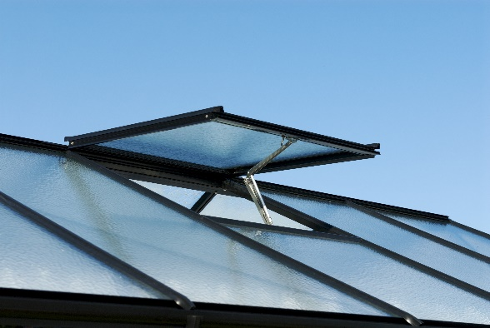  Self-opening windows |   Anti-scald taps

Task 3
Hyrdochromic pigment is a smart material which responds to moisture. When it’s dry, it is white and opaque, when it’s wet it becomes transparent to reveal whatever is beneath. Common applications for hydrochromic pigment include colour changing swimwear, umbrellas and tents.
How could smart materials be combined with every day products to add functionality, improve performance or change aesthetics? Use the smart materials and product combinations below to inspire a new product. Use sketches and annotations to describe
your ideas overleaf.

