Name: Class:

Task 1
Downhill mountain biking is a dangerous sport. Riders wear protective clothing and accessories to reduce the risk of injury while remaining as agile as possible. The bike itself must be extremely durable and reliable. How might Kevlar be used to protect the rider and improve the performance of the bike?


Task 2
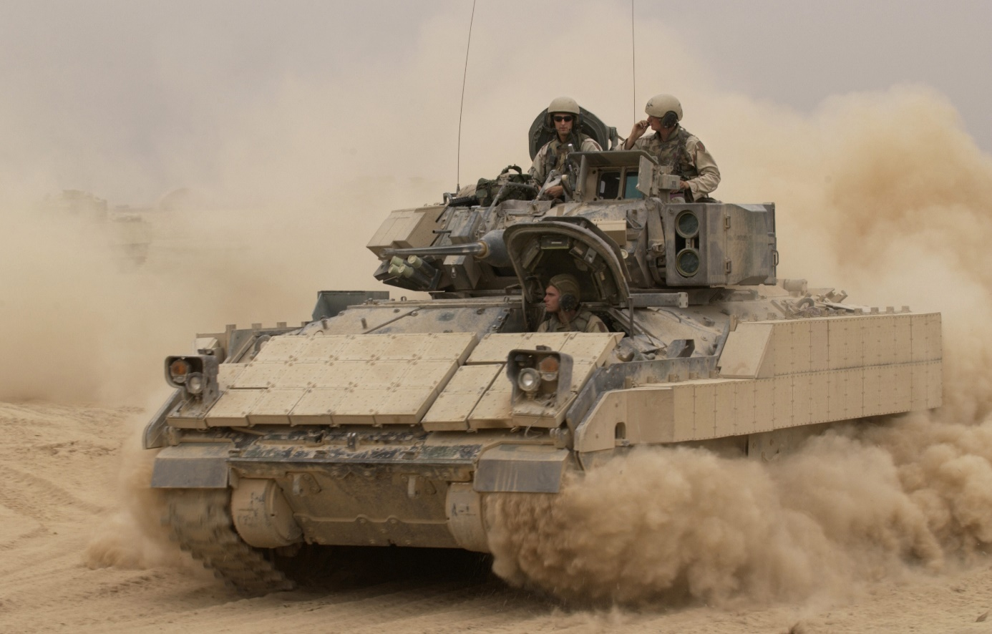
The Bradley Fighting Vehicle incorporates Kevlar into the armour on the vehicle. What makes Kevlar suitable for use in this kind of vehicle?

Task 3

Silver is a popular choice for use in Precious Metal Clay. List some of the advantages that PMC offers to both the professional and hobbyist jewellery designers.

What are the disadvantages of using PCM compared to traditional materials?

Polymorph and high-density modelling foam (HDMF) could be used to create prototypes for jewellery and personal accessories. List the advantages of using each of these materials for this purpose.
Advantages of polymorph | Advantages of HDMF

