Name: Class: Mark:

1. Define the term modern material. [2]

2. What does PMC stand for? [1]

3. Other than mouth guards, name one suitable application for polymorph. [1]

4. Describe one advantage of using Kevlar in boat hulls. [2]

5. This question is about high-density modelling foam (HDMF).
(a) HDMF can be used to make vacuum forming moulds. Explain one
disadvantages of using HDMF for this purpose. [2]

(b) Evaluate the use of HDMF as a material to make high-quality prototypes. [6]

6. Kevlar is widely used as protective body armour. Police dogs can also be protected
with bullet proof vests. State three properties of Kevlar and explain what makes
them suitable for these applications. [6]
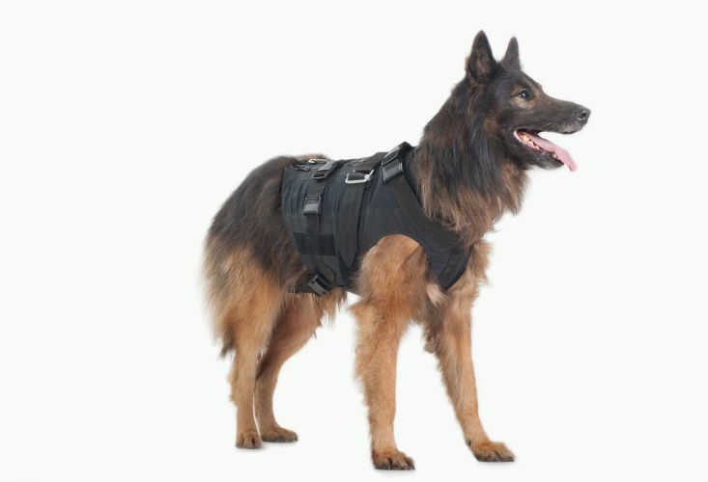
Property:
Explanation:

Property:
Explanation:

Property:
Explanation:

[Total 20 marks]

