Name: Class:

Task 1
Photo-degradable polymers can be used to create plastic six-pack rings for drinks cans like the one pictured. What are the benefits of these?
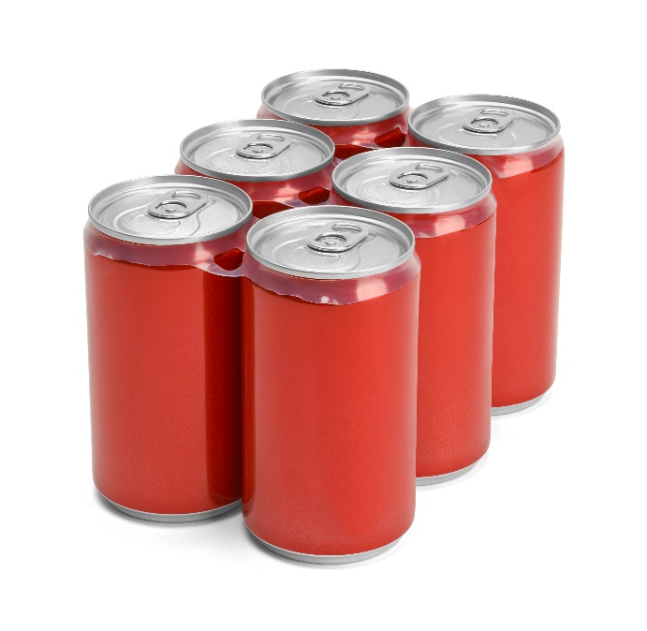

Task 2
Polylactide (PLA) sheet and film is used extensively as biodegradable single use food packaging however, PLA granules are also used in the manufacture of reusable plastic items.
Discuss its suitability for use in reusable plastic mugs like those shown below.
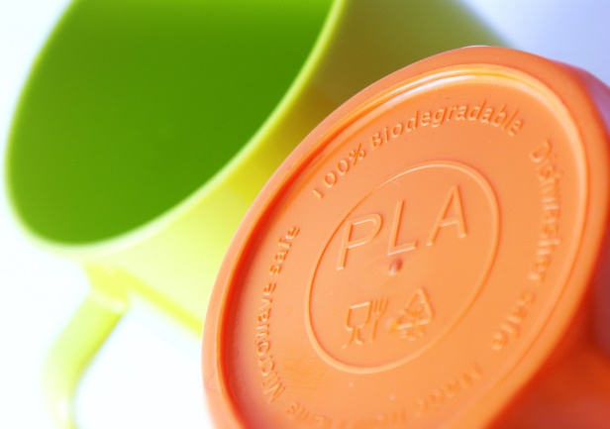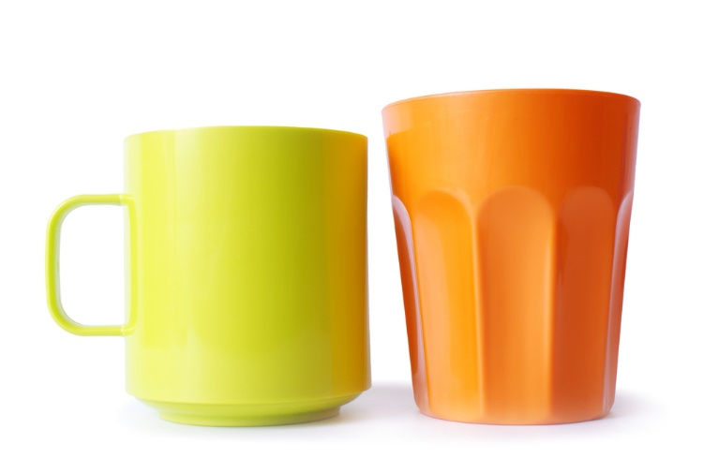

Task 3
Most local councils now collect food waste from households which have collected and stored it in special food waste bags like the one pictured below.
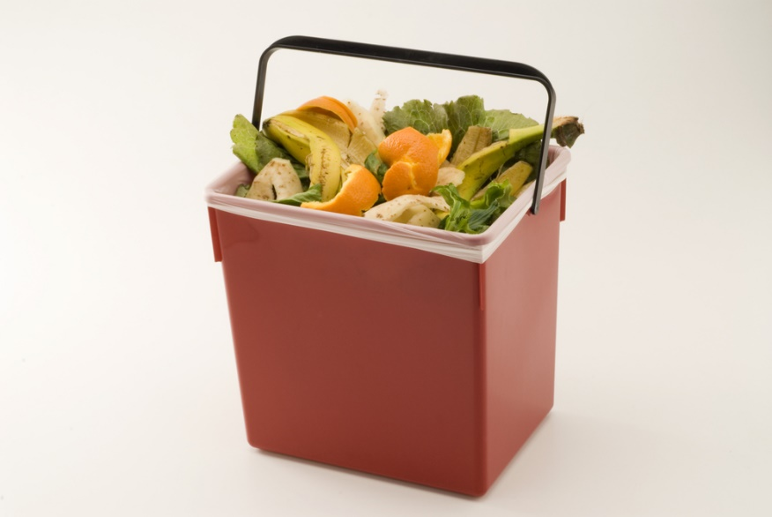

Discuss the advantages and disadvantages of using bags for lining food waste bins.

