Name: Class:

Task 1
Study the image of the battery powered handheld torch below.
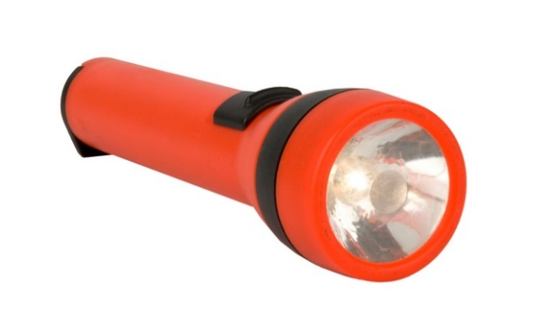
Suggest one way in which the design could be modified to improve the ergonomics of
this product.

Sketch your modification below.

Task 2
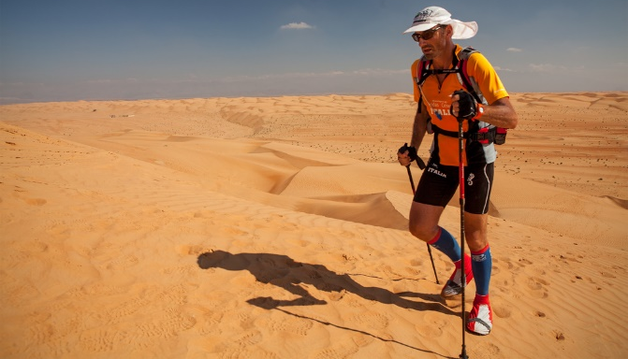
A company specialising in running shoes for desert marathon runners is looking to improve the longevity of the soles on their shoes.
Suggest a specific material that could be used to create a new sole and explain the advantages this would offer the runner.

Task 3
Complete the table below by identifying an elastomer that would be best for the given product. Explain why it would be a good selection and identify the properties it has that means it would be fit for purpose.
Product | Elastomer | Fit for purpose
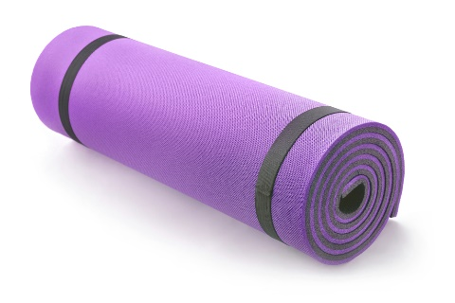
Exercise mat
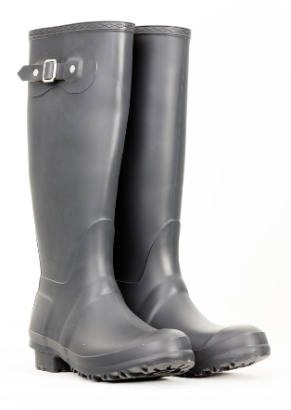
Wellington boots
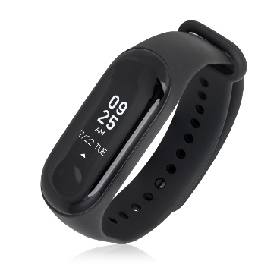
Activity tracker watch

Task 4
Study the racing bike saddle pictured below and suggest how two elastomers could be used together in the design of a saddle cover to increase comfort.
