Name: Class: Mark:

1. Which one of the following describes the process of curing and hardening rubber? [1]
⬨ Vulcanisation
⬨ Polymerisation
⬨ Over moulding
⬨ Cross linking
2. Are all elastomers thermosetting? Explain your answer. [3]

3. This question is about ergonomics.
(a) Suggest one process that could be used during manufacture to improve the comfort and friction of the grip of toothbrush. [1]

(b) Study the orthopaedic wrist support below.
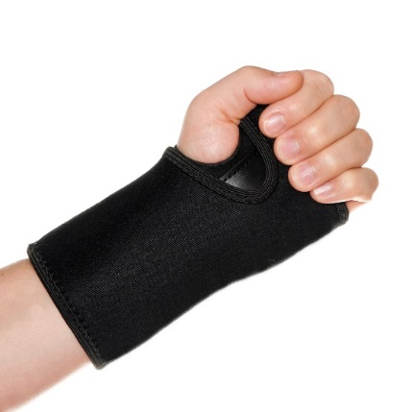
(i) Name a suitable material for the wrist support. [1]

(ii) Give two reasons for your choice. [2]
Reason 1:

Reason 2:

4. Study the image below.
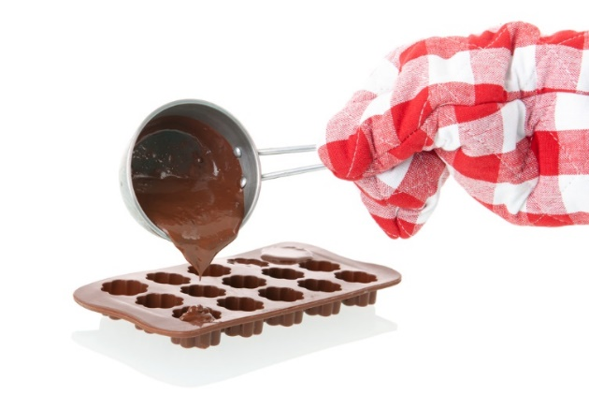
Evaluate the use of silicone in mould making for confectionery. [6]

5. Explain one possible safety issue with wearable rubber or latex products like
surgical gloves. [2]

[Total 16 marks]

