Name: Class:

Task 1
Study each of the products listed below. Select the most suitable scale of production and justify your answers.
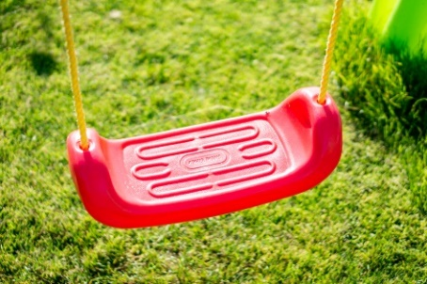 | Circle the most suitable scale of production:  Mass production / continuous
 | Explanation:
Blow moulded HDPE plastic swing seat | Explanation:
 | Circle the most suitable scale of production:  Mass production / continuous
 | Explanation:
Injection moulded PP bottle tops | Explanation:
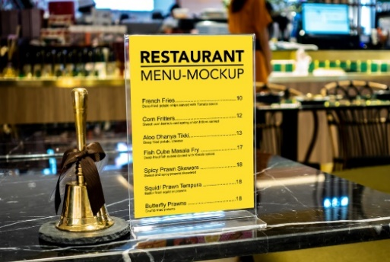 | Circle the most suitable scale of production:  Mass production / Batch production
 | Explanation:
Line bent acrylic menu holder | Explanation:
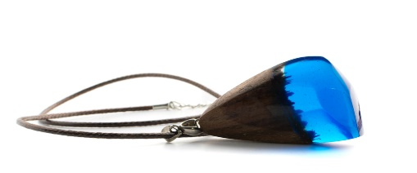 | Circle the most suitable scale of production:  One off production / Batch production
 | Explanation:
Cast resin and wood pendant necklace | Explanation:

Task 2
The sports hall flooring below is made from PVC sheeting.

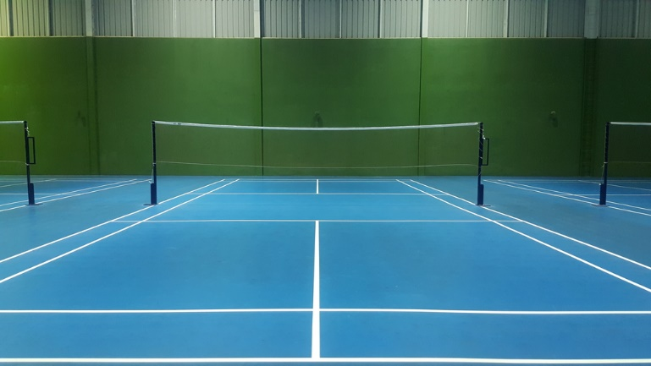
In pairs, discuss and write down responses to the following:

- Explain what production method has been used to create the PVC sheet used to make sports hall flooring and describe how the process works.
- Why is this method of production appropriate for the production of PVC sports hall flooring?
- Some sports hall floors are textured/embossed. How is this finished achieved within the manufacturing process you have suggested?
- Suggest four further applications for PVC sheeting.

