Name: Class: Mark:

1. Which one of the following best describes the machine part used to move polymer
granules through an extruder whilst they are heated and softened? [1]
⬨ Barrel
⬨ Cut-off machine
⬨ Hopper
⬨ Archimedes screw
2. Suggest one stock form that is produced by extrusion. [1]

3. Study the picture below.
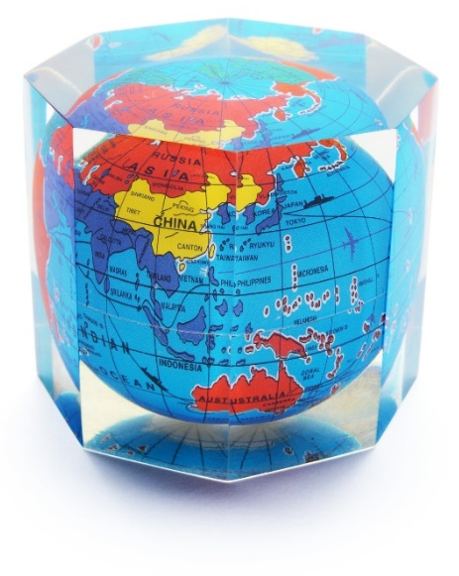
(a) Identify the material used to create the paperweight pictured above. [1]

(b) The paperweight has been produced in batches of 20 pieces. Explain why this
scale of production is suitable. [2]

4. The following question is about producing polymer stock forms.
(a) Explain why extrusion is suitable for mass or continuous production. [2]

(b) Extrusion is used to create many polymer profiles.
(i) Give three reasons why extrusion is used to uPVC window frames. [3]

(ii) Give one mechanical method of producing polymer sheet and explain three stages of the process. [4]

5. Evaluate the advantages and disadvantages of using jigs, patterns and moulds to
batch produce polymer products. Comment on both machine-made and hand-made production aids in your answer. [6]

[Total 20 marks]

