Name: Class:

Task 1
Study the picture of the black HIPS seed pot below.
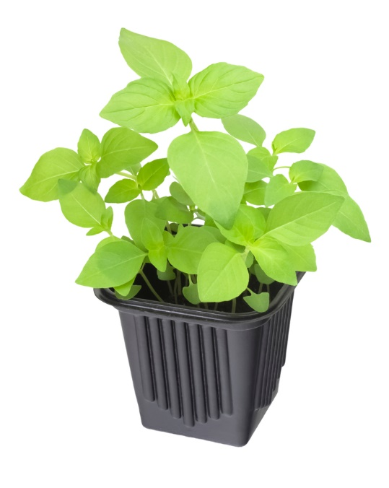
(a) Give three reasons why vacuum forming is suitable process to manufacture the
seed pot pictured above.

(b) List at least four things that must be considered when creating a suitable mould.

Task 2
(a) Fill in the table below.
(i) Define the polymer forming process
(ii) State the scale(s) of production they are best suited to
(iii) Give an example of a product commonly made using this process
Process | Definition | Scale of production | Product example
Blow moulding
Compression moulding
Vacuum forming
Rotational moulding

(b) Give one reason why blow moulding is best suited to continuous or mass production.

