Name: Class: Mark:

1. Which one of the following is a method of creating hollow forms? [1]
⬨ Thermoforming
⬨ Rotational moulding
⬨ Injection moulding
⬨ Compression moulding
2. Study the pictures below.
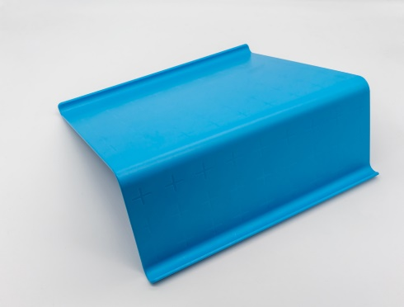
(a) Identify the forming process used to create the acrylic iPad stand above. [1]

(b) Explain why this is a suitable process to use. [2]

3. Give two suitable forming process that would have been used in manufacture of the
plastic jerry cans pictured below. [2]
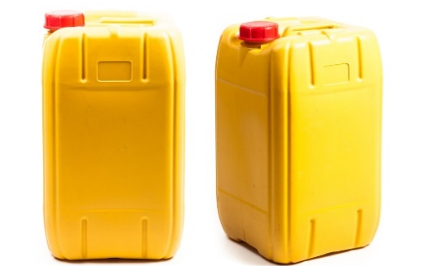

4. Complete the grid below and state how the products below could have been
moulded. [3]
Liquid storage tank | Toy construction bricks | 3-pin plug
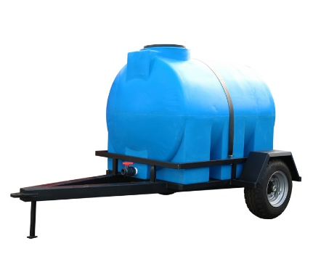 | 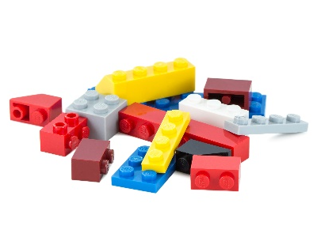 | 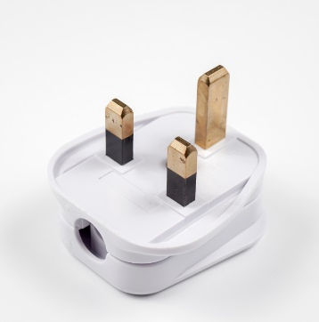

5. List five stages of the rotational moulding process. [5]
Stage 1:
Stage 2:
Stage 3:
Stage 4:
Stage 5:

6. Layup or laminating is a technique used to form thermosetting polymers to create rigid forms. Evaluate the advantages and disadvantages of this forming processes. [6]

[Total 20 marks]

