Name: Class:

Task 1
Study the strip thermometer pictured below.
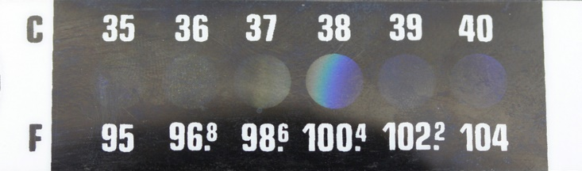
Thermometers like this are used by placing them on the forehead. Explain what type of pigment has been used in this product and why it is suited to the task.

In what other polymer products could thermochromic pigments be utilised?

Task 2

Describe the most appropriate finish for each of the following products. You may wish to refer to the application, characteristics and aesthetics of the finish.

Product A | Product B | Product C
 |  | 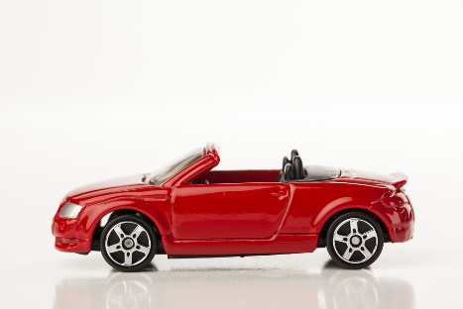
GRP canoe | The handle of a pair of scissors | Small plastic toy car

