Name: Class:

Starter
- Working in pairs, use this activity to revise your existing knowledge of woods.
- Woods are categorised into three different types. Complete the table below to give a definition for each type and some examples of woods for each category.
Category | Definition | Example of woods
Hardwood
Softwood
Manufactured board

- Consider the standard stock forms that woods are commercially sold in.
An example has been given for you.

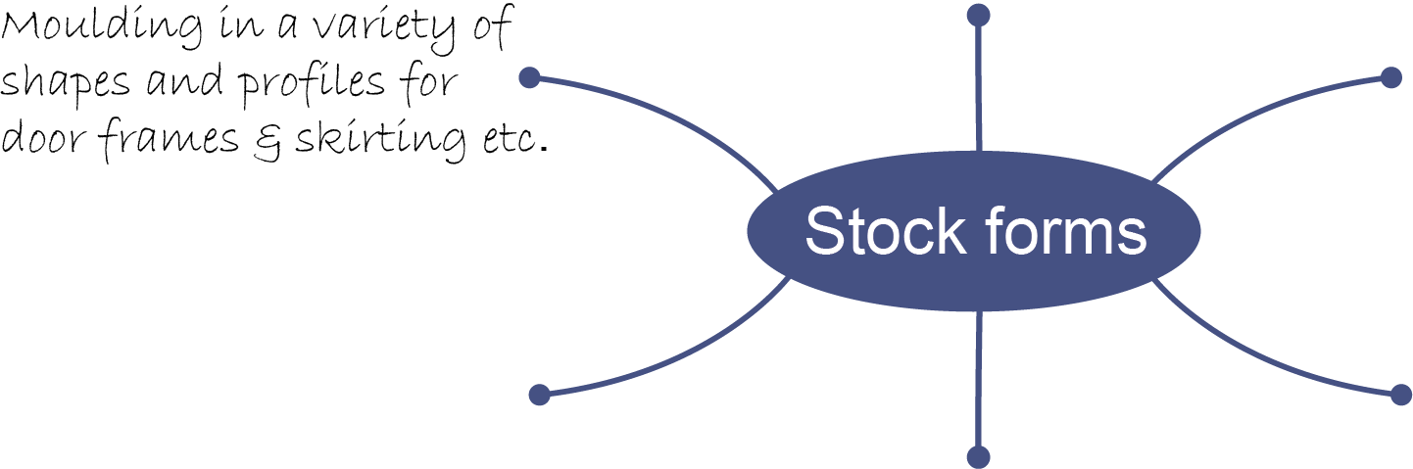

Task 1
- Give one reason why selling materials in stock forms is beneficial for the manufacturer.

Give one reason why buying materials in stock forms is beneficial for the customer.

- Study the image below and label the different types of mouldings you can see.
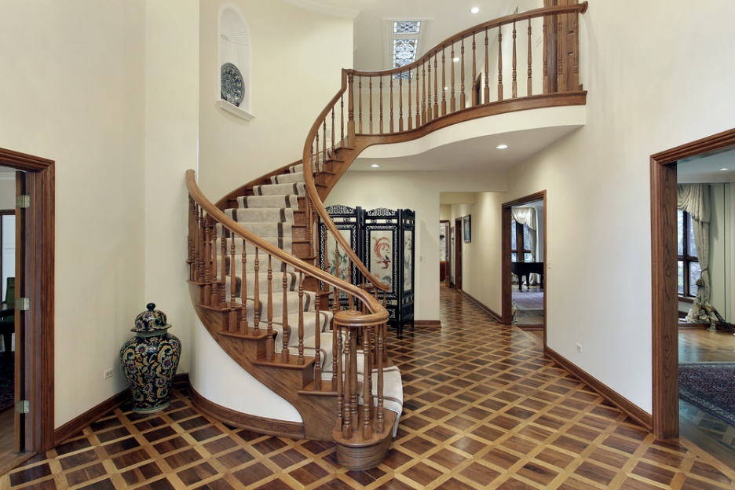

Task 2
- The image below shows a sample of oak which is highly prized for its aesthetically pleasing grain and durability.
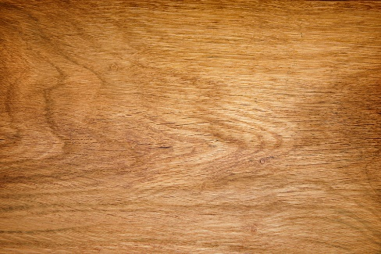
Explain some limitations of using this material.

- Match the products to the woods and properties below.
Larch |  | 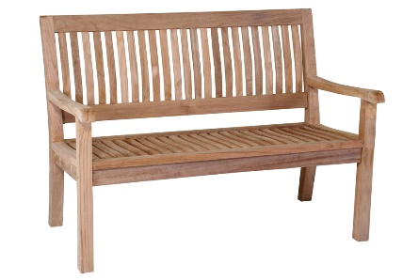 |  | A hard, tough wood that can withstand rough use. Unlikely to split.
Teak |  | 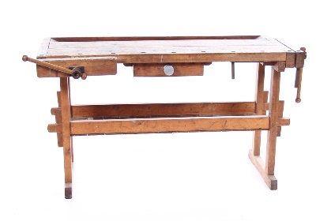 |  | High resin content which can clog up tools. No preservatives required for outdoor applications.
Beech |  | 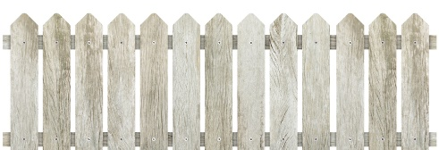 |  | A very strong, hard wood resistant to acids and alkalis

Task 3
- How do the images below relate to manufactured boards? Give some examples of manufactured boards to help explain your answer.
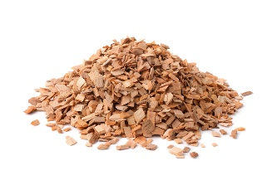
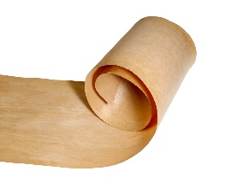
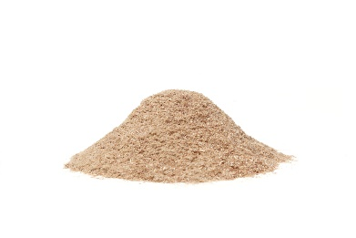

- Can manufactured boards be considered eco-friendly?

Task 4
Select a number of products from the illustration below and suggest which wood would be suitable for a given application. Explain your answers and refer to at least five different woods from the following:
Hardwood | Softwood | Manufactured board
Oak  Ash  Mahogany  Teak  Beech  Birch | Pine  Spruce  Douglas fir  Redwood  Cedar  Larch | Plywood  Marine plywood  Aeroply  Flexible plywood  Chipboard  MDF
