Name: Class:

Task 1
1. The following terms refer to different performance characteristics of wood.
Grain pattern  Grain direction  Surface defects  Warpage  Shrinkage | Splitting  Joining  Forming  Steam bending  Laminating | Machining qualities  Resistance to decay  Moisture resistance  Toxicity
Select some of the terms above and attempt a definition to share with the rest of the class. Use the box below to make notes.
Task 2
1. Natural wood is anisotropic. Consider how this characteristic affects the design and manufacture of the product below.
(a) Add arrows to show the direction of the grain for each part of the bench.

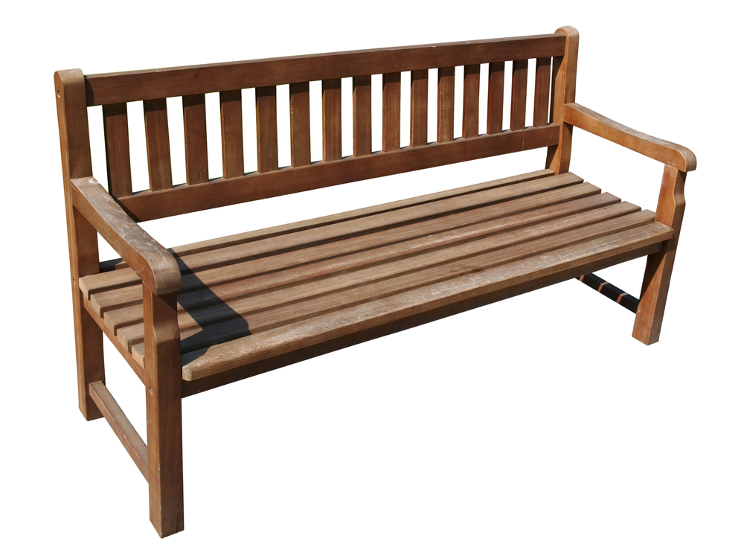

(b) Explain your answers from 1(a) below.

(c) When preparing the parts of the bench above, the manufacturer finds several knots in one of the sections of timber. What problems could this cause?

Task 3
The image below shows a damaged natural wood floor.
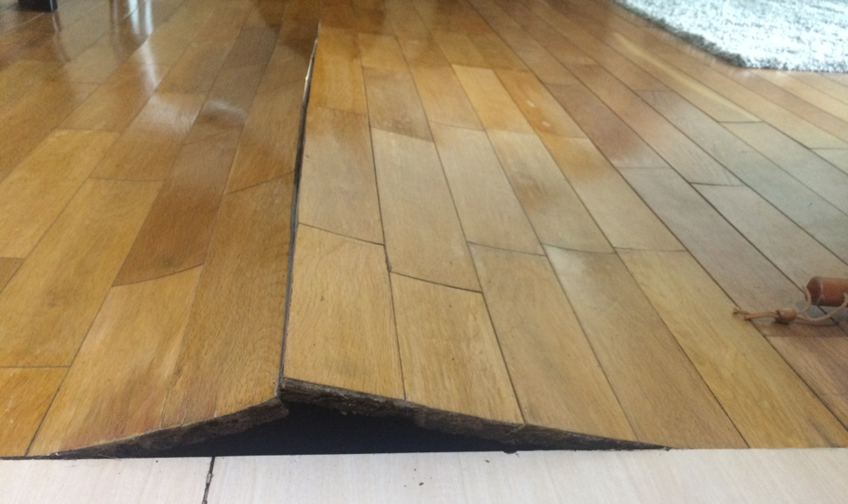

1. Suggest two factors that could have caused this damage and explain your answers.

Task 4
Study the exploded view of the surfboard below. Use notes and arrows to label the surfboard parts to:
- Show and explain where lamination has been used
- Show and explain where manufactured board has been used
- Show where CNC machine has been used to create the parts
- Show the direction of the grain along the top skin of the surfboard

