Name: Class:

Task 1
Work in pairs to give definitions for the following material properties:
Tensile strength
Toughness
Hardness
Corrosion
Malleability
Task 2
Study the diagram below which shows how to conduct a workshop test for toughness.
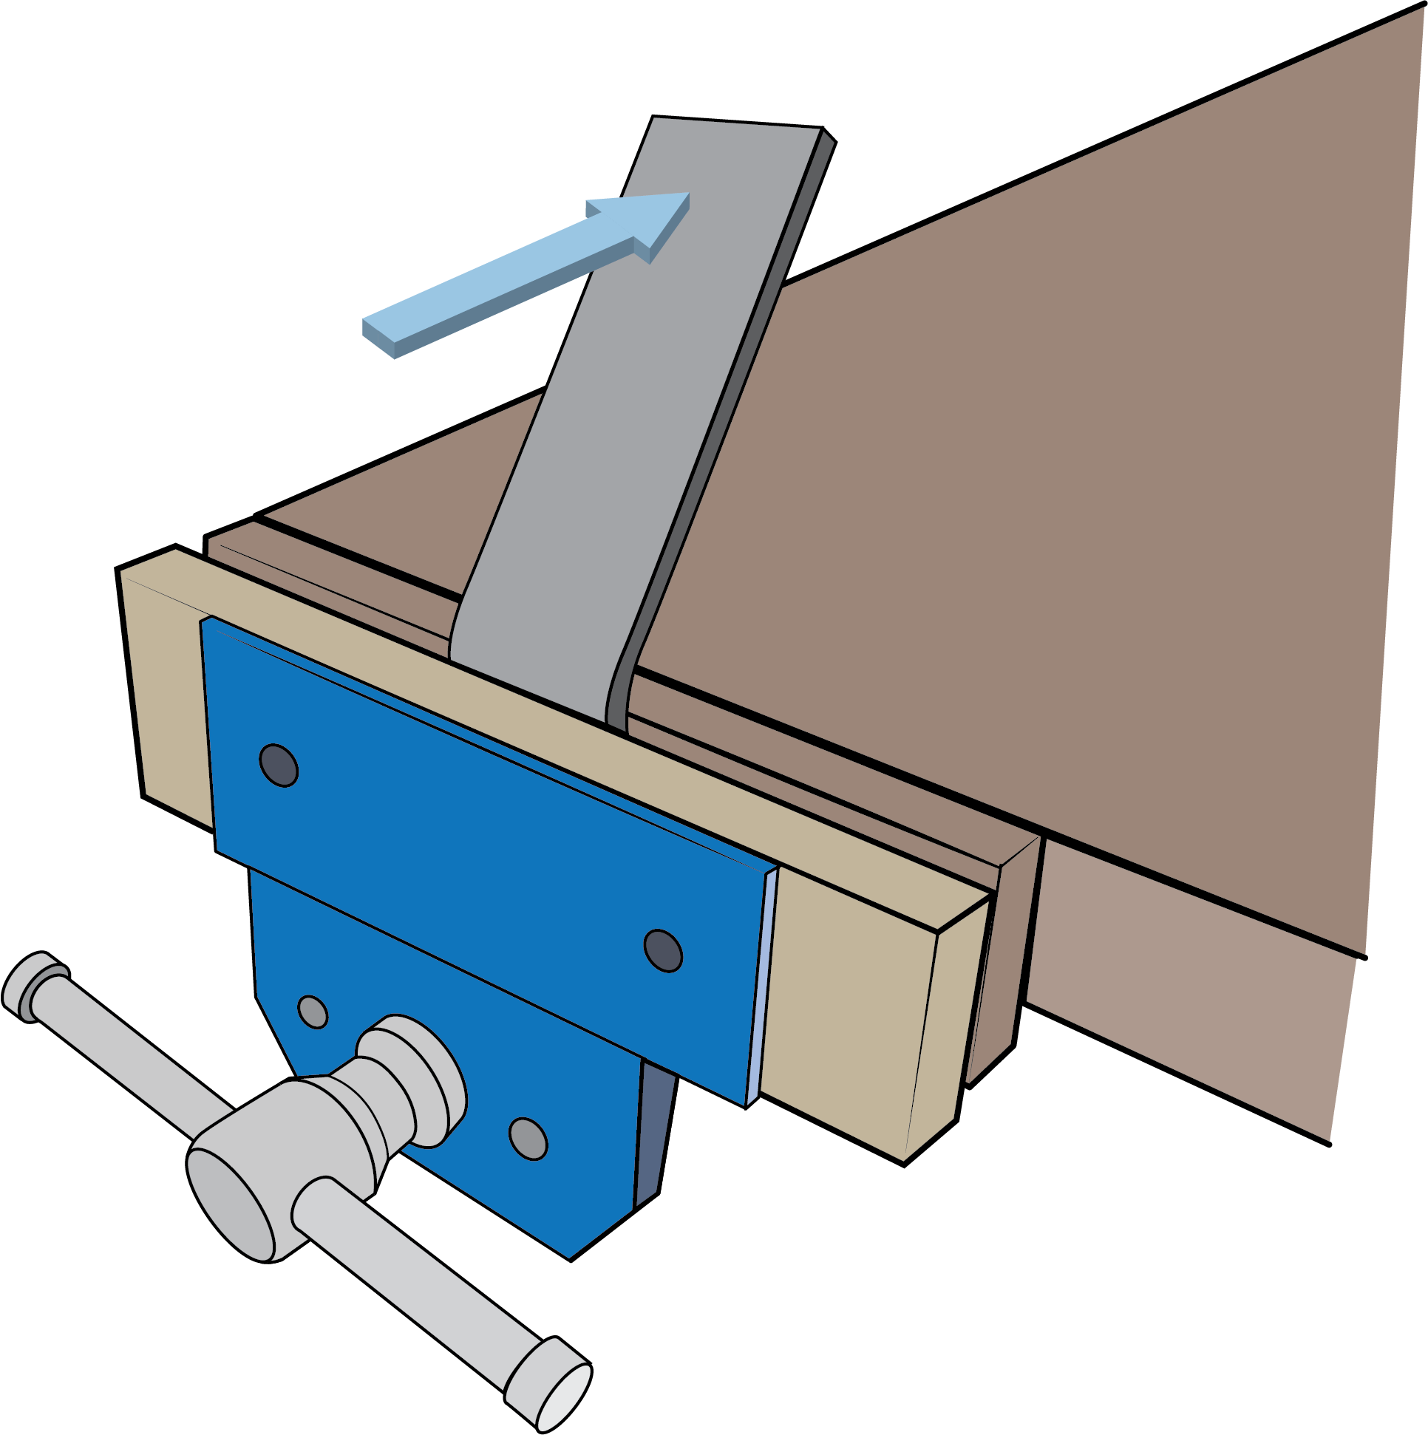  Direction of hammer strike |  | 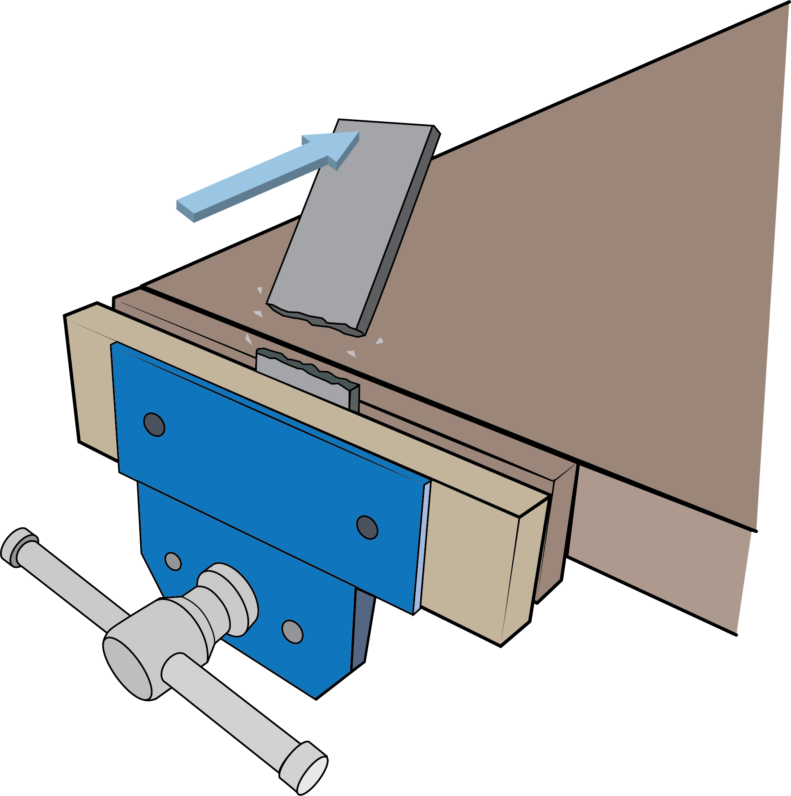  Direction of hammer strike
Tough |  | Brittle
1. Draw a diagram to show how to conduct each of the tests below and explain how you will record your findings.
Diagram to demonstrate how to conduct a workshop test for tensile strength:
Diagram to demonstrate how to conduct a workshop test for hardness:
Diagram to demonstrate how to conduct a workshop test for resistance to abrasion:

2. Carry out the tests on at least two different woods and complete the table below to describe your findings.
Wood sample | Toughness | Tensile strength | Hardness

Task 3
Study the images below and explain the benefits of applying a finish to wood.
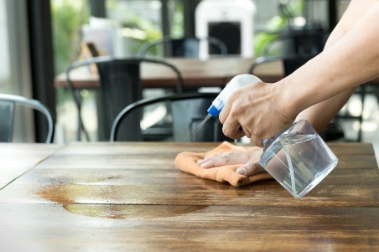 |  | 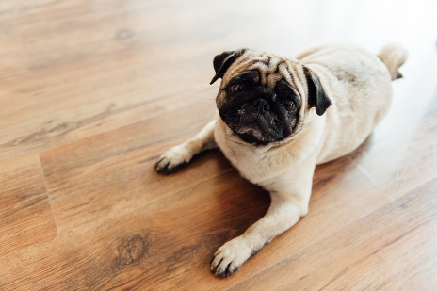 |  | 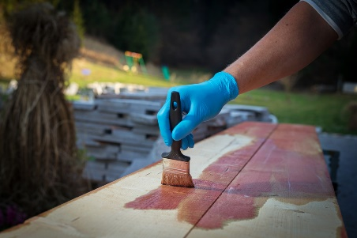

Task 4
Read the case study and answer the questions below.
1. How have the designers considered sustainability in their choice of materials and preservation techniques used?

2. How did the use of composite materials make the bridges feasible?

3. What tests could have been used to assess the properties of the accoya® wood?

4. Which test could be used to check the safety, quality and stability of the bridge while it is in use?

