Name: Class: Mark:

1. Select one of the following tests that is not routinely carried out on wood. [1]
⬨ Electrical conductivity
⬨ Ultrasonic test
⬨ Tensile strength
⬨ Toughness

2. This question is about material ‘toughness’.
(a) Give the meaning of the term ‘toughness’ in respect to material properties. [1]

(b) Describe why the ‘toughness’ of a wood needs to be considered in material selection for traditional children’s toys. [2]

3. This question is about how materials tests are conducted.
(a) Name the material property assessed by the Janka test. [1]

(b) Describe how this test is carried out. [3]

4. Give two ways in which the timber used in a wooden window sill could be
treated to resist decay. [2]

5. The diagram below shows the specific size and shape required for a test specimen for an industrial toughness test.
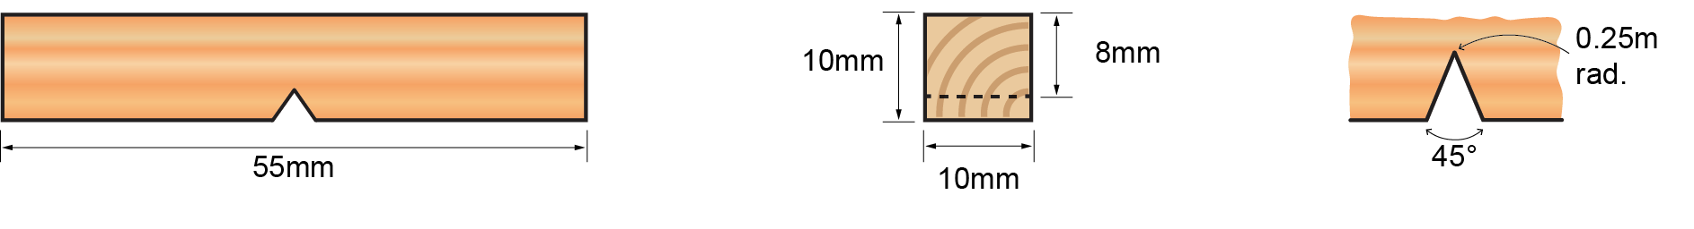
(a) Name the two industrial tests for toughness. [2]

(b) Describe why it is essential that each test specimen is the same. [2]

6. Evaluate the advantages of materials testing on woods. [6]

[Total 20 marks]

