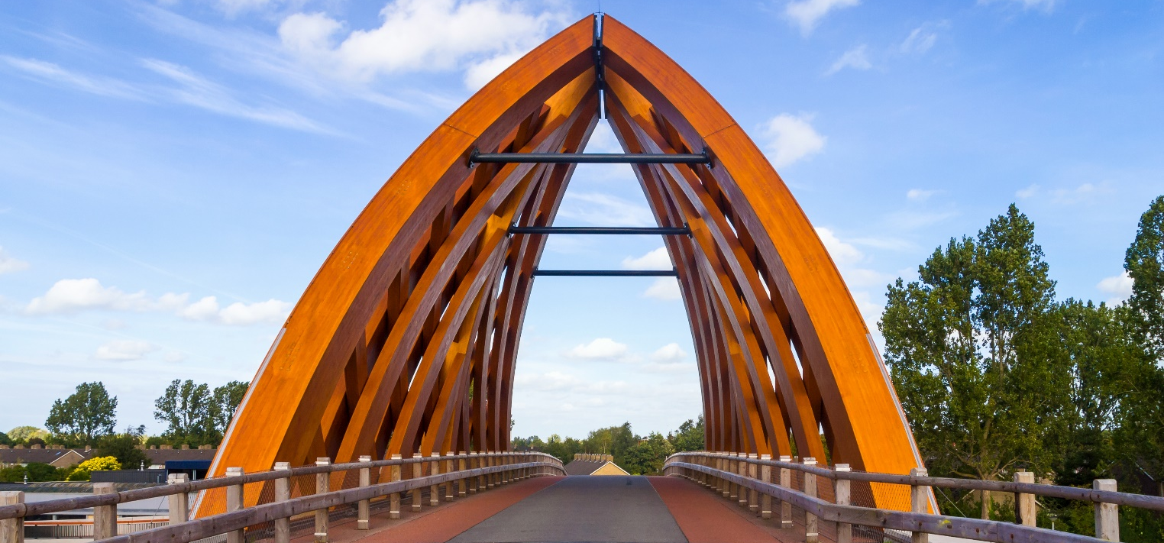
Wooden bridges, Sneek, Netherlands

Above: view of a bridge by architect Hans Achterbosch made with a span of curved wooden beams. Sneek, Netherlands.

The province of Sneek in the Netherlands needed two landmark bridges to welcome visitors. A competition was launched – a sustainable and high-tech design by Hans Achterbosch was selected as the winning entry.
The design of these bridges features a series of exposed structural beams, laminated to enhance the strength of the material and achieve the shapes and forms needed. The bridge carries two traffic lanes and a cycle path with pedestrian walk way and is 1134m long. These two bridges can cope with more traffic load than any other wooden bridge in the world.
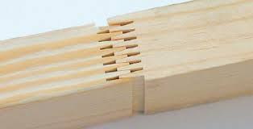
Approximately 1,200 cubic meters of Accoya® was used to create the beams. Each beam is 1m x 1.4m thick and created by laminating planks connected by structural finger joints (Figure 1). Accoya® is a modified timber made from sustainably sourced softwoods enhanced with a preservation treatment called acetylation. Accoya® has a low carbon footprint; it has 50% less impact than concrete in terms of CO₂ emissions.
Acetylation is a non-toxic preservation process which uses an organic compound called acetic anhydride. This chemically modifies the lignin and cell structure within the wood to prevent fungal decay while increasing dimensional stability.

Figure 1:
Structural finger joint

All bridges in the Netherlands must have a minimum lifespan of 80 years or more. Sneek province needed to be sure that the bridges would meet this specification point. A design team was arranged to test the Accoya® to ensure that the material would endure. The lifespan of a steel bridge is approximately 55 years, concrete bridges last around 90 years and a bridge made from the tropical hardwood, azobe, would last 45 years. However, tests concluded that Accoya® would last over 80 years. This, plus its low carbon foot print made it the right material for the job. For more info on Accoya® visit www.accoya.com.

