Name: Class:

Task 1
Joints may be permanent or temporary. Some need to be glued while others require components for extra strength and stability. The properties of different joining methods will affect how they are used.
Consider the wood joining methods you are familiar with and complete the diagram below. An example has been done for you.
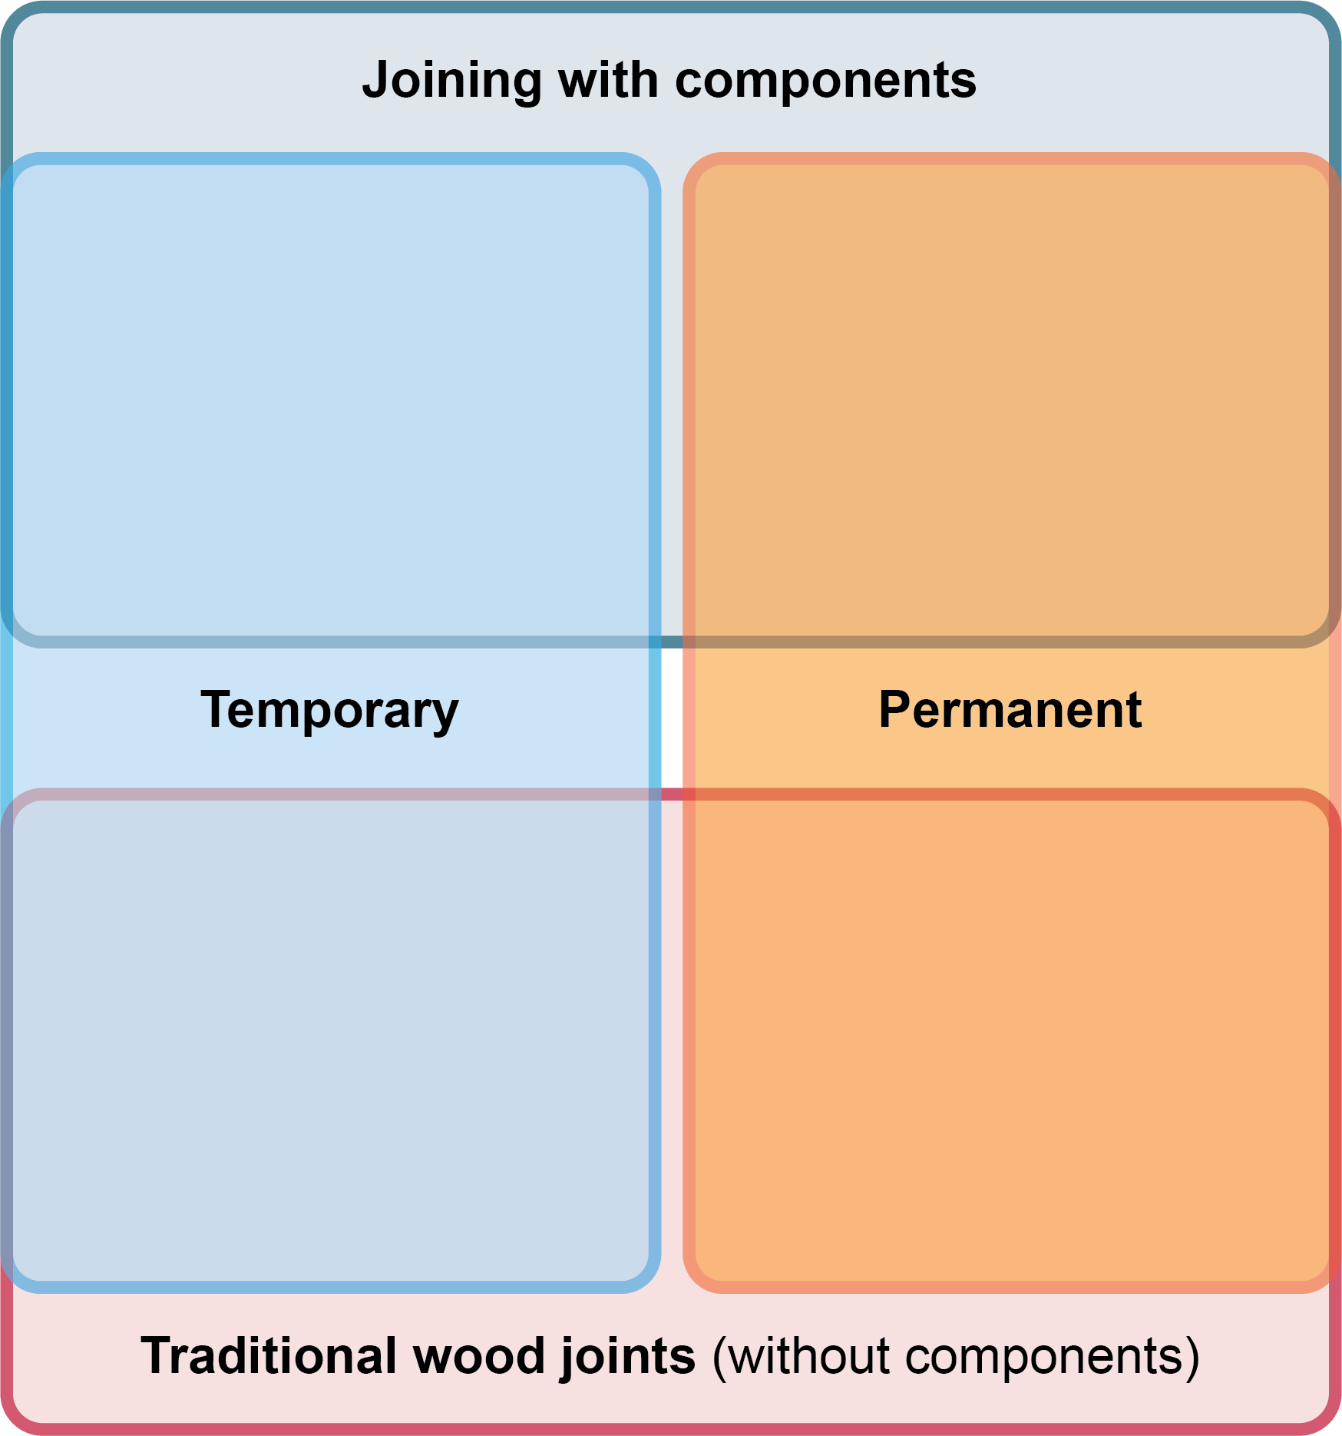

Butt joint glued and screwed

Task 2
The diagram below describes a butt joint. You may be familiar with this joining method. The butt joint requires no extra machining and is supported only by the strength of the glue.
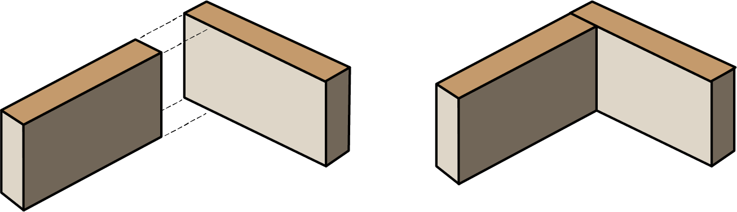
Complete the table below to explain the functional and aesthetic advantages of other
joining methods.
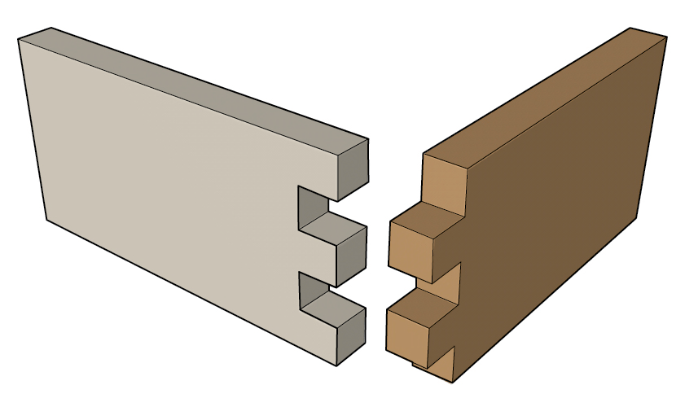 | 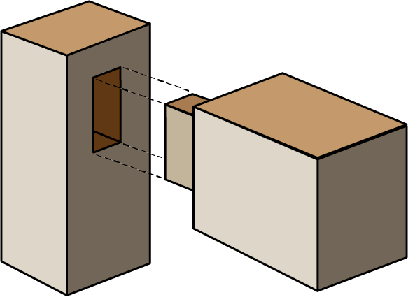 | 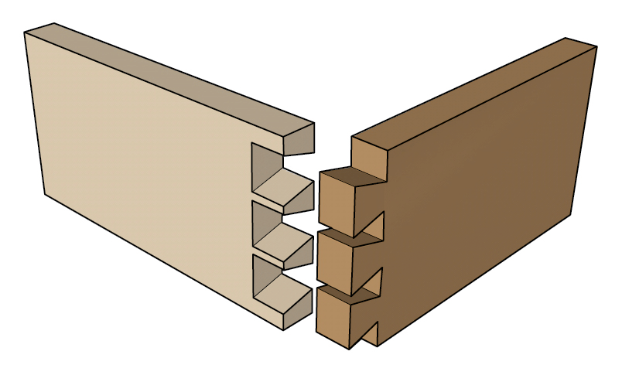
Comb joint | Mortise and tenon | Dovetail joint
Task 3
Study the diagram of a drawer below.

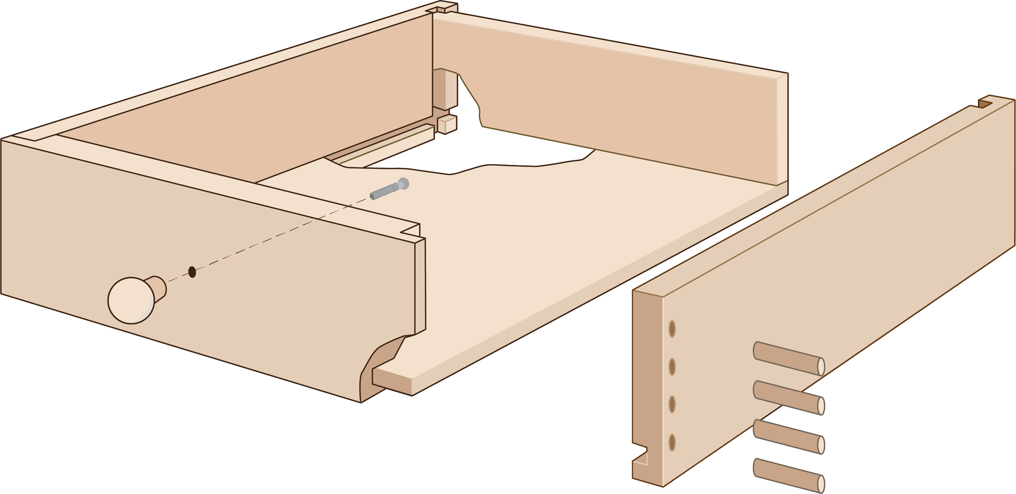
Wood screw – Quick and easy to install. Joint goes through the front panel to give strength to a key stress point.

Label the diagram above to name each of the joints used in the construction of the drawer and explain why each joint is suitable for the component in question. An example has been done for you.
Why are the dowels driven into the side of the drawer rather than the front?

Task 4
The bed frame below is sold as a flat-pack piece of furniture and assembled by the user at home. All the components for the joints are supplied by the manufacturer.
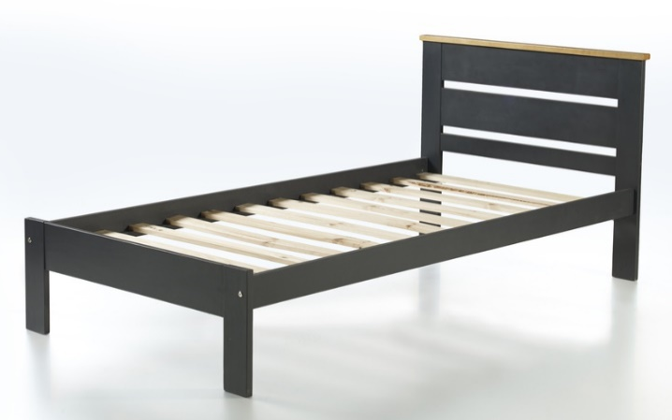
Suggest a suitable joining method for the corners of the frame. Justify your response.

The bed head board is assembled by the manufacturer. None of the joints are visible from the outside. Draw an exploded diagram below to describe the joining techniques that could have been used to assemble the sides, slats and top panel of the head board.

