Name: Class: Mark:

1. Which one of the following would be best suited to construct a lightweight frame
being made on a budget? [1]
⬨ Dovetail joint
⬨ Half lap joint
⬨ Comb joint
⬨ Mortise and tenon

2. Name two holes that could be drilled before inserting a dome headed screw. [2]

3. The images below show how the table legs are attached to the top framework. [1]
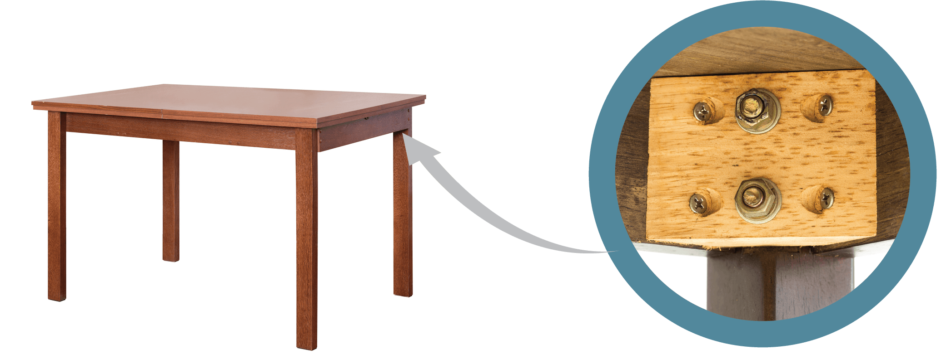
Add a label to name at least one of the components used to make this joint.

4. Study the product below.
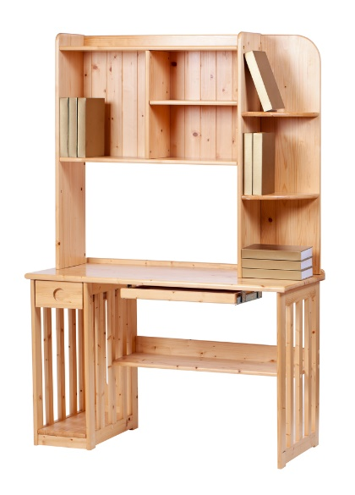
B
A
(a) Name and sketch a traditional joint that could be used at Point A. [3]

(b) Name and sketch a different traditional joint that could be used at Point B. [3]

(c) Name two knock down fittings that could be used at Point A [2]

5. The product below has been batch produced and joined with traditional joining methods.
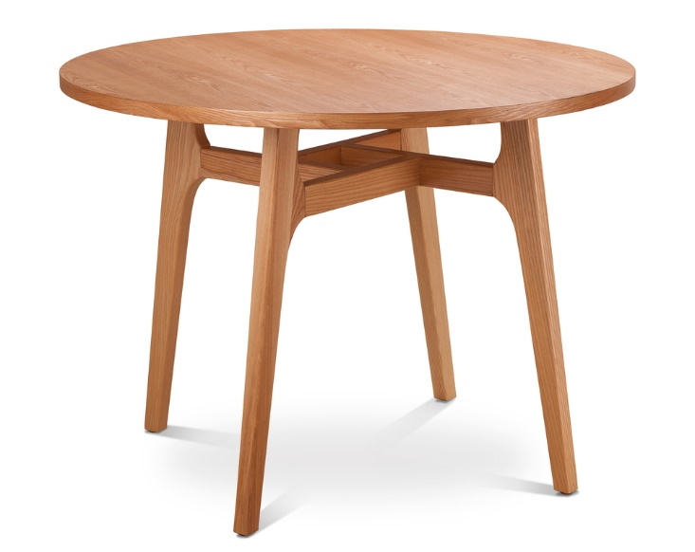
Table top
Four rails connect
Legs join to table top
Leg joins to rail
Leg
- Explain how the manufacturer could have increased efficiency when machining
the traditional wood joints. [2]

- The table is to be redeveloped for mass-production. The new table must fulfil the following specification points:
- Suitable for flat-pack
- Joints must be discreet
- Suitable for automated manufacture
Explain, using annotated 2D sketches, how the joints of the table could be modified to meet these new specifications.

Join leg to table top
[3]
Join rail to rail
[3]

[Total 20 marks]

