Name: Class:

Task 1
Use notes and sketches to describe the step by step process of how to create the laminated magazine rack and seat below.
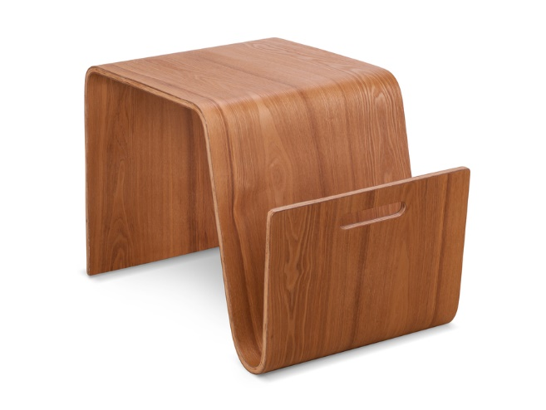
Task 2
Give two reasons why woods may need to be steamed before forming.

Design a jig that could be used to form the walking stick below. Use notes and sketches to describe your design.
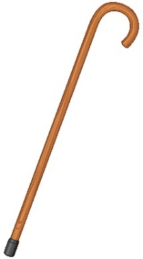
Task 3
Using a wood lathe involves securing a piece of wood in a chuck or on a face plate or between centres.
Which setup is shown in the image below?
Headstock
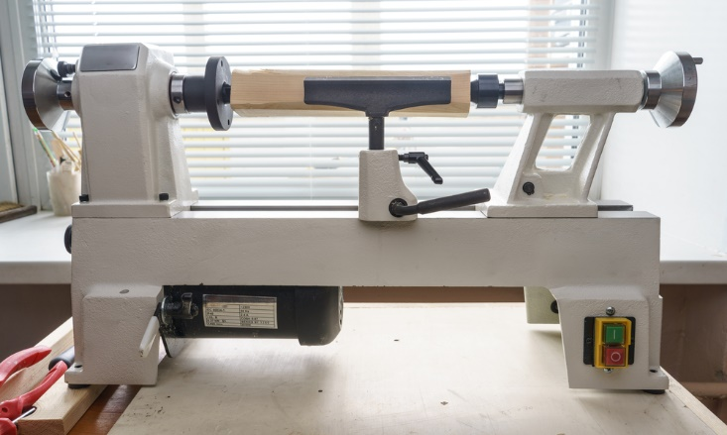
Tool rest
Chuck or
faceplate
fitted here
Tailstock

Referring to the diagram and labels above, describe how the lathe works.

Task 4
Design a three-legged side table which incorporates at least two of the following processes:
- Turning on a lathe
  - Turning between centres
  - Turning with a faceplate or chuck
- Routing
- Milling
- Steam bending
- Laminating

