Name: Class: Mark:

1. Which one of the following is not a wasting process? [1]
⬨ Drilling
⬨ Gluing
⬨ Milling
⬨ Turning

2. Complete the grid below and state how the products below could have been
machined. An example has been completed for you. [3]
Tongue & groove flooring | Pepper mill | 3D Statuette
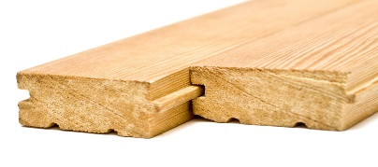 |  | 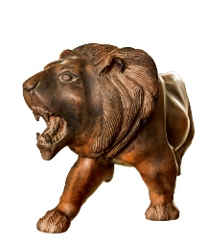
 | Wood lathe

3. Name one factor that would require the speed of rotation set on a wood lathe to
be changed. [1]

4. Explain two reasons why you would choose to turn with a faceplate or chuck as opposed to turning between centres. [4]

5. The diagram below left shows a template used to create a form on the lathe. [3]
(a) Draw a 2D view of what the finished product would look like in the grid on the right.
(b) Add a dotted line to show the central axis.
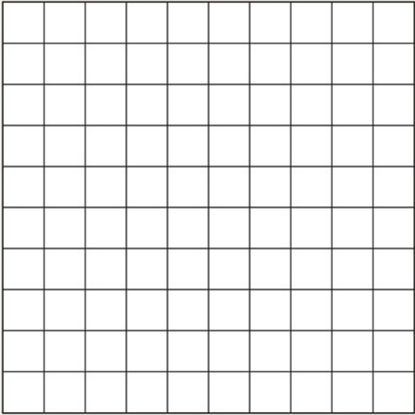

6. State two main purposes of using a former to laminate wood. [2]

7. Steam bending and laminating are techniques used to form woods. Evaluate the similarities and differences between these two forming processes. [6]

[Total 20 marks]

