Name: Class:

Task 1
All finishes require the substrate to be properly prepared. Use the word bank below to fill
out the grid on the Do’s and Don’ts of material preparation. An example has been
completed for you.
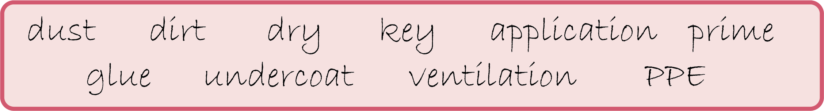
Do’s | Don’ts
Make sure surface is dust and dirt free | Apply a finish to a damp or dirty surface

Task 2
- The image below shows a table top damaged by heat and moisture from tea/coffee cups.
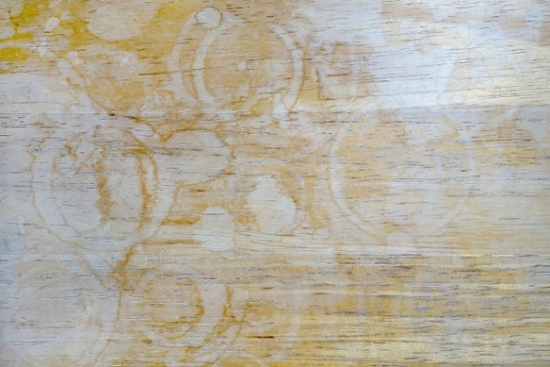
Describe how you would repair the damage.
- The product below has been revamped for a sale in a vintage furniture boutique.

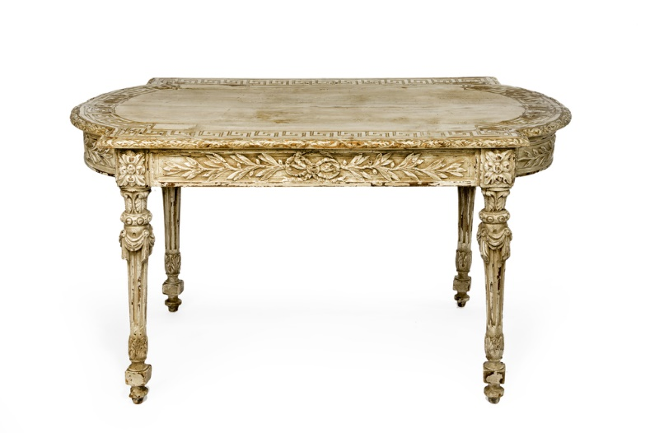
Give an explanation of how finishes have been applied to achieve this aesthetic and suggest a heat resistant finish that could be used to protect the table.

Task 3
The diagrams below describe the step by step process of pressure treating wood. Match the descriptors to the correct diagram.
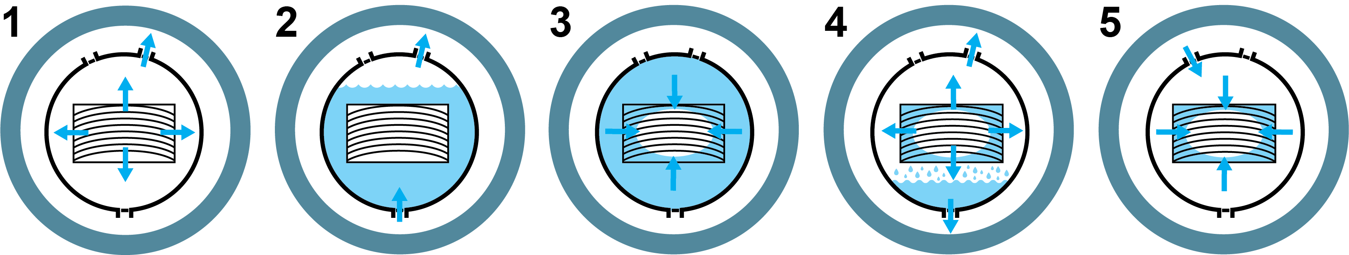

Hydraulic pressure forces preservative deep into the wood | Create vacuum to evacuate air from timber cells | Low pressure draws preservative into the wood as air vent is opened | Treatment vessel flooded with preservative | Second vacuum extracts preservative

Task 4
Describe the most appropriate finish for each of the following products. You may wish to refer to the application, characteristics and aesthetics of the finish.
Product A | Product B | Product C
Rowing boat  made from oak | Wooden toy  made from beech | Dressing table  made from teak

Product A: Rowing boat made from oak

Product B: Wooden toy made from beech

Product C: Dressing table made from teak

