Name: Class: Mark:

1. Name two reasons why a finish might be applied to wood. [2]

2. Which application method would be best suited to mass manufacture? [1]
⬨ Spray
⬨ Brush
⬨ Cloth
⬨ Roller

3. Name one piece of personal protective equipment (PPE) you would recommend
while applying polyurethane varnish. [1]

4. Identify the finish being applied on the wood sample below and explain your answer. [3]

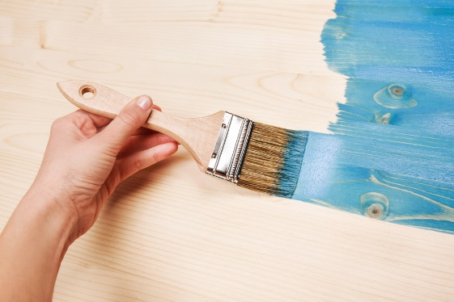

Finish used:

Explanation:

5. Wax finishes nourish and protect wood. Give a further two advantageous
characteristics of a waxed wood finish. [2]

6. This question is about pressure treated timber.
(a) Pressure treated timber is treated professionally. Give the two types of
pressure that timber is subjected to during this process. [2]

(b) A copper-based chemical solution is used for pressure treatment. Explain how
this protects the wood. [2]

(c) Give one common application of pressure treated timber. [1]

7. Evaluate the advantages and disadvantages of using polyurethane varnish
to finish woods. [6]

[Total 20 marks]

