Name: Class: Mark:

Starter
Working in pairs use this activity to revise your existing knowledge of metals.
Metals are classified into three main types - ferrous, non-ferrous and alloys which can be further classified as ferrous alloys or non-ferrous alloys. Complete the table below to give a definition for each type and some examples of metals for each category.
Category | Definition | Example of metal
Ferrous
Non-ferrous
Ferrous Alloys
Non-ferrous Alloys

Task 1
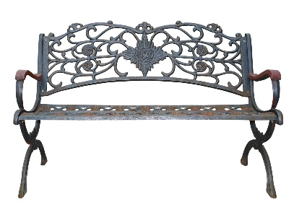
Study the metal bench below. Consider the advantages and disadvantages of the following metals in the manufacture of the bench.

Explain the advantages and disadvantages of each metal listed.
(a) Gold

(b) Aluminium

(c) Low carbon steel

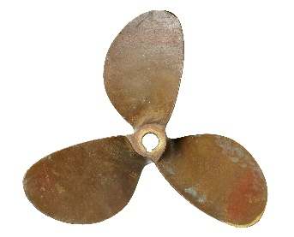
Task 2
Bronze was used on ship hulls used to sail across the Atlantic as early as the 15th Century. It is also used for propellers and other nautical components and instrumentation. Which properties of bronze made it suitable to be used at sea?

(i) Name a suitable metal or alloy used to make ship hulls today.

(ii) Explain why the metal or alloy named above is suitable to use on boat and ship hulls.

Task 3
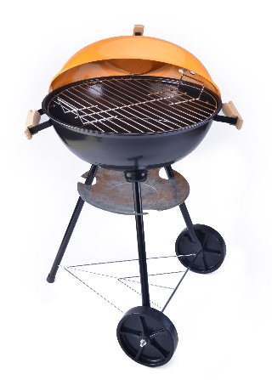
The self-assembly kettle BBQ below is designed to be relatively inexpensive and appeal to the mass market.
Answer the following questions in relation to the BBQ pictured above.
(a) Which metal has been used for each component and which stock form was it
made from?
Grill -
Kettle (base and lid) -
Handles -
Legs -
Drip tray -
Axel -

(b) At the top end of the BBQ market, manufacturers are increasingly using titanium in the manufacture of products. A kettle BBQ, like the one above, costs around £30, however a titanium portable gas BBQ grill may cost upwards of £150.

Explore the arguments for using titanium and discuss whether they justify the vastly increased cost.

