Name: Class: Mark:

1. Give three examples of non-ferrous metals. [3]

2. Give two reasons why sheet metal is used in the manufacture of car bodies. [2]

3. A range of metals, including titanium and its alloys, are used in the manufacture of an aeroplane’s fuselage and wings.
(a) Name one other metal or alloy that could be used for these applications. [1]

(b) Evaluate the use of titanium in aviation engineering [6]

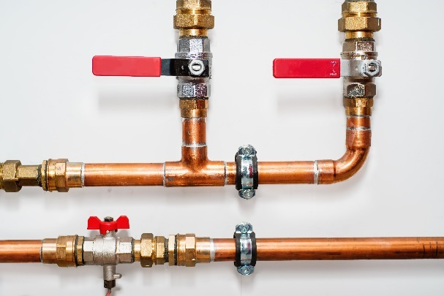
4. The photo below shows copper hot water pipes.
Give one physical and one mechanical property of the metal. In each case state why the property is suitable for the product pictured.
(a) Physical property: [2]

(b) Mechanical property: [2]

5. Give three characteristics of the following metals and suggest one suitable application for each.
(a) Silver
Characteristics: [3]

Application: [1]

(b) Stainless steel
Characteristics: [3]

Application: [1]

(c) Grey cast iron
Characteristics: [3]

Application: [1]

[Total 28 marks]

