Name: Class: Mark:

Task 1
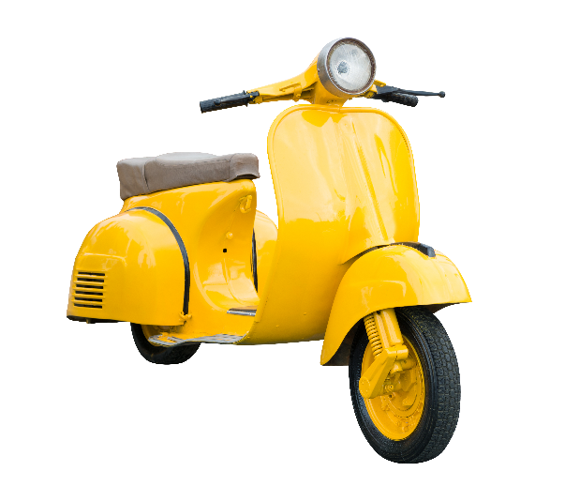
Study the scooter below. The body panels are made from sheet steel.
Consider the importance of the properties listed below in the selection of sheet steel as the main material. Define each property and discuss the relevance of each property to the manufacture and function of the scooter.

Property | Definition | Relevance of property to the function
Toughness
Malleability

Task 2
Look at the applications of the metals listed below, state one important physical property required for the application and describe the impact of this property on the product.

Application | Metal | Property | Impact of property
 | Tungsten  filament
 | Aluminium hull
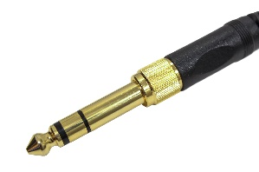 | Gold  plating

Explain why, despite having great electrical conductivity, silver is not as widely used in electronics as copper or gold.

Task 3
A still is used to distill liquid by heating to boiling point and then cooling to condense the vapor. Stills are used to produce many products from distilled alcoholic beverages like gin and whisky to perfume and medicines.

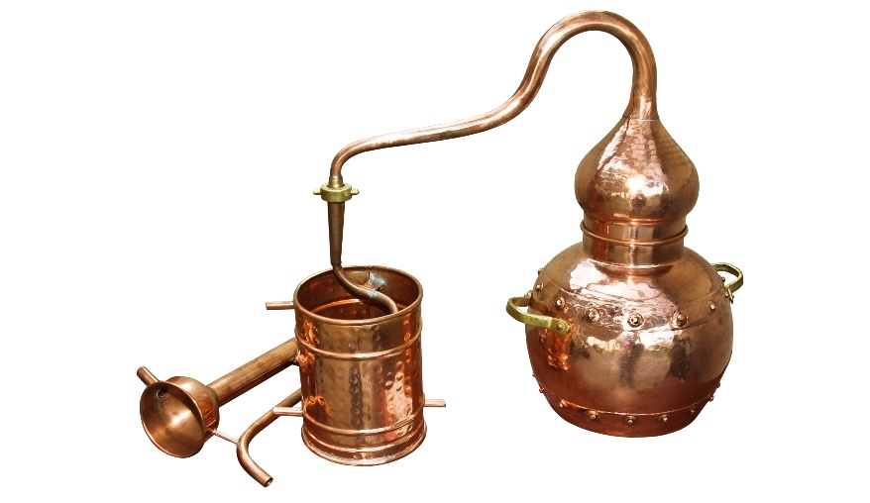
With reference to both mechanical and physical properties, evaluate the use of copper in an industrial alcohol still like the one pictured.

