Name: Class: Mark:

1. Give one example of a metal that is difficult to join using heat processes. [1]

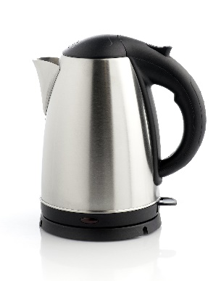
2. Study the kettle below.
(a) Name a suitable specific metal for the kettle. [1]

(b) Explain why this metal is suitable for the kettle. [2]

3. Mild steel sheet is often used in the manufacture of 'white goods’ such as washing machines, tumble dryers and fridges.
(a) Explain two mechanical properties that make mild steel suitable for manufacturing white goods. [4]

(b) Explain two physical properties that make mild steel suitable for this application. [4]

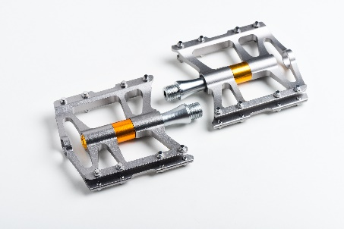
4. Study the image below. With reference to both the physical and mechanical properties, evaluate the use of aluminium alloys in bicycle pedals. [6]

[Total 18 marks]

