Name: Class: Mark:

Task 1
Study the diagram below which shows how to conduct a workshop test for toughness.
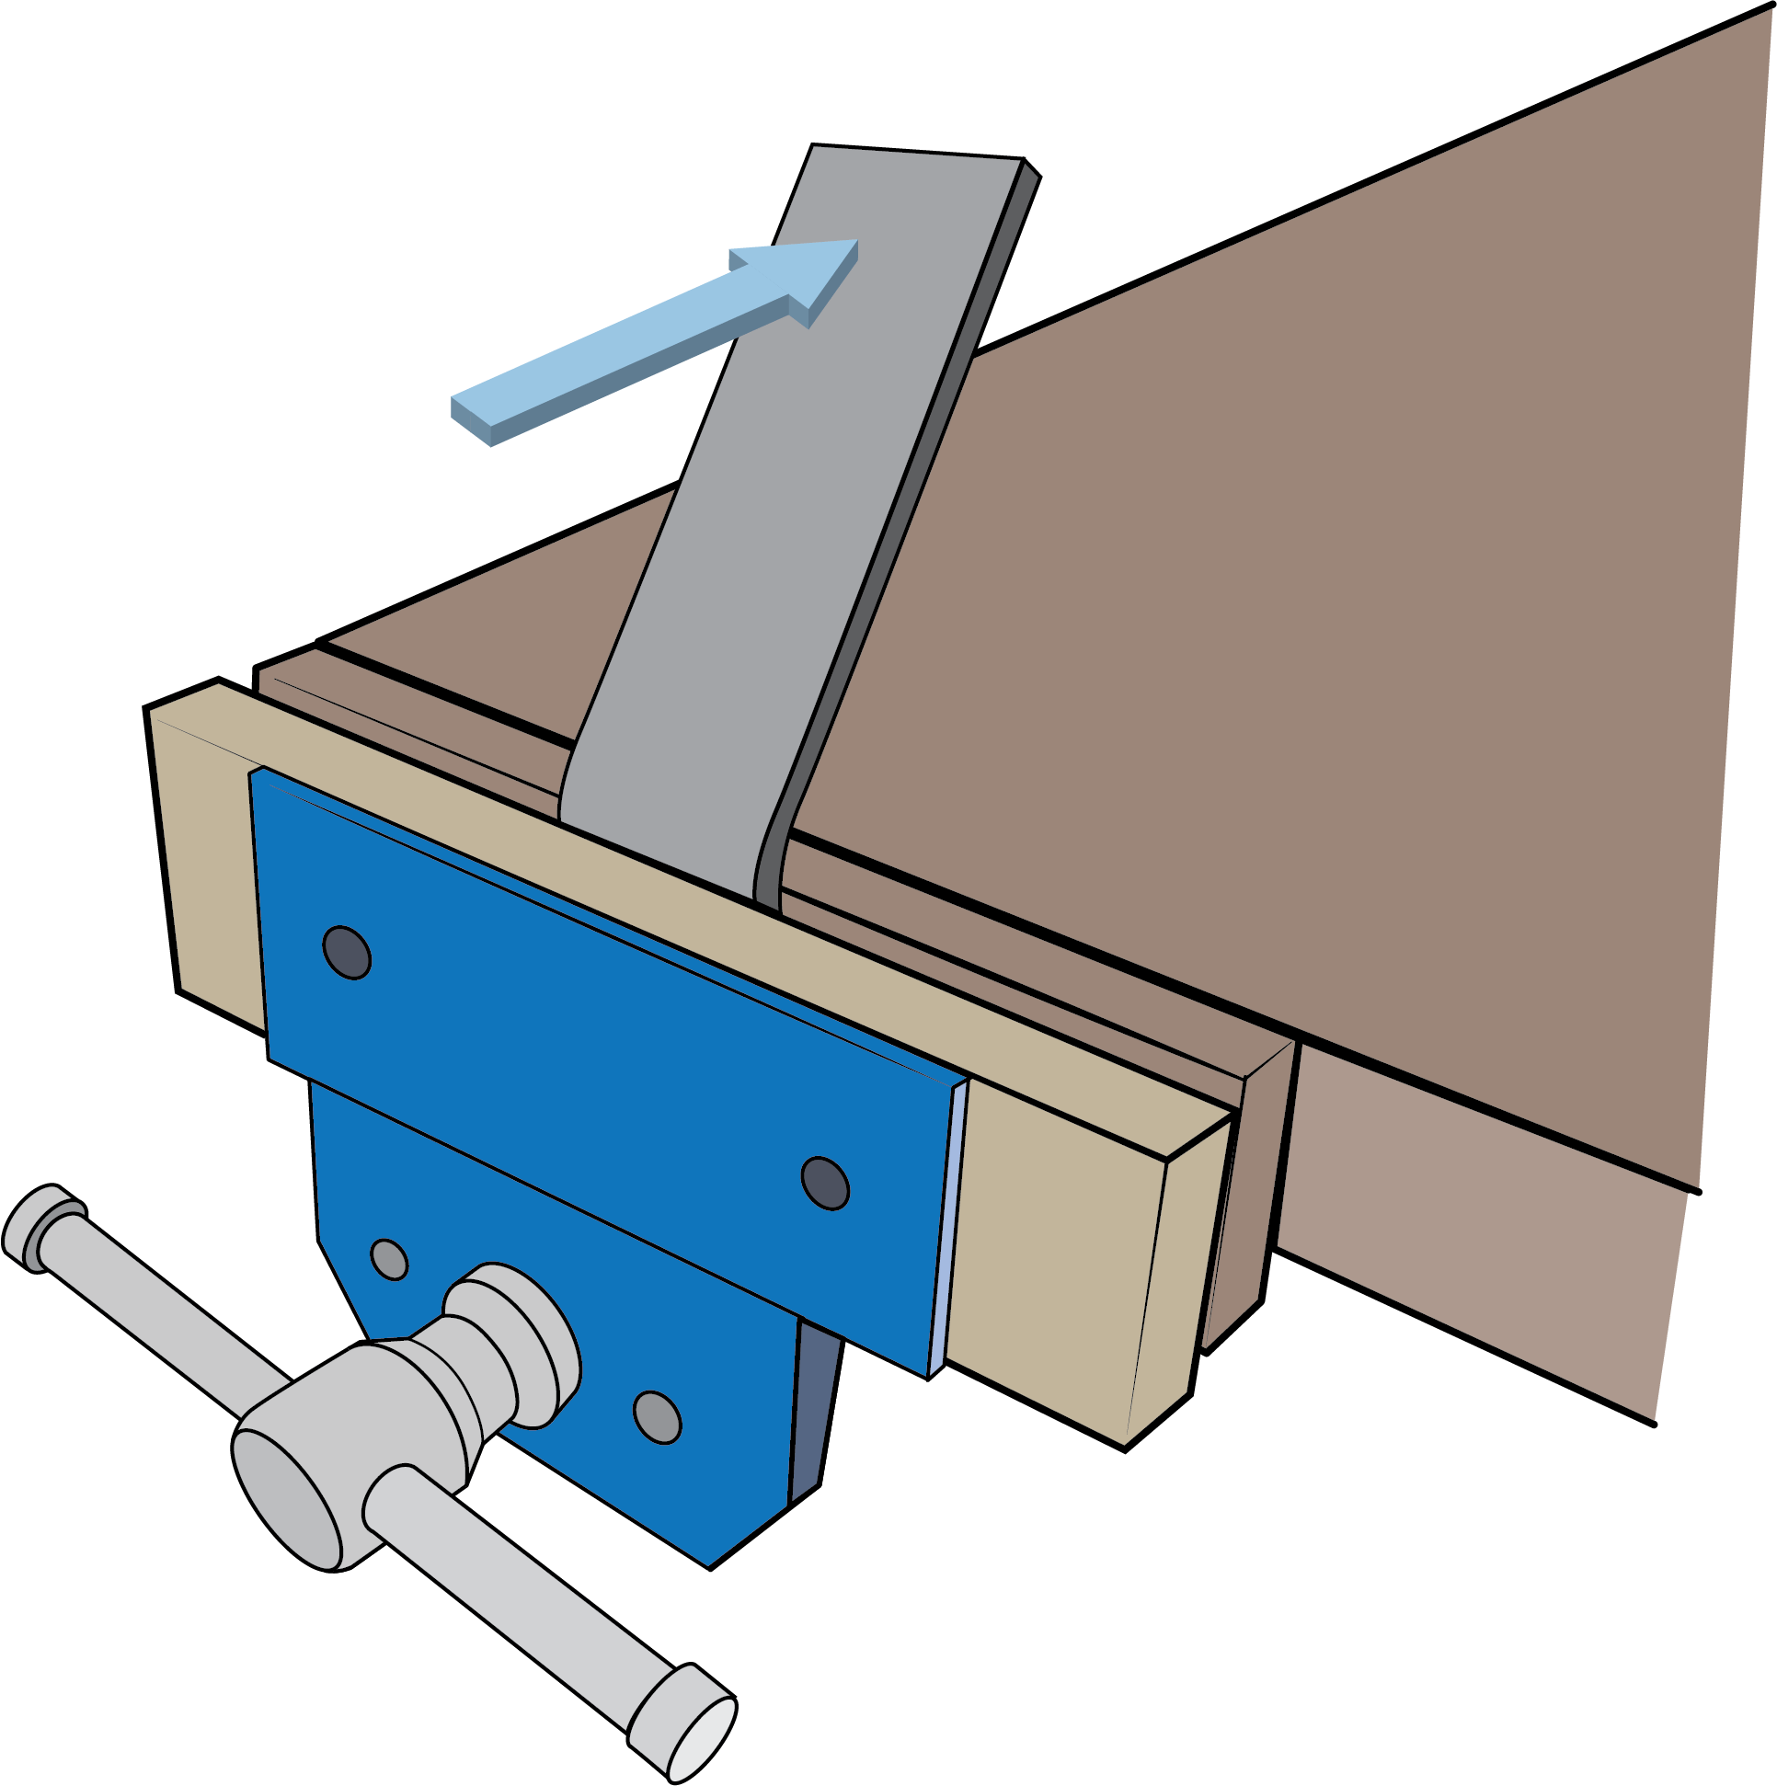  Direction of hammer strike | Direction of hammer strike | 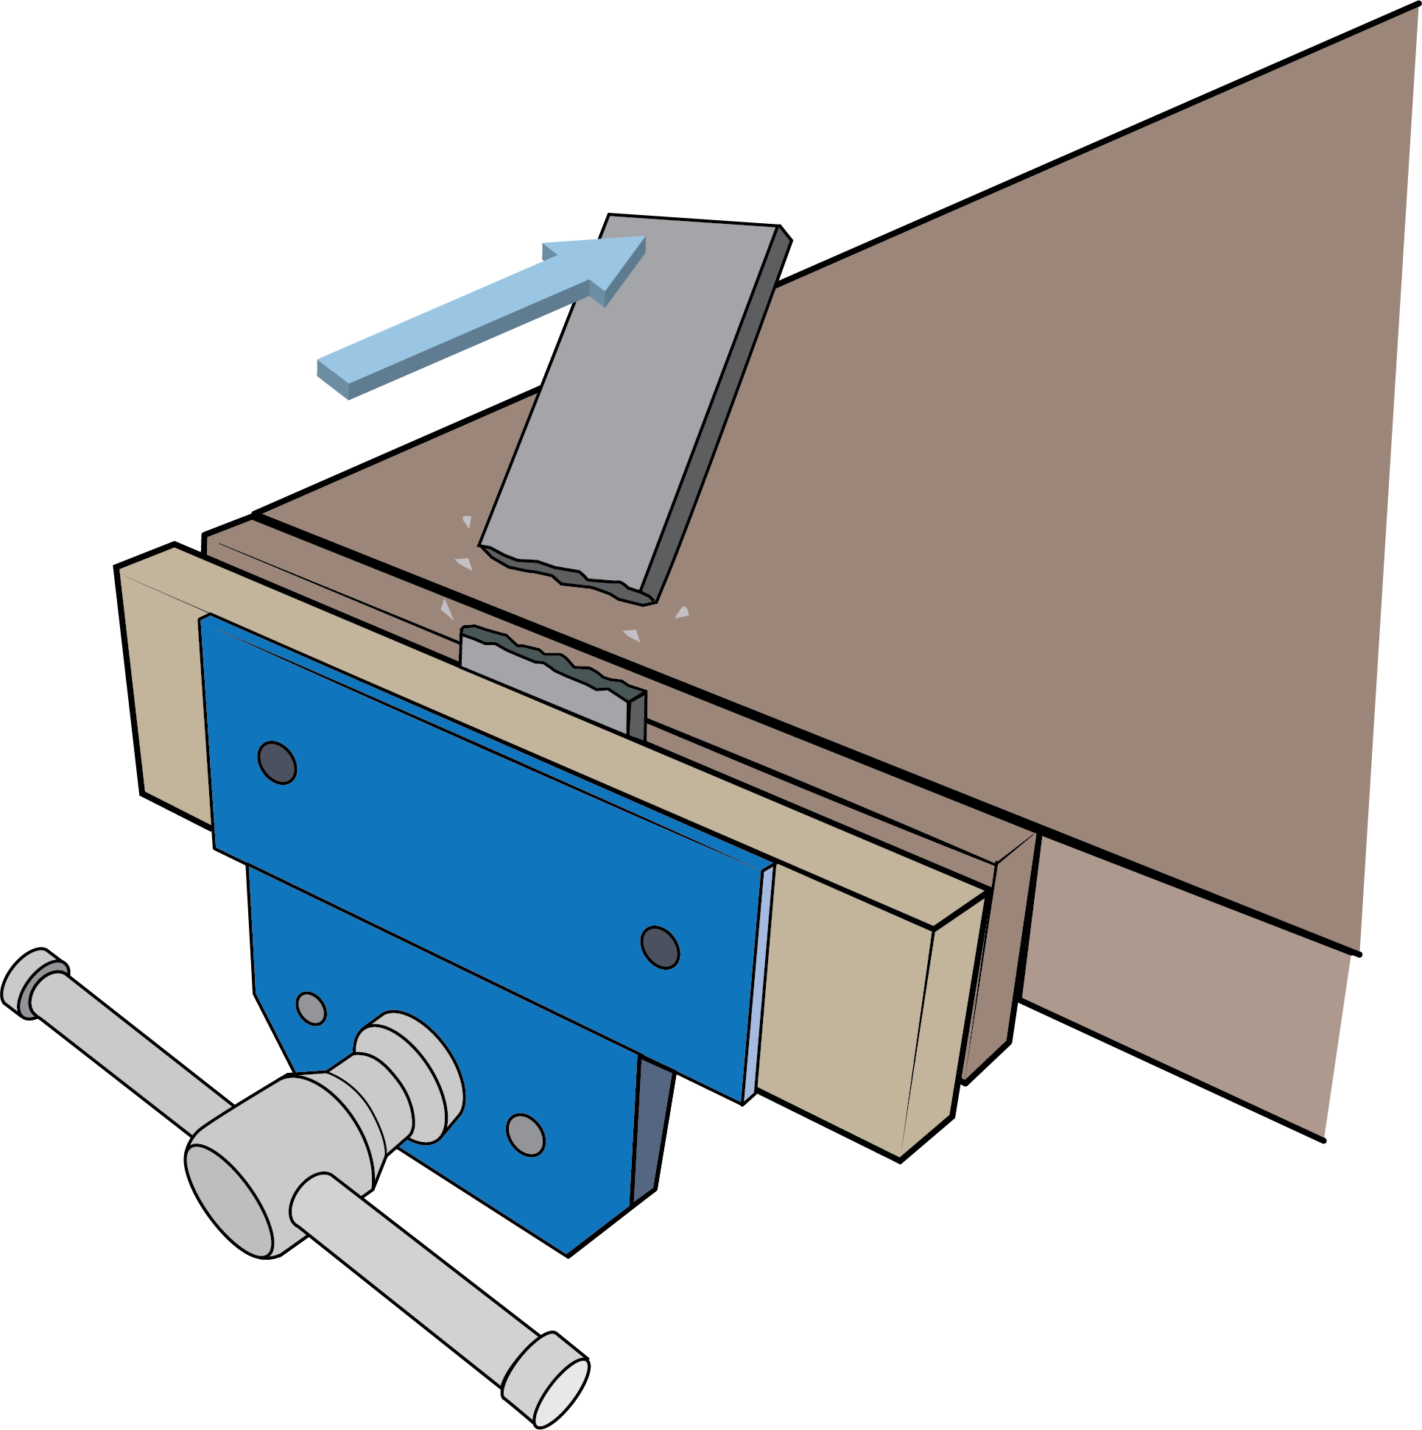
Tough |  | Brittle

1. Using notes and sketches show how you would conduct each of the tests below and explain how you will record your findings.
Malleability/ductility:

Electrical conductivity
Corrosion testing:

Task 2
Match the terms with the correct descriptions.

Annealing |  | A post-hardening process for ferrous metals to relieve internal stresses, increasing toughness and reducing brittleness.
Normalising |  | Heating metals and allowing them to cool slowly in order to remove internal stresses from work hardening, increasing malleability
Tempering |  | Heating a medium or high carbon steel and then quenching to increase hardness
Case hardening |  | Hardening the surface of a low carbon steel with a carbon layer allowing the metal core to remain soft
Hardening |  | Heating ferrous metals for a period of time before cooling slowly to remove internal stresses giving uniform strength and decreasing hardness

Task 3
Evaluate the hardening and tempering of steel in comparison to case hardening steel.

