Name: Class: Mark:

1. Describe the process of case hardening mild steel. [5]

2. Explain the process of annealing of copper and the effects it has on its
mechanical properties. [5]

3. This question is about the mechanical property ‘hardness’.
(a) Describe a simple workshop test which could be carried out on a range of metals to determine their hardness. [3]

(b) Explain in detail one industry standard test which could be carried out to investigate the hardness of a range of metals. [4]

(c) Name two other industry standard test to investigate hardness. [2]

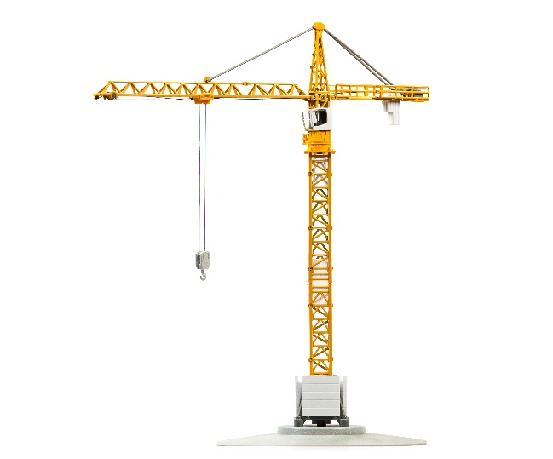
4. Identify and justify two different tests which may be carried out on the specific steel used for the struts used in tower cranes before manufacture. [6]

[Total 25 marks]

