Name: Class:

Task 1
(a) Fill in the table below.
(i) Define the metal forming process
(ii) State the scale(s) of production they are best suited to
(iii) Give an example of a product commonly made using this process
Process | Definition | Scale of production | Product example
Spinning
Press forming
Deep drawing
Cupping
(b) Give one reason why the deep drawing process is only suitable for continuous or mass production.

Task 2
Study the picture of the clamping device known as a G-cramp.
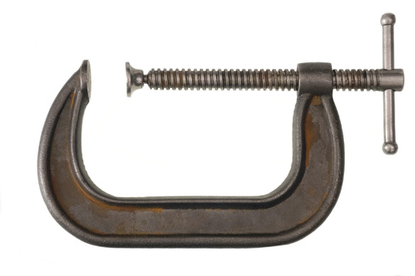
(a) Give three reasons why sand casting is suitable process to manufacture the
G-cramp pictured above.
1.

2.

3.

(b) Describe the process of wrought iron forging.

Task 3
Using annotated sketches explain the process of investment casting.

