Name: Class: Mark:

1. Study the picture below.
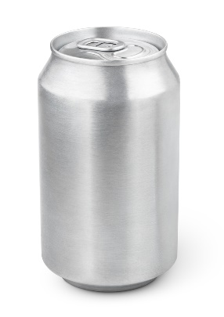
(a) Identify the forming process used to create the aluminium can pictured above. [1]

(b) Explain why this is a suitable process to use. [2]

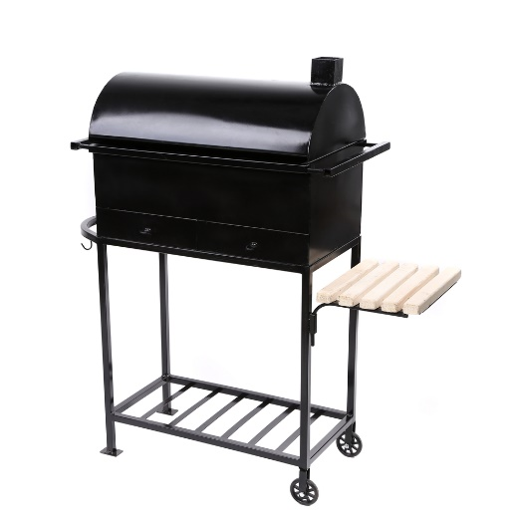
2. Give two suitable forming process that have been used in the BBQ pictured above. [2]

3. The following question is about hot forming metals
(a) Explain why sand casting is only suitable for one-off or batch production. [2]

(b) Drop forging is used to create many metal objects.
(i) Give three reasons why drop forging is used to make spanners. [3]
1.
2.
3.

(ii) Give two additional methods of hot forming metal and two applications. [4]
Method 1:
Application:
Method 2:
Application:

4. Evaluate the advantages and disadvantages of the spinning process to produce
metal products. Comment on both CNC equipment and hand-held tools in your
answer. [6]

[Total 20 marks]

