Name: Class:

Task 1
Annotate the following diagrams of various fabrication processes.
MIG welding | Brazing
 | 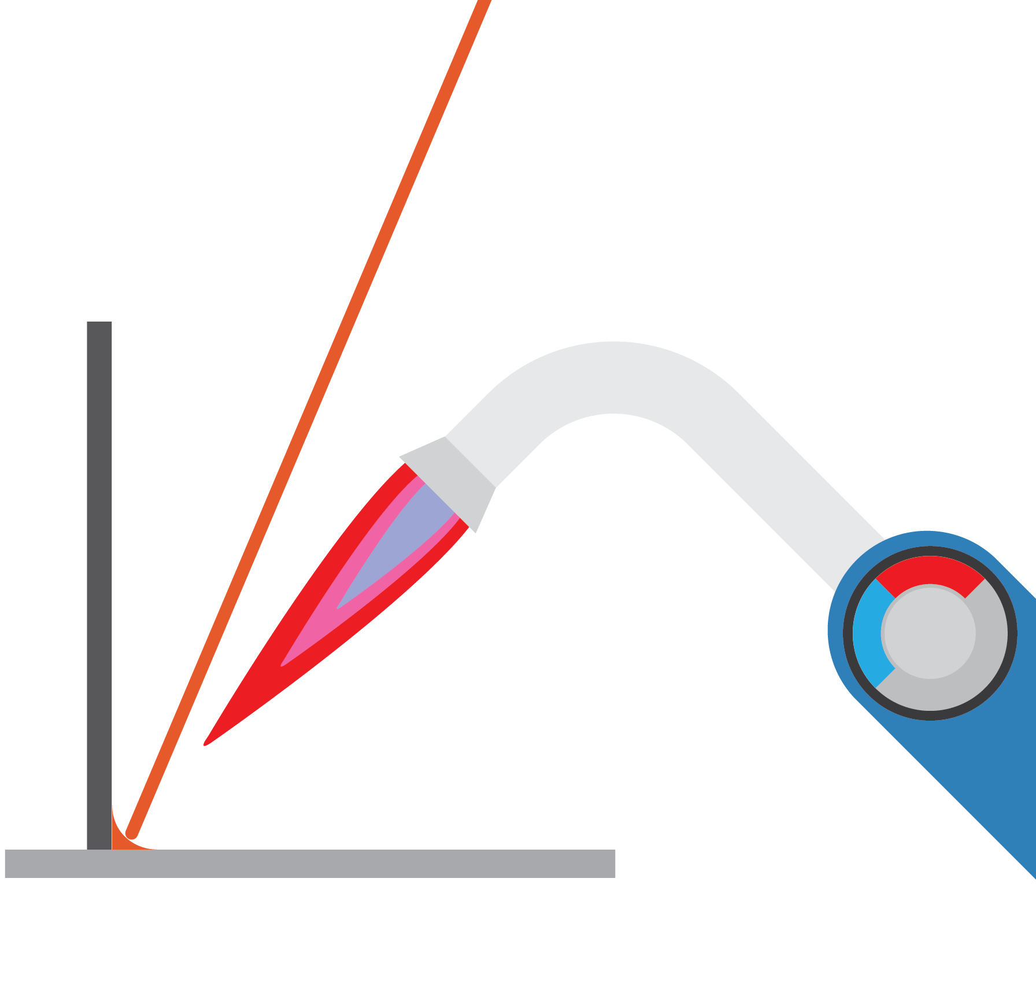
TIG welding | Pop riveting
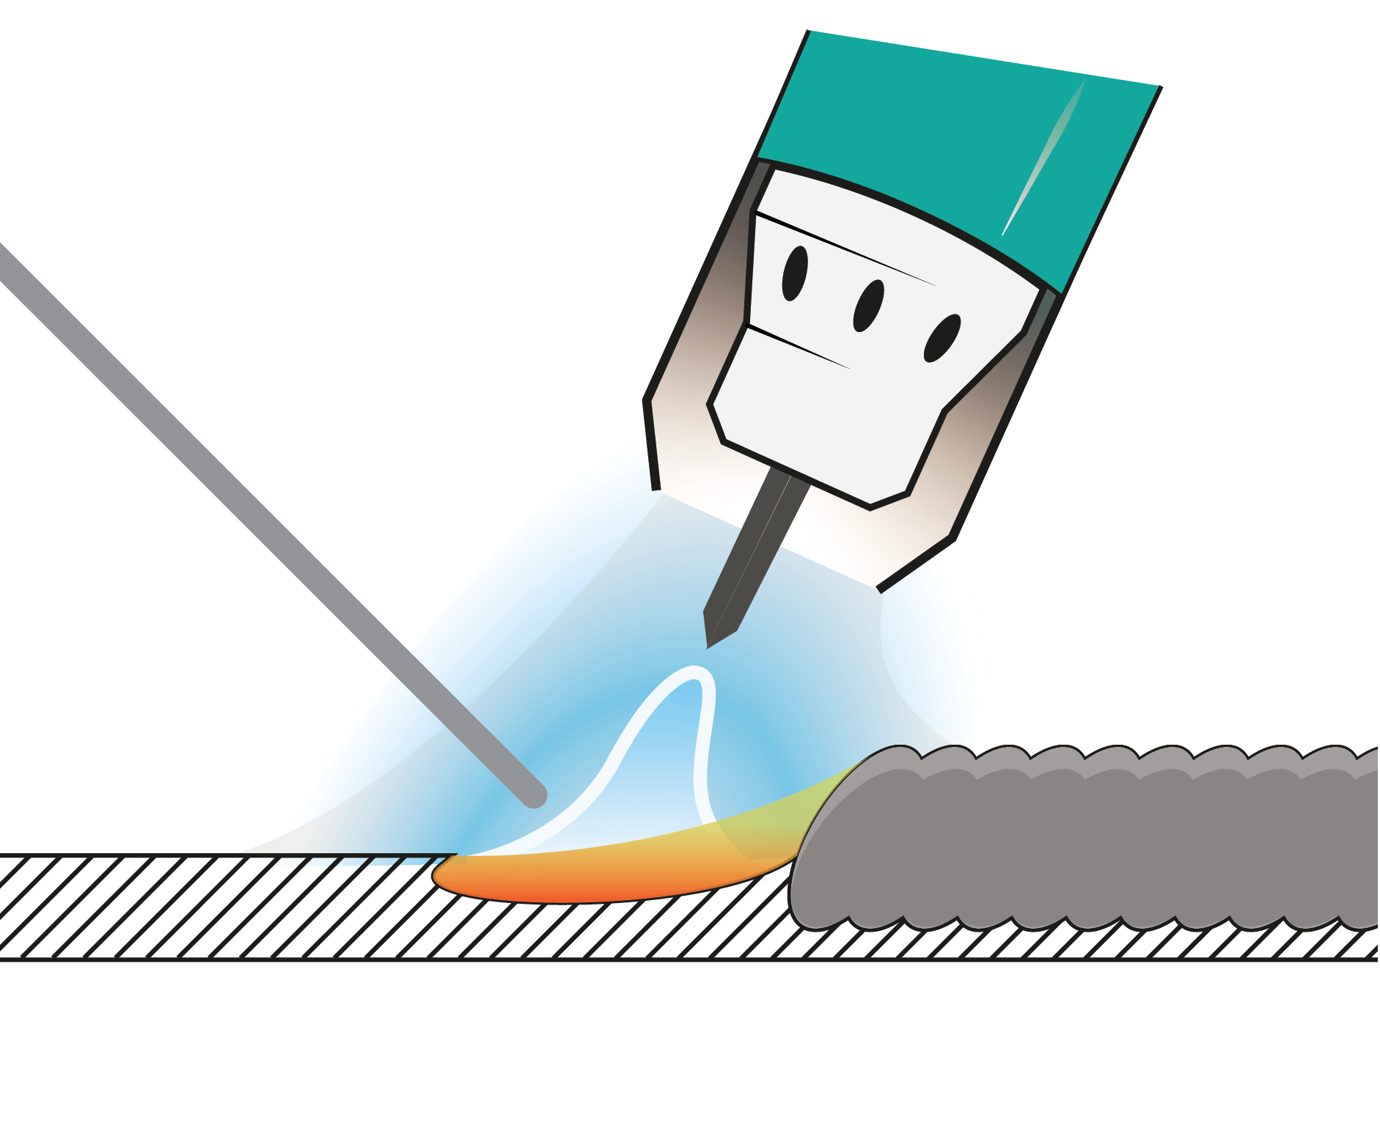 | 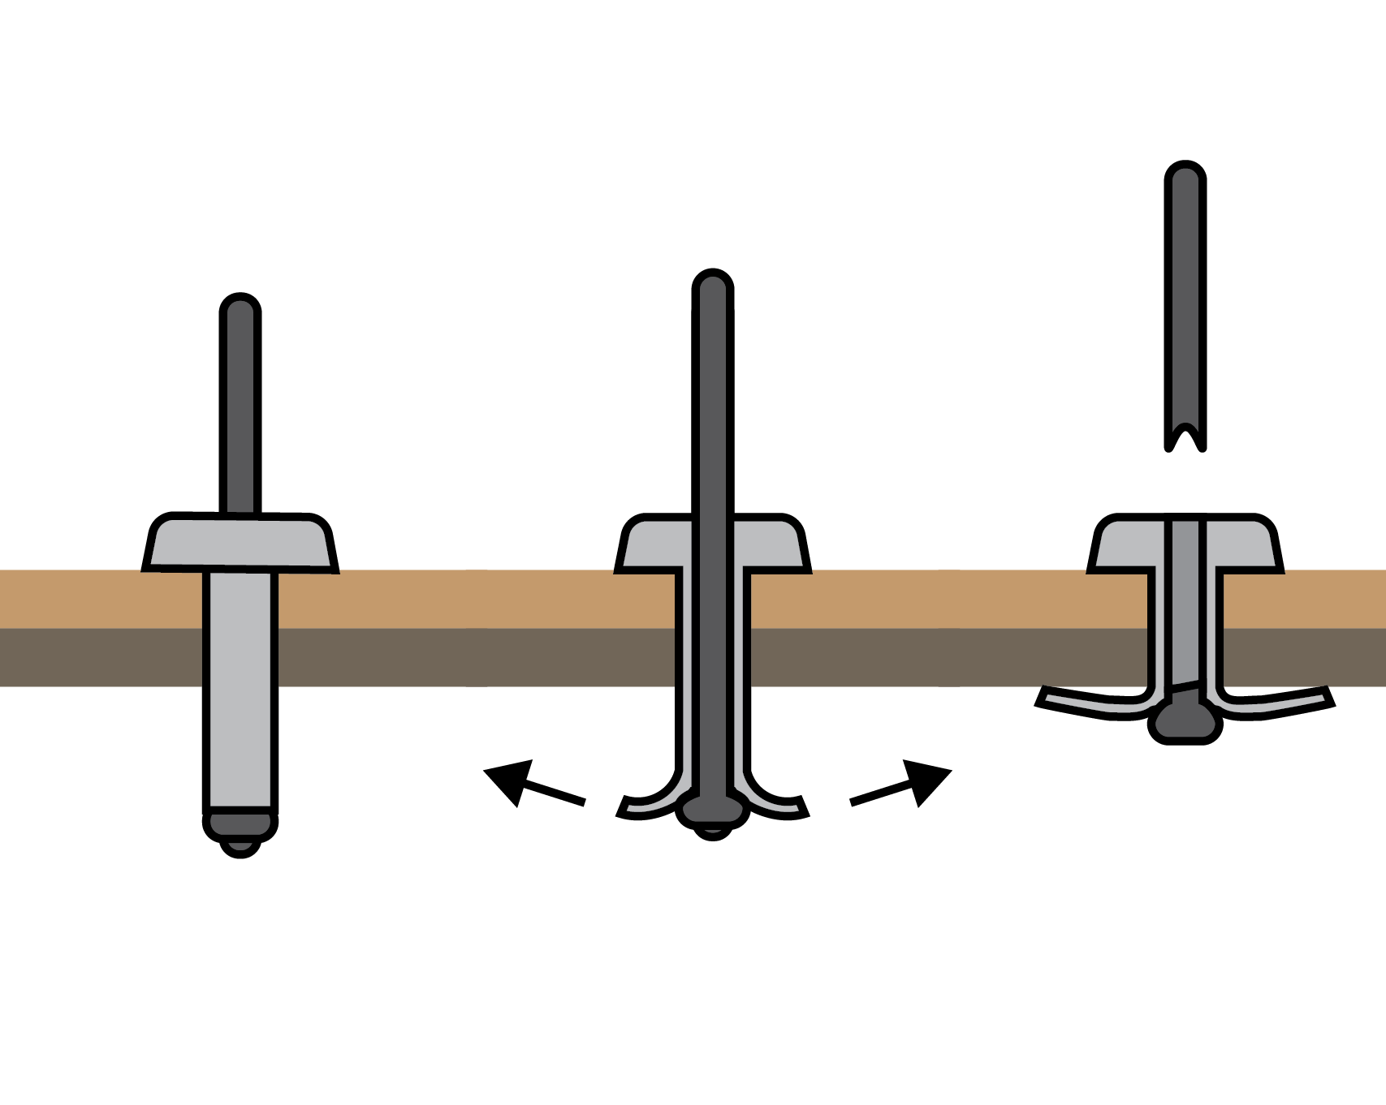
Task 2
Evaluate the use of nuts and bolts in construction when compared to rivets.

Task 3
Match the terms with the correct descriptions and photo.
MIG  welding |  | Applies heat and pressure through contacting electrodes, no filler material is required. |  | 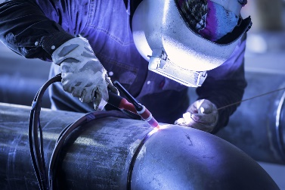
TIG  welding |  | Uses an electric arc and a wire electrode which melts in the arc to fill the gap between two metals. |  | 
Soft  soldering |  | Uses a gas torch to heat the metal, can be used in locations where there is no electrical supply. |  | 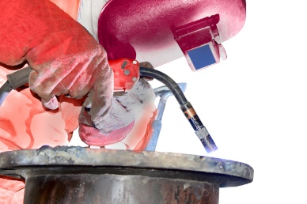
Oxy-acetylene welding |  | Uses an electric arc, an electrode made from tungsten and requires an additional filler rod to be melted into the weld pool. |  | 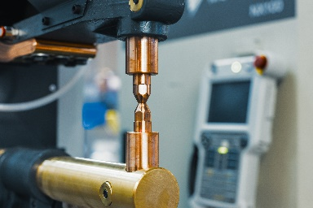
Spot  welding |  | Uses a filler metal with a much lower melting point to join the parent metals together. |  | 