Name: Class:

Task 1
For each of the items below identify and justify which finishing processes have been used.
Item | Finishing Process | Justification
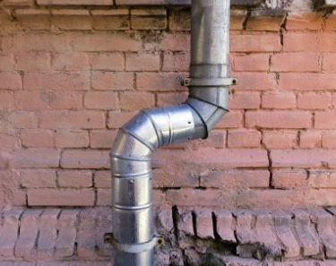
Drainpipe
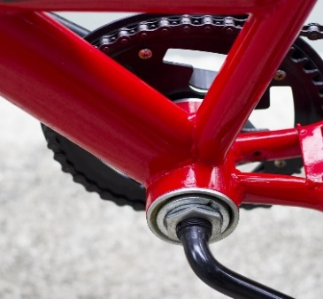
Bicycle frame

Cutlery
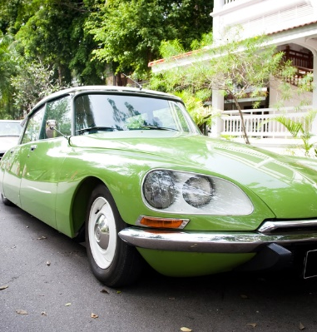
Vintage car

Task 2
Use annotated sketches to explain how the following processes are performed.

Anodising:
Plating using physical vapour deposition (PVD):
Task 3
Study the images below and answer the following questions about metal finishes.

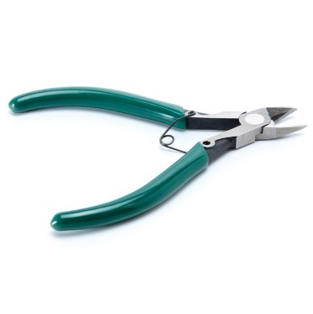 |  | 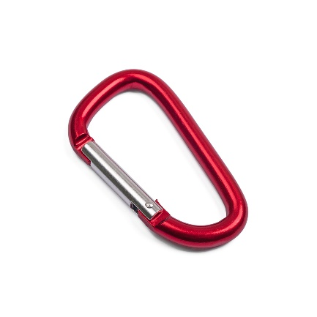 |  | 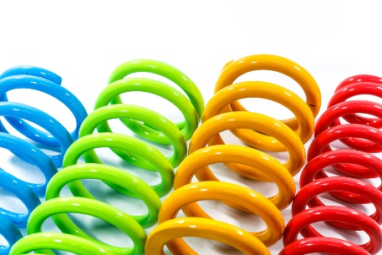

1. Identify the finishing process used on the above pair of side cutters. Explain why it is a suitable process to use for a pair of side cutters.

2. Give two reasons why rock climbers could benefit from the carabiner above being anodized.

3. The car springs above have been powder coated. Compare the use of electroplating car and motorbike parts with powder coating.

