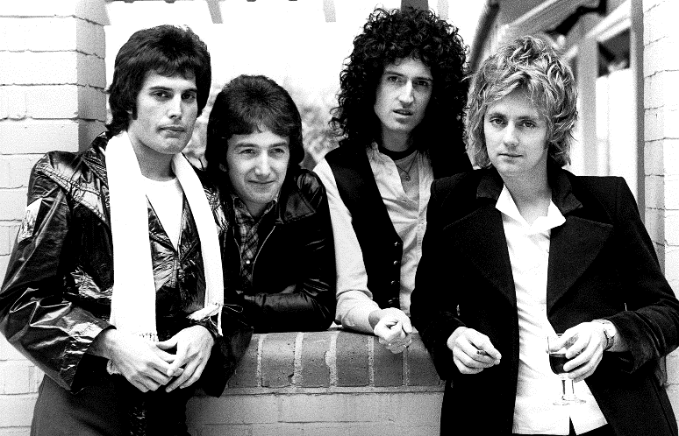
Queen ‘Killer Queen’ from the album Sheer Heart Attack
Structure
The overall structure of this song is:

__________________________________________
Have a go at naming the sections as you listen to the song.
You should use the following words to describe the sections:

Introduction
Verse
Chorus
Guitar solo
Outro
Bar | Section
1-2
(0.00)
2-14
(0.03)
15-22
(0.27)
23-26
(0.44)
27-38
(0.51)
39-43
(1.15)
44-51
(1.25)
52-61
(1.43)
62-69
(2.00)
70-78
(2.16)
79-end
(2.35)

What is unusual about the phrase structure?

Instrumentation & Sonority

1. Listen to the song. List the instruments you hear.

2. Listen to the chorus. How do you think the sound of a 4-part choir has been created?

3. What is the role of the backing vocals?

4. What is the effect of using 2 pianos playing exactly the same part?

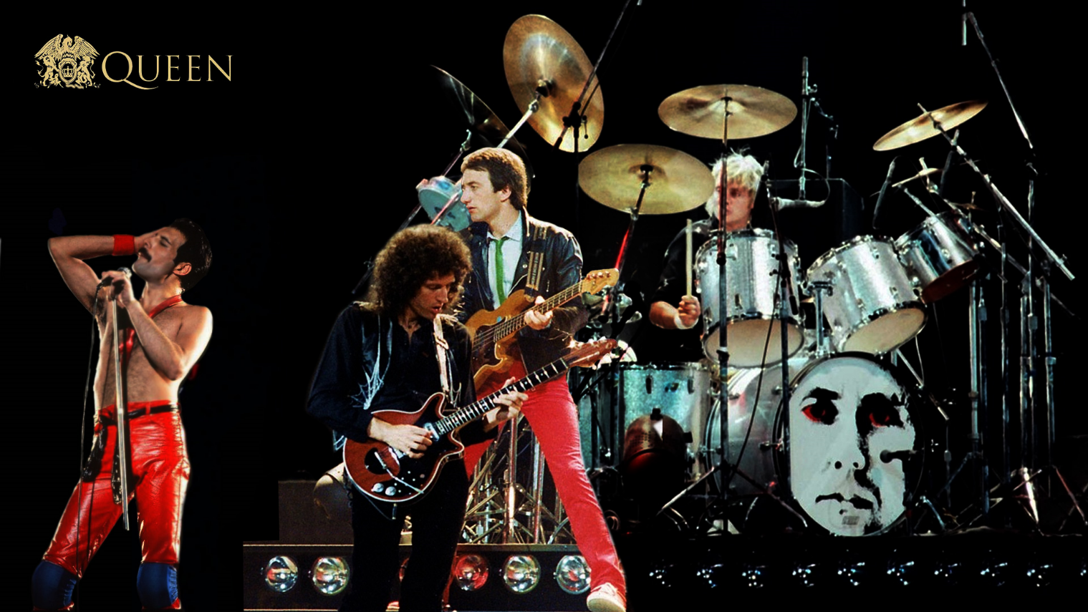
Queen were very proud that no synthesisers were used in the making of the album Sheer Heart Attack. Synths were very popular in the 1970s and provided all sorts of options for crafting the sound. Queen did things the hard way, creating similar effects with their voices and guitars.

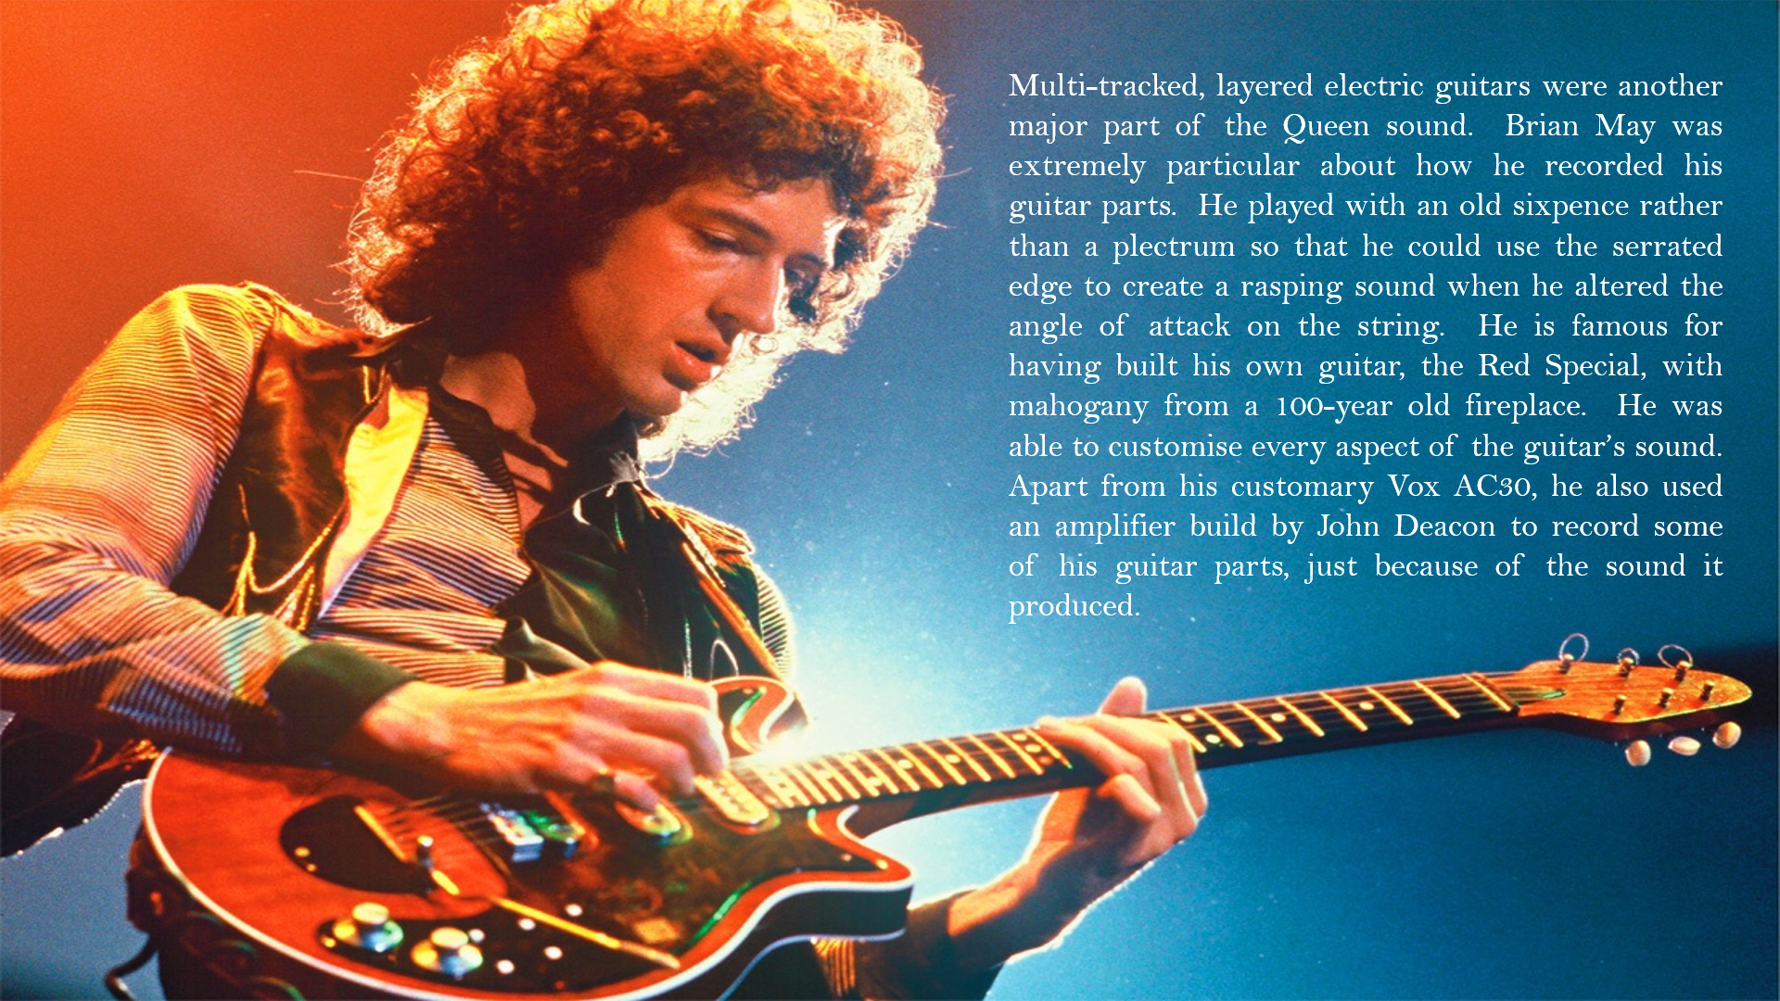
Instrumentation & Sonority

1. Listen to the guitar parts in bars 70-73 and 55-61. What effect has been used here?

2. What is the role of the bass guitar part?

3. What is the role of the drum-kit?

4. Can you identify the extra percussion used in the song? Other than the finger clicks in the introduction there are only two additional percussion instruments. These can be heard at the start of bar 29 and the end of bar 68.

Guitar Techniques
Write a definition of each of the following guitar techniques used by Brian May:
- String bends

- Slides
Music Tech Glossary
Microphone
Distortion
Flanger
Multi-track recording
Reverb
Wah-wah
Panning
Over-dubbing
- Pull-offs

- Vibrato

Music Technology
The art of using effects in the appropriate place, panning parts to the centre, left and right, balancing all the different sounds and mixing all the ingredients into a cohesive whole can add considerable amount to the success of a song.
In ‘Killer Queen’ the following use of music technology can be heard:

- Much use of ………………………. , especially of the backing vocals (e.g. 73-74) and guitar parts (55-61)

- The distinctive swooshing sound of …………………….. On the whole mix (77-78) and for word-painting on the word laser-beam (17) in the vocal part.

- The dependence on ……………..….………….……. and ……………………….…… for the basic sound of the band.

- Use of effects on the guitar - …………………..………... throughout the track, creating the sustained tone;
……………………… at the start of Verse 3 (62).

- ………………………….. on all tracks to some extent, though this is not a major feature of the piece other than to create a sense of space.

- Clever use of …………….……….………... positioning when recording the guitars to create different timbres.
Music Technology and Guitar Techniques
Task: Find examples of the following techniques on your score. Give the precise bar number.
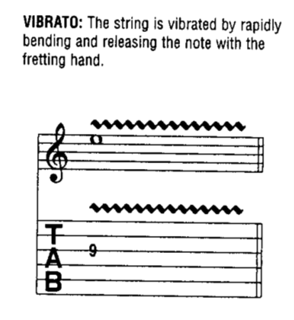
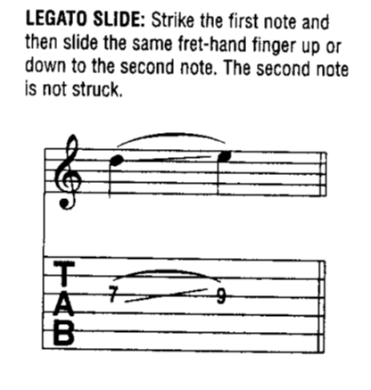

Music Technology and Guitar Techniques
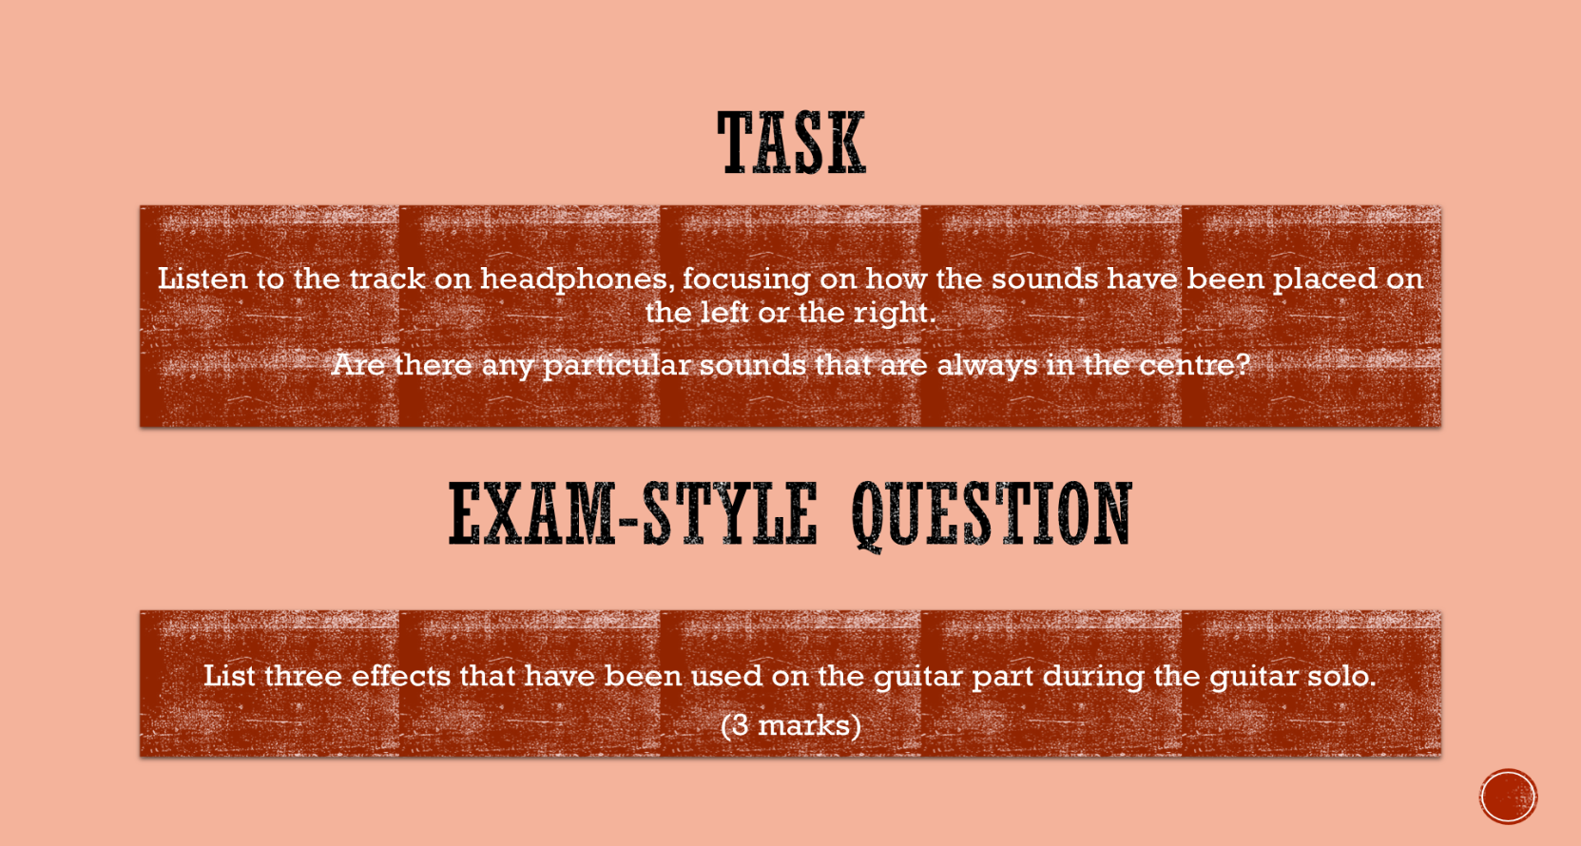

……………………………………………………………………………………………………………………………………………………………………….......
……………………………………………………………………………………………………………………………………………………………………………
……………………………………………………………………………………………………………………………………………………………………………

………………………………………………………………………………………………………………………………………………………………………
………………………………………………………………………………………………………………………………………………………………………
………………………………………………………………………………………………………………………………………………………………………
………………………………………………………………………………………………………………………………………………………………………
………………………………………………………………………………………………………………………………………………………………………
………………………………………………………………………………………………………………………………………………………………………
Rhythm, Metre & Tempo

1. What is the time signature? Can you see any changes in time signature?

2. What is the tempo marking?

3. Syncopation is an important rhythmic feature of this piece. There are two important syncopated motifs. Can you find them?

Melody
- Is the vocal line mostly melismatic or syllabic?

- Describe the melodic shape of the first phrase of verse 1.

- Name the musical device used on the words “recommended at the price” (bar 20) and “(in)satiable an appetite” (bar 21)

- Describe the pitch range of the guitar in the solo.

- Sometimes the vocal line has an ‘x’ printed as the note-head. What does this mean?
Texture
The texture of this piece changes frequently. Only the piano seems to be present throughout the whole song.
1. Using one word describe the texture from when the vocals enter.

2. How do parts come in at the start of the song?

3. Describe the articulation of the verse. How does this affect the texture?

4. What do you notice about the backing vocals in the chorus (compared with the verse)?
Texture Glossary:
Monophonic
Homophonic
Polyphonic
Antiphony
Thin/Thick
Layered
Sparse
Light

5. Describe the articulation of the chorus. How does this affect the texture?

6. Describe the texture of the first chorus using one word.

7. What happens to the texture in the 2nd verse?

8. What do you notice about the chords played by the 2nd and 3rd guitar parts in the 2nd half of the guitar solo?

9. There is antiphony at bars 42-43 and 67-68. Describe this effect.

10. What happens to the texture in the 2nd half of the guitar solo?

Tonality & Harmony
The chord sequences owe more to songs from musicals than to the blues-based sequences of rock music. A standard rock song will often follow an adapted 12-bar-blues sequence or will use chords I, IV and V as the basis of their harmony.
The middle 8 may briefly venture into something more exciting, but the song will generally stay rooted in the tonic key throughout.
Songs from musicals tend to be much more harmonically adventurous.

- What key is ‘Killer Queen’ in?

…………………………………………………………………………………………………………………………………………………………………………………………
…………………………………………………………………………………………………………………………………………………………………………………………

- What features make the song more harmonically interesting?

…………………………………………………………………………………………………………………………………………………………………………………………
…………………………………………………………………………………………………………………………………………………………………………………………
…………………………………………………………………………………………………………………………………………………………………………………………
…………………………………………………………………………………………………………………………………………………………………………………………
…………………………………………………………………………………………………………………………………………………………………………………………
…………………………………………………………………………………………………………………………………………………………………………………………
…………………………………………………………………………………………………………………………………………………………………………………………
…………………………………………………………………………………………………………………………………………………………………………………………
…………………………………………………………………………………………………………………………………………………………………………………………
…………………………………………………………………………………………………………………………………………………………………………………………
…………………………………………………………………………………………………………………………………………………………………………………………

Tonality & Harmony
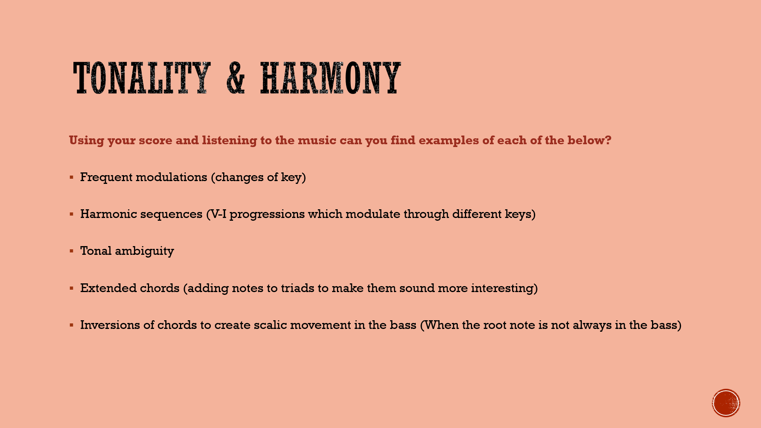

Recap
List the keys and harmonic devices used in ‘Killer Queen’ in the table below:
Keys | Harmonic Devices

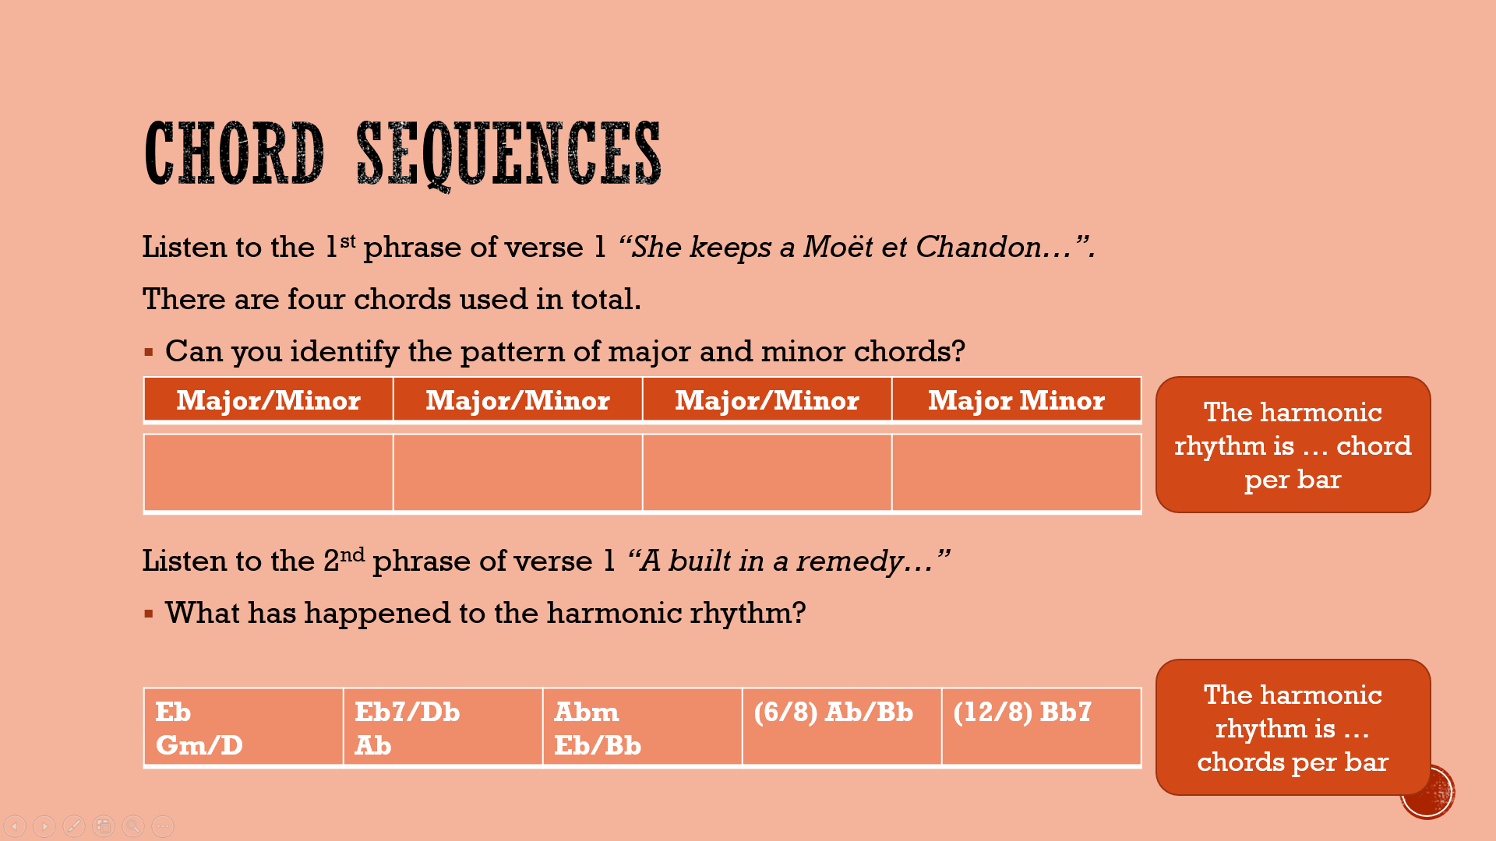
Tonality & Harmony

- Listen for the difference in harmonic rhythm from the 1st 4-bars of the verse onwards. What effect does this have? What effect does it have when the chords start changing on every beat (e.g. bar 18)?

- Listen to the circle of 5ths sequence in bars 20-21. Do you think you would recognise this sequence if you heard it in an unfamiliar piece of music?

- Do you think the ending is effective when the song returns to Eb-major at the end? What words would you use to describe the key change here?

Summary
The structure can be described as verse-chorus. There is also an intro, guitar solo (middle 8 / bridge) and outro. The phrase lengths are unusual. There is clever reuse of phrases in different sections.
The key is Eb major which is unusual for rock music. The piece modulates many times. The harmony is inspired by musicals rather than the blues because it is quite complex. There is use of harmonic sequences.
There are a limited number of instruments. Queen did not want to use synths in this album. Synths were commonly used in the 1970s, but by clever orchestration Queen created interesting timbres and effects without one. Multi-tracking was used to layer parts. The backing vocals are carefully crafted and often move in parallel motion. The guitar parts sometimes emulate other instruments.
The time signature is 12/8 which means the piece is in compound time and there are 4 dotted crotchet beats per bar. It has a swung feel. There is use of syncopation. There are important rhythmic motifs that appear throughout the song. The tempo is fast.
The melody returns through several sections. The vocal line is mostly syllabic which means there is one note per syllable. There is development of the vocal melody in the guitar solo.
The texture is varied throughout with clear contrast between sections. Parts have been carefully placed so as not to crowd the texture. There is use of homophonic, polyphonic and antiphonal textures.
Music technology plays a fundamental role in the overall sound. Multi-tracking and overdubbing are used frequently. Effects such as flanger, wah-wah and distortion are used. Panning helps to separate out sounds and creates antiphonal effects.
Brian May uses string-bends, slides, vibrato and pull-offs to create his characteristic guitar sound. There are no strummed parts. He carefully articulates each note and does not use a plectrum, instead he uses an old sixpence to create a more interesting sound.

Summary
The structure can be described as ………………………………………….. There is also an …………………., …………………………………………….. (middle 8/bridge), and …………………………………….. . The ……………………………… lengths are unusual. There is clever reuse of phrases in different sections.
The key is …………………………………. which is unusual for rock music. The piece …………………………………… many times. The harmony is inspired by ……………………………………………. rather than the blues because it
is quite complex. There is use of …………………………………………………………………… .There are a limited number of instruments. Queen did not want to use ………………………….. in this album.
Synths were commonly used in the 1970s, but by clever orchestration Queen created interesting timbres and effects without one. …………………………………………………… was used to layer parts. The backing vocals are carefully crafted and often move in …………………………………… motion. The …………………………………….. parts sometimes emulate other instruments.
The time signature is …………………… which means the piece is in ………………………………………………… time and there are 4 dotted crotchet beats per bar. It has a ………………………………………. feel. There is use of ……………………………………………………. There are important rhythmic motifs that appear throughout the song. The tempo is fast.
The melody returns through several sections. The vocal line is mostly ………………………………………… which means there is one note per syllable. There is ……………………………………………………………….. of the vocal melody in the guitar solo.
The ………………………………………………….. is varied throughout with clear contrast between sections. Parts have been carefully placed so as not to crowd the texture. There is use of ………………………………………………….., ………………………………………………….. and ………………………………………………….. textures.
Music technology plays a fundamental role in the overall sound. ………………………………………………….. and ………………………………………………….. are used frequently. Effects such as ………………………………………, ……………………………………… and ……………………………………… are used. ……………………………………… helps to separate out sounds and creates antiphonal effects.
Brian May uses ………………………………………………….., ………………………………………………….., ………………………………………………….. and ………………………………………………….. to create his characteristic guitar sound. There are no …………………………………………… parts. He carefully articulates each note and does not use a ……………………………………………, instead he uses an old sixpence to create a more interesting sound.

