Workbook 10
Ornaments and musical devices
Ornaments
Ornaments are mainly used to decorate melody lines and have been a common feature in music since the Baroque era. There are five main types of ornaments:
- mordent
- acciaccatura
- appoggiatura
- turn
- trill.

The mordent
The upper mordent is commonly played starting from the written note to the note above and back to the first note, as follows:
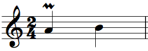 | 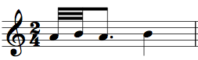
Written | Played
The lower mordent is played starting from the written note to the note below and back to the first note, as follows:
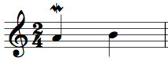 | 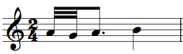
Written | Played

The acciaccatura
This is often referred to as the crushed note. The small note with a line through it is played as fast as possible just before the main note, hence it sounds crushed.
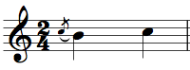 | 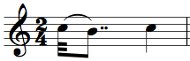
Written | Played

The appoggiatura
Although it looks similar to the acciaccatura, the aural effect is quite different – the appoggiatura is a leaning note. It is usually approached by a leap in the melody line and causes a clash or dissonance with the harmony, which resolves by step onto the second note. The effect of the leaning note is to take half the value of the principal note, or two-thirds in the case of a dotted note. Look at the following two examples:
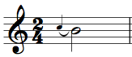 | 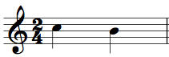
Written | Played
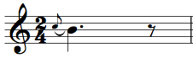 | 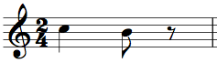
Written | Played

The turn
As the name implies, this ornament turns about a note. It is essentially a decoration of a note as it features the note above, the note itself, the note below and back to the note itself. There is a slight difference when the turn occurs between two notes (see second example below).
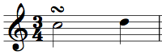 | 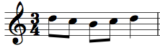
Written | Played
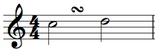 | 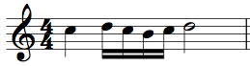
Written | Played

The trill
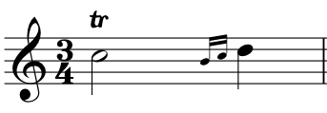
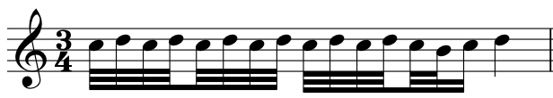
This is one of the commonest ornaments. It involves two notes played in rapid succession, one after the other, and sometimes finishes with a turn at the end. There is no one set way to play a trill and the number of notes will depend on the tempo of the music. The faster the music, the fewer the notes that will be played in the trill; while the slower the music, the more the notes that can be played.
Written | Played

1. Name the ornaments and write out how each is played.

Written |  | Played
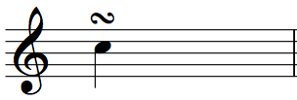 |  | 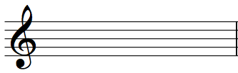
(i) | __________________________
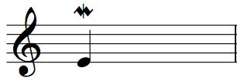
(ii) | __________________________
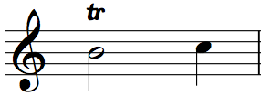
(iii) | __________________________
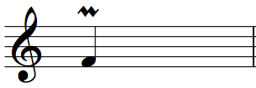
(iv) | __________________________
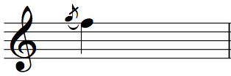
(v) | __________________________

Musical devices
In examination papers, questions are often asked about ‘musical devices’. This strange term is a catch-all for several unrelated musical phenomena. The term is used in examination papers because it is often quite difficult to avoid giving away the name of the device in the question without using the more general expression. The six examples below will give you an idea of what examiners expect when they ask you to identify the ‘musical device’.

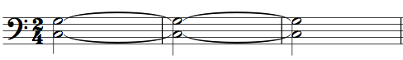 | 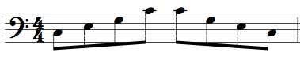
Drone | Arpeggio
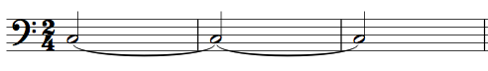 | 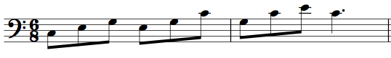
Pedal | Broken chord
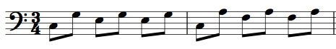 | 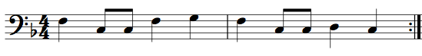
Alberti bass | Ostinato / riff

