Lesson Element

Unit 1: Body systems and the effects of physical activity

LO3: Understand the cardiovascular system in relation to exercise and physical activity

Understanding the structure and functions of the cardiovascular system

Instructions and answers for tutors

These instructions cover the learner activity section which can be found on page 6. This Lesson Element supports Cambridge Technicals Level 3 in Sport and Physical Activity.
When distributing the activity section to the learners either as a printed copy or as a Word file you will need to remove the tutor instructions section.

The activity
These activities will help your learners to consolidate their knowledge of the structures of the heart, along with their functions.

Suggested timings
Activity 1: 1 hour
Activity 2: 1 hour
ABC – This activity offers an opportunity for English skills development.

Activity 1
Split learners into equal teams and set up the session as for a relay race. At the ‘start’ the teams line up, each with a large unlabelled diagram of the heart. At the ‘end’ each team has all of the structures of the heart on separate pieces of paper, face down on the floor. You can use the labels on the heart diagram below and/or add others as appropriate.
On ‘go’ the first learner from each team runs to the other end, selects a ‘label’, brings it back to the rest of their team and places it in the correct place on the diagram. The next learner then runs, collects a label, runs back and places it on the diagram. The game continues until the last team has all of their labels in place.
Give 30 seconds for a final check and swapping around of any misplaced labels before the answers are revealed. Teams can score 1 point for each correct label.
This activity can be extended by adding in the functions of each structure (shown below in boxes); functions cards can be used along with structure label cards (with learners having to place the correct label and assign the correct function to their label) or, after labels have been scored and moved to the correct position, learners can be awarded extra points for explaining the function of each structure.
Deoxygenated blood from body
Oxygenated blood to body
Deoxygenated blood to lungs

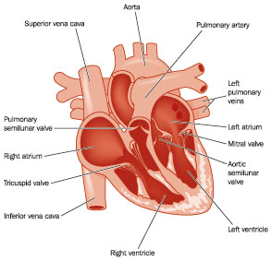
Stops backflow of blood
Receives deoxygenated blood from the body
Stops backflow of blood
Brings deoxygenated blood from body into heart

Pumps oxygenated blood to the body
Stop backflow of blood
Receives oxygenated blood from lungs
Oxygenated blood from lungs
Pumps deoxygenated blood to the lungs
Free to use unlabelled heart diagrams can be found here:
http://cliparts.co/heart-diagram-unlabeled

Activity 2
Split learners into groups of three. Give each learner in the group one of the blood vessels to research e.g. one will be allocated ‘arteries’, another given ‘veins’ and the other ‘capillaries’.
Ask learners to research and collate information regarding their given blood vessel. They should find out:
- the job(s) it does
- a diagram of the blood vessel
- specific elements of the structure that make it fit for purpose
- any other interesting facts (how many miles of capillaries are in the body or the pressure inside the aorta as blood leaves the heart etc)
- any other relevant information.
Learners can then present their findings to the other two members of their group, who must complete the table below using the information their peer has given to them.
To extend the activity, groups could select one ‘fascinating fact’ relating to each of the blood vessels, write it on a sticky note and stick it to the board at the front of the class. Each group can ‘present’ their chosen fact in turn, with other learners asking questions and clarifying their understanding with input from you as appropriate.

 | Veins | Arteries | Capillaries
Function | Carry deoxygenated blood towards the heart | Carry oxygenated blood from the heart out into the body | Allow diffusion of substances in and out of blood/body tissues
Diagram | 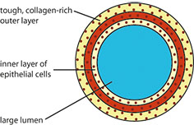 | 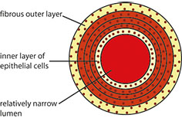 | 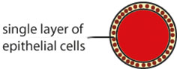
Link between structure and function | Veins carry blood under low pressure so they have valves to prevent backflow and have thinner walls than arteries | Blood is under high pressure so arteries have thick walls | The very thin walls allow for diffusion of substances in and out of the blood stream. Capillaries are so narrow that blood flows through slowly enough that diffusion can take place
Interesting fact | Veins don’t have a pulse | Artery walls stretch as the blood is forced through them and then go back to their normal size once the blood has passed | When you cut yourself it is the capillaries that you cut and that the blood comes from (unless it’s a really deep cut!)
Any other information

This website gives a clear and concise overview of the blood vessels, along with diagrams and animation showing blood moving through the vessels: http://www.abpischools.org.uk/page/modules/heartandcirculation/heart5.cfm


We’d like to know your view on the resources we produce. By clicking on ‘Like’ or ‘Dislike’ you can help us to ensure that our resources work for you. When the email template pops up please add additional comments if you wish and then just click ‘Send’. Thank you.
If you do not currently offer this OCR qualification but would like to do so, please complete the Expression of Interest Form which can be found here: www.ocr.org.uk/expression-of-interest
OCR Resources: the small print
OCR’s resources are provided to support the teaching of OCR specifications, but in no way constitute an endorsed teaching method that is required by the Board, and the decision to use them lies with the individual teacher. Whilst every effort is made to ensure the accuracy of the content, OCR cannot be held responsible for any errors or omissions within these resources.
© OCR 2016 – This resource may be freely copied and distributed, as long as the OCR logo and this message remain intact and OCR is acknowledged as the originator of this work.
OCR acknowledges the use of the following content: labelled heart diagram, Blamb/Shutterstock.com; unlabelled heart diagram BlueRingMedia/Shutterstock.com.
Please get in touch if you want to discuss the accessibility of resources we offer to support delivery of our qualifications: resources.feedback@ocr.org.uk

Lesson Element

Unit 1: Body systems and the effects of physical activity

LO3: Understand the cardiovascular system in relation to exercise and physical activity

Learner Activity

Understanding the structure and functions of the cardiovascular system
Activity 1 will help you to consolidate your knowledge of the main structures of the heart and their function.
Activity 2 will give you the opportunity to explore the different types of blood vessel and present your findings to your peers.

Activity 1
You are going to take part in a team relay race. At the ‘start’ your team will line up and be given a large unlabelled diagram of the heart. At the ‘end’ you will see all of the structures of the heart on separate pieces of paper, face down on the floor.
On ‘go’ the first learner from each team runs to the other end, selects a ‘label’, brings it back to the rest of their team and places it in the correct place on the diagram. The next learner then runs, collects a label, runs back and places it on the diagram. The game continues until the last team has all of their labels in place.
You will have 30 seconds for a final check and swapping around of any misplaced labels before the answers are revealed. Teams can score 1 point for each correct label.
Your tutor may also ask you to add the function of each structure you identify.

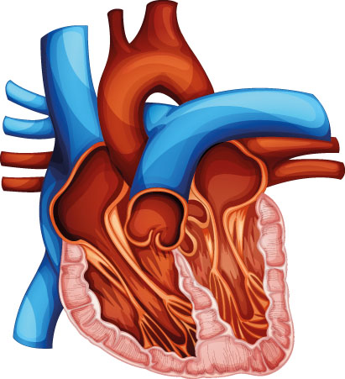

Activity 2
Your tutor will put you into a group with two other learners and give each of you one of the blood vessels to research i.e. one of you will be allocated ‘arteries’, another given ‘veins’ and the other ‘capillaries’.
Research and collate information regarding your given blood vessel. You should find out:
- the job(s) it does
- a diagram of the blood vessel
- specific elements of the structure that make it fit for purpose
- any other interesting facts (how many miles of capillaries are in the body or the pressure inside the aorta as blood leaves the heart etc)
- any other relevant information.
Present your findings to the other two members of your group, who must complete the table below using the information you have given to them. The other members of your group will do the same and you must record the information they give you in the table too.

 | Veins | Arteries | Capillaries
Function
Diagram
Link between structure and function
Interesting fact
Any other information

