Lesson Element

Unit 1: Body systems and the effects of physical activity

LO2: Understand the muscular system in relation to exercise and physical activity

Understanding the muscular system and the effects of exercise

Instructions and answers for tutors

These instructions cover the learner activity section which can be found on page 6. This Lesson Element supports Cambridge Technicals Level 3 in Sport and Physical Activity.
When distributing the activity section to the learners either as a printed copy or as a Word file you will need to remove the tutor instructions section.

The activity
These activities will help your learners to consolidate their knowledge of the muscular system: the main muscles, muscle function and muscle contraction.
It will also enable them to explore the short- and long-term effects of exercise and training on the muscular system.

Suggested timings
Activity 1: 45 minutes
Activity 2: 1.5 hours
Activity 3: 30 minutes to 1 hour
ABC – This activity offers an opportunity for English skills development.

Activity 1
Split learners into pairs and give each pair a pad of sticky notes and a pen.
Ask learners to work with their partners to list as many muscles as they can think of. They can write each muscle on a separate sticky note and then the whole class can compare notes to ensure that everyone has a comprehensive list of the muscles.
Working back in their pairs, one learner is a statue and must stand completely still, whilst the other learner must stick the sticky notes onto the ‘statue’ to correspond with the correct place for that muscle.
Once all of the statues are covered in sticky notes they can remain standing still whilst the rest of the group have a look around to see who has stuck what, where!
If you are feeling generous you might like to give 30 seconds for learners to move any sticky notes they aren’t so confident about!
Now bring the whole class together to confirm the correct position for each muscle. Pairs can be awarded one point for each sticky note they put in the right place on their statue.
Learners can record the muscle names and locations on the diagram so that they have an accurate record to keep.
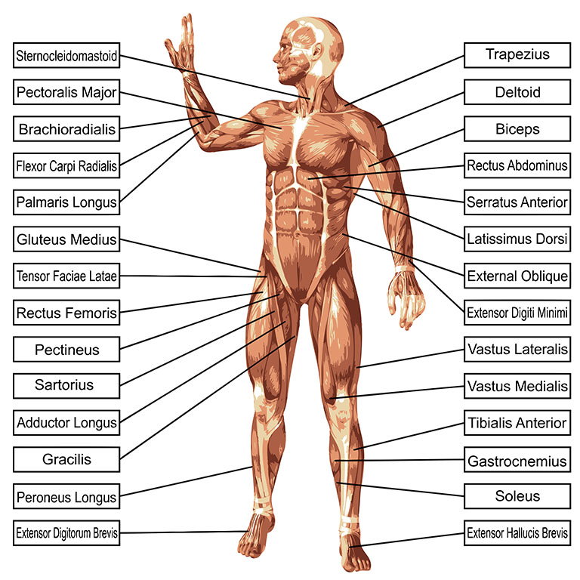
This website includes several different diagrams of the muscles of the human body, both labelled and unlabelled: http://humananatomybody.info/full-body-muscle-lable/

Activity 2
Learners can work individually or in pairs. Ask learners to select two basic exercises or activities that they might find in a circuit session. Activities such as press ups, sit ups, squats, dips, star jumps etc will be fine. Check that no two activities are repeated within the class.
Now learners can go into a practical space and set up a circuit involving each pair’s two activities. Each pair can then explain and demonstrate their activity to the rest of the group.
Once the circuit is set up and all learners know what to do at each station, tell them that whilst they are doing each activity, they must think about which muscles are playing which role – which is the agonist, antagonist and fixator.
Learners can work their way around the circuit, stopping after each exercise to write down in the table which muscle/s played which role/s in the exercise they have just completed.
Once all learners have done every activity and completed their ‘muscle function’ worksheet each answer can be discussed and a consensus reached.
Exercise/activity | Agonist muscle/s | Antagonist muscle/s | Fixator muscle/s
Example:  Press up | Down phase –  pectorals  Up phase –deltoids, triceps | Down phase – trapezius, deltoids, triceps  Up phase – pectorals, biceps | Rotator cuff, abdominals, quads

Information about the different types of muscle function (as well as types of muscle contraction) can be found here: http://www.ptdirect.com/training-design/anatomy-and-physiology/skeletal-muscle-roles-and-contraction-types

Activity 3
For this activity, give each learner a copy of the ‘drag and drop’ activity below. They must try to fill in the missing words in order to explain the short- and long-term effects of exercise on the muscular system.
You can either give your learners the missing words – requiring them to make sure they put them in the correct places. Or you may choose to ask learners to fill in the blanks from their own knowledge and research, without giving them the missing words beforehand.
Note the words in bold are those that are missing from the learners’ version of this passage.
Exercise has both short- and long-term effects on the muscular system.
Short-term effects are those that occur during and immediately after exercise. They include:
- Bigger muscles – they can increase in size by up to 25% because of the increased blood flow to them.
- Muscle fatigue – this is the decline in the ability of the muscle to generate force. There are two main causes of muscle fatigue: the limitations of a nerve’s ability to generate a sustained signal (neural fatigue) and the reduced ability of the muscle fibre to contract (metabolic fatigue).
- Muscle soreness – once thought to be due to lactic acid accumulation, has more recently been attributed to small tearing of the muscle fibres caused by eccentric contraction.
Long-term effects of exercise can include:
- Increased muscle size – exercising specific muscles regularly can increase their size by up to 60%. This increase in muscle size is mainly due to the increased diameter of individual muscle fibres.
- Improved muscle coordination – muscles learn to work more efficiently and effectively by working together e.g. when the agonist contracts more rapidly the antagonist must relax as quickly to prevent blocking the movement.
- More effective blood supply – as a result of frequent exercise over a sustained period of time both the quantity of blood vessels and the extent of the capillary beds increases. This allows oxygen to reach the muscles more efficiently and carbon dioxide to be taken away quickly. This increased blood supply also improves delivery of various nutrients, minerals and vitamins to muscles, making them more effective and faster at regenerating after injury or workout.
Information that learners will need to complete this activity can be found here: http://simpleask.co.uk/effects-of-exercise-on-muscular-system/


We’d like to know your view on the resources we produce. By clicking on ‘Like’ or ‘Dislike’ you can help us to ensure that our resources work for you. When the email template pops up please add additional comments if you wish and then just click ‘Send’. Thank you.
If you do not currently offer this OCR qualification but would like to do so, please complete the Expression of Interest Form which can be found here: www.ocr.org.uk/expression-of-interest
OCR Resources: the small print
OCR’s resources are provided to support the teaching of OCR specifications, but in no way constitute an endorsed teaching method that is required by the Board, and the decision to use them lies with the individual teacher. Whilst every effort is made to ensure the accuracy of the content, OCR cannot be held responsible for any errors or omissions within these resources.
© OCR 2016 – This resource may be freely copied and distributed, as long as the OCR logo and this message remain intact and OCR is acknowledged as the originator of this work.
OCR acknowledges the use of the following content: human muscle groups, design36/Shutterstock.com
Please get in touch if you want to discuss the accessibility of resources we offer to support delivery of our qualifications: resources.feedback@ocr.org.uk

Lesson Element

Unit 1: Body systems and the effects of physical activity

LO2: Understand the muscular system in relation to exercise and physical activity

Learner Activity

Understanding the muscular system and the effects of exercise
Activity 1 will help you to consolidate your knowledge of the main muscles of the body.
Activity 2 will enable you to explore the different types of muscle function (agonist, antagonist, synergist and fixator) in a practical setting, before recording the main muscles and their functions for a range of basic exercises.
Activity 3 will test how well you know the short- and long-term effects of exercise on the muscular system.

Activity 1
You will be asked to work in pairs and given a pad of sticky notes and a pen.
Firstly you and your partner must list as many muscles as you can think of and compare notes with the rest of the group to ensure that you have a comprehensive list of all the main muscles.
Then write each muscle on a separate sticky note.
Nominate one of you to be a statue – the statue must stand completely still, whilst the other learner places sticky notes onto the ‘statue’ to correspond with the correct place for that muscle.
Once all of the statues are covered in sticky notes they can stay where they are whilst the rest of the group have a look around to see who has stuck what, where!
You will be awarded one point for each sticky note you put in the right place on your statue.
Having carried out the ‘muscle identifying’ activity with your partner and sticky notes, you can now record the muscle names and locations on the diagram below so that you have an accurate record to keep.
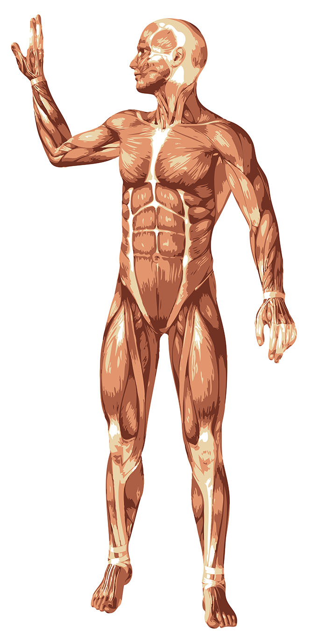

Activity 2
Working with a partner, select two different basic exercises or activities that you’d normally find in a circuit.
In a practical space, set up your two stations and then explain them to the rest of the group. The other learners will do the same so that eventually there is a complete circuit made up of activities devised by you and your peers.
You will carry out each station in the circuit, but whilst you are carrying out the activities you must think about which muscle/s are taking on which function – which are acting as agonists, antagonists, synergists and fixators?
Between stations you will have a chance to discuss this with your partner and write down your answers in the table provided.
At the end of the circuit the whole group can discuss their thoughts and answers and a general consensus can be reached, with support from the tutor.

Exercise/activity | Agonist muscle/s | Antagonist muscle/s | Fixator muscle/s | Synergist muscle/s

Activity 3
For this activity you will be given a copy of the ‘drag and drop’ activity below. You must try to fill in the missing words in order to explain the short- and long-term effects of exercise on the muscular system.
Exercise has both _________ and ________________ effects on the muscular system.
_______________ effects are those that occur during and ________________________ exercise. They include:
- Bigger ___________ – they can increase in size by up to 25% because of the increased ___________________ to them
- Muscle ______________ – this is the decline in the ability of the muscle to generate force. There are two main causes of muscle _____________: the limitations of a nerve’s ability to generate a sustained signal (__________ fatigue) and the reduced ability of the muscle fibre to contract (___________ fatigue).
- Muscle ____________ – once thought to be due to __________________ accumulation, has more recently been attributed to small ___________ of the muscle fibres caused by _______________________________.
____________________ effects of exercise can include:
- Increased muscle __________ – exercising specific muscles regularly can increase their ________ by up to 60%. This increase in muscle _________ is mainly due to the increased diameter of individual _____________________.
- Improved muscle ___________________ – muscles learn to work more efficiently and effectively by working together e.g. when the ___________ contracts more rapidly the __________________ must _____________ as quickly to prevent blocking the movement.
- More effective ____________ supply – as a result of frequent exercise over a sustained period of time both the quantity of _____________________ and the extent of the ______________ beds increases. This allows ____________ to reach the muscles more efficiently and ____________________________ to be taken away quickly. This increased blood supply also improves delivery of various _____________________ ____________________________________ to muscles, making them more effective and faster at regenerating after ____________ or workout.
Words that you’ll need to fill in the gaps (please note – some words may be needed more than once):

INJURY CARBON DIOXIDE BLOOD VESSELS SHORT-TERM
SORENESS LONG-TERM SIZE LACTIC ACID FATIGUE
AGONIST BLOOD FLOW TEARING IMMEDIATELY AFTER RELAX
METABOLIC MUSCLE FIBRES NEURAL MUSCLES ANTAGONIST
NUTRIENTS, MINERALS AND VITAMINS ECCENTRIC CONTRACTION OXYGEN
CAPILLARY COORDINATION BLOOD SHORT

