Lesson Element

Unit 1: Body systems and the effects of physical activity

LO4: Understand the respiratory system in relation to exercise and physical activity

Understanding the structure and functions of the respiratory system

Instructions and answers for tutors

These instructions cover the learner activity section which can be found on page 6. This Lesson Element supports Cambridge Technicals Level 3 in Sport and Physical Activity.
When distributing the activity section to the learners either as a printed copy or as a Word file you will need to remove the tutor instructions section.

The activity
These activities will help your learners to consolidate their knowledge of the structures and muscles of the respiratory, along with their functions.

Suggested timings
Activity 1: 45 minutes
Activity 2: 45 minutes
ABC – This activity offers an opportunity for English skills development.

Activity 1
Give your learners a copy of the blank diagram of the lungs and ask them to label the main structures that are involved in breathing.
To make it more/less challenging you can either give or not give a list of the structures that need labelling at the start of the activity.
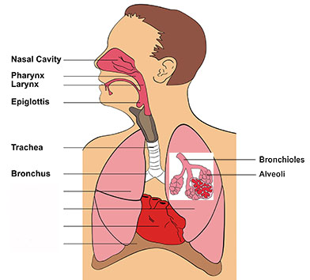
Once learners have a correctly labelled diagram they can write down each structure that air will pass through/into in the correct order down the side of a page:
- nasal cavity
- pharynx
- larynx
- epiglottis
- trachea
- bronchus
- bronchioles
- alveoli
Then learners can create a mnemonic that they will use to ensure they know the structures and order in which they ‘appear’ (for example: northern people like every thin brown bear around). Learners can share their mnemonic with the rest of the group.

Activity 2
Give learners a copy of the diagram below, which shows the different muscles that are involved in the breathing process.
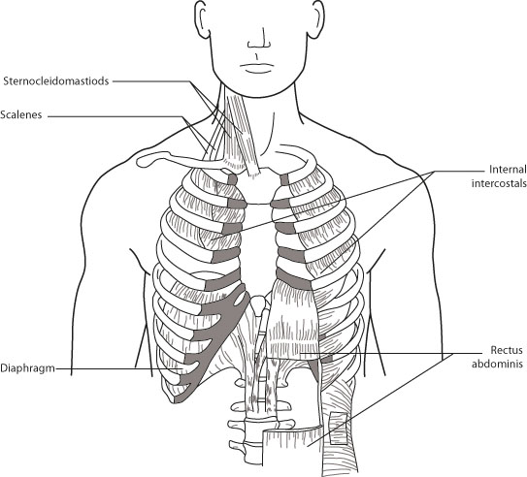
Ask learners to suggest what each identified muscle does during inspiration and expiration.
Learners may need reminding of the movements within the chest cavity during breathing (i.e. during inspiration the ribs move up and out and the diaphragm flattens, during expiration the opposite happens).
Learners can complete the table below to state which muscles are involved, what their action is during inspiration and expiration and why this muscle action takes place.

Muscle | Movement during inspiration | Movement during expiration | Reason for this movement
Sternocleidomastoid | Contract to lift the top of the chest | Relax to lower the top of the chest | Contribute to controlling the size and therefore the air pressure in the thoracic cavity
Scalene | Contract to lift the top of the chest | Relax to lower the top of the chest | Contribute to controlling the size and therefore the air pressure in the thoracic cavity
Internal intercostal | Contract, moving the ribs up and out | Relax, moving the ribs down and in | Contribute to controlling the size and therefore the air pressure in the thoracic cavity
Rectus abdominis | Mainly concerned with expiration | Contract to pull the lower ribs down and compress the abdominal cavity | Contribute to raising the air pressure in the thoracic cavity, expelling air from the lungs
Diaphragm | Contracts and flattens  Contributes to the ribs moving up and out | Relaxes and domes upwards  Contributes to the ribs moving down and in | When it flattens more space is created in the thoracic cavity contributing to the negative pressure which draws air into the lungs

Relevant information can be fund here: http://www.humankinetics.com/excerpts/excerpts/learn-the-anatomy-and-physiology-of-the-muscles-involved-in-breathing


We’d like to know your view on the resources we produce. By clicking on ‘Like’ or ‘Dislike’ you can help us to ensure that our resources work for you. When the email template pops up please add additional comments if you wish and then just click ‘Send’. Thank you.
If you do not currently offer this OCR qualification but would like to do so, please complete the Expression of Interest Form which can be found here: www.ocr.org.uk/expression-of-interest
OCR Resources: the small print
OCR’s resources are provided to support the teaching of OCR specifications, but in no way constitute an endorsed teaching method that is required by the Board, and the decision to use them lies with the individual teacher. Whilst every effort is made to ensure the accuracy of the content, OCR cannot be held responsible for any errors or omissions within these resources.
© OCR 2016 – This resource may be freely copied and distributed, as long as the OCR logo and this message remain intact and OCR is acknowledged as the originator of this work.
OCR acknowledges the use of the following content: respiratory system diagram, udaix/Shutterstock.com.
Please get in touch if you want to discuss the accessibility of resources we offer to support delivery of our qualifications: resources.feedback@ocr.org.uk

Lesson Element

Unit 1: Body systems and the effects of physical activity

LO4: Understand the respiratory system in relation to exercise and physical activity

Learner Activity

Understanding the structure and functions of the respiratory system
Activity 1 will help you to consolidate your knowledge of the main structures of the respiratory system.
Activity 2 will help you to understand the muscles that are involved in the breathing process, including their actions during inspiration and expiration.

Activity 1
Label the diagram below to show the main structures of the respiratory system.
Write down each structure that air will pass through/into in the correct order down the side of a page.
Now see if you can create a mnemonic that you will use to ensure you know the structures and order in which they ‘appear’ (for example: northern people like every thin brown bear around).
Share your mnemonic with the rest of the group – whose is the best?

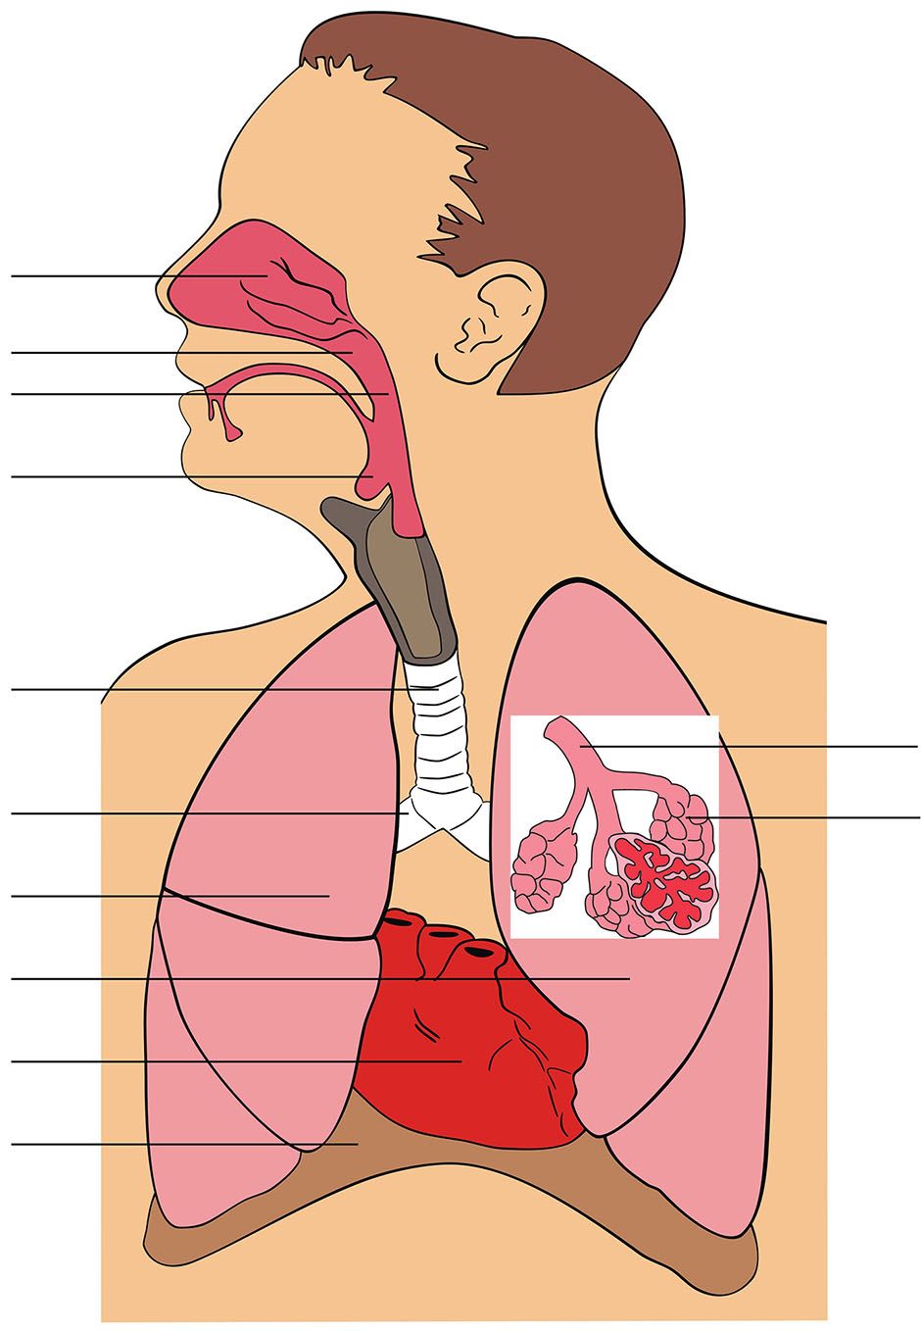

Activity 2
Study the diagram below to see the different muscles that are involved in the breathing process.
Now complete the table below to state which muscles are involved in breathing, what their action is during inspiration and expiration and why this muscle action takes place.

Muscle | Movement during inspiration | Movement during expiration | Reason for this movement

