Homework 1: File management

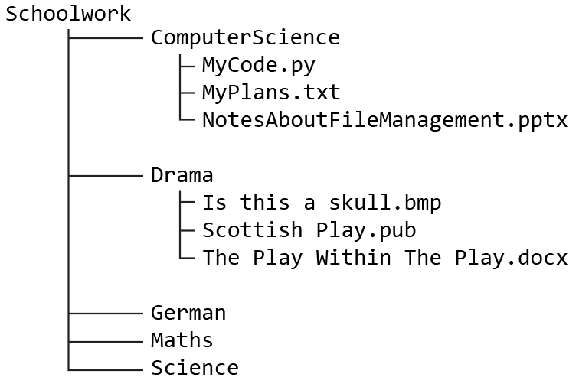

Figure 1

1. In Figure 1, what is the path name for [2]
(a) The file MyCode.py

(b) The folder I use for Maths

2. Backing up files to an online cloud server has advantages, but there are also disadvantages. Write down two disadvantages of cloud backups. [2]

3. Describe two different commands or methods for saving a file. [2]

4. In Figure 2, [2]
(a) Which file is a Bitmap Picture?
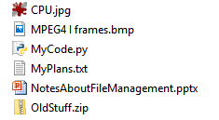

Figure 2

(b) What sort of file is OldStuff.zip?

5. Draw a diagram for a tree structure of folders which would be useful for a teacher of French and Spanish, who teaches both subjects to Years 7, 8 and 9. [2]

[Total 10 marks]

