Worksheet 3: Keeping your data safe

Task 1: Password security
- Which of these are secure passwords? Underline the secure ones and say why you think each is secure or insecure. Could you remember them, or something similar to them, easily?
QWERTY123456

Your address, e.g. 12 Elm Road

I like swimming

ILS

lLik3Sw1mming

876543

Secret

- Now check the passwords with the password checker at:
https://howsecureismypassword.net/ or http://www.passwordmeter.com/
- How many different passwords do YOU use? Test them out with the password checker.

Task 2: Spot a phishing email
Look at the email below from a computer game called “The Underworld”. Find the clues that tell you this is not a genuine email. Circle or highlight them in the worksheet.
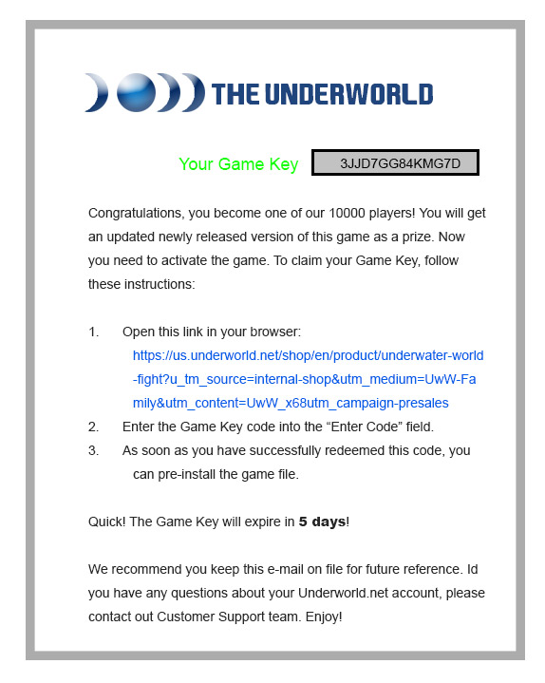
The email takes you to a web page that looks like this:
