Worksheet 4: Sending Email

Tasks:

Send an email to Sarah at flamingo@pgonline.co.uk and ask what makes flamingos pink.
- Reply to an email from a pupil and add another email address in the CC box.
- If you get a response, forward it on to erik.henderson@pgonline.co.uk.
- Try sending an email to the person sat next to you and add vishal.scott@pgonline.co.uk to the BCC box. Who knows who else got the email?
- Add an attachment to an email and send that to hannah.watts@pgonline.co.uk.

Email at work:
Look at the following emails and respond to them appropriately:

Email 1:

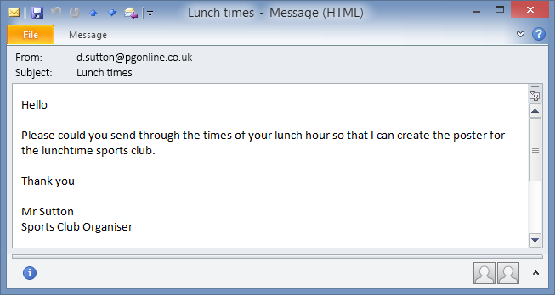

Email 2:

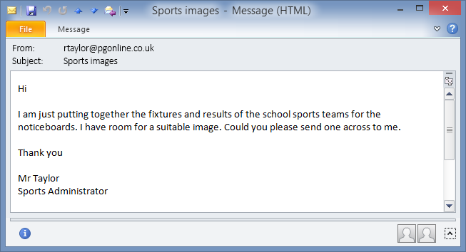

Email 3:

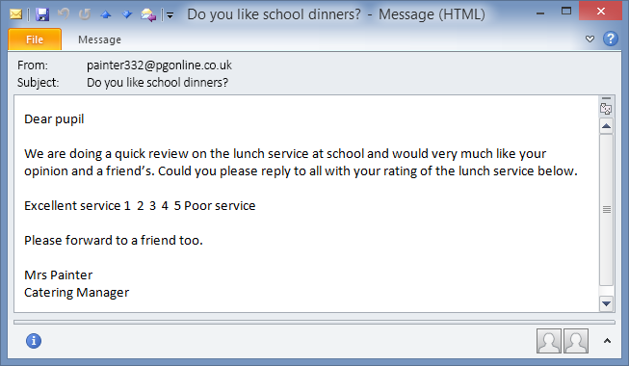

Email 4:

